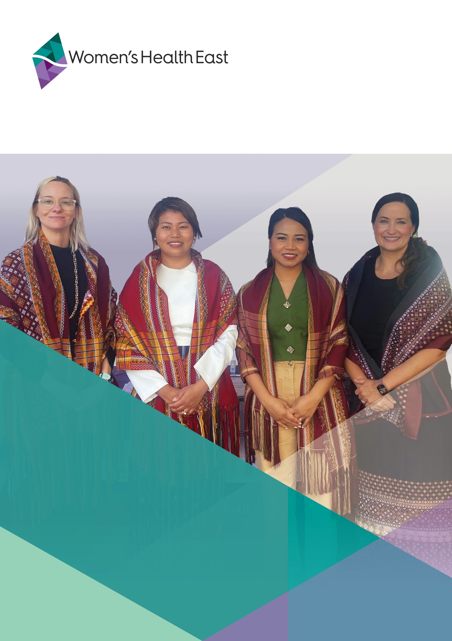Annual Report 2023-2024

Contents

About this report 3

Acknowledgement of Country 3

Chair and Chief Executive Officer report 4

Our People 7

Women’s Health East Strategic Plan 2021-2025 9

Advance gender equality 11

Prevent violence against women 21

Improve sexual and reproductive health 31

Strengthen our dynamic and sustainable organisation 37

Financial summary 43

Membership 45

Our peers, partners and funders 46

# About this report

Welcome to the Women’s Health East 2023-2024 Annual Report.

This report provides an overview of Women’s Health East’s major accomplishments, activities and financial performance for 2023-2024. Please visit our website for our complete financial statements for the year ending 30 June 2024.

For further details about Women’s Health East, please visit the [Women’s Health East website](http://www.whe.org.au/) or contact us at [health@whe.org.au](mailto:health@whe.org.au).

# Acknowledgement of Country

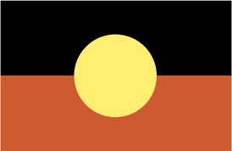 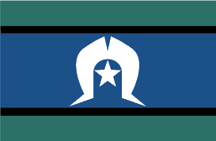

Women’s Health East acknowledges the Wurundjeri Woi-wurrung people, the Traditional Owners of the land on which we work. We pay our respects to Elders past, present and future. We affirm that sovereignty was never ceded, and that colonialism and racism continue to impact the lives of Aboriginal and Torres Strait Islander women and contribute to the high rates of violence they experience. We recognise the strength, resilience and leadership of Aboriginal and Torres Strait Islander women and express our hope for, and commitment to, reconciliation.

# Chair and Chief Executive Officer report

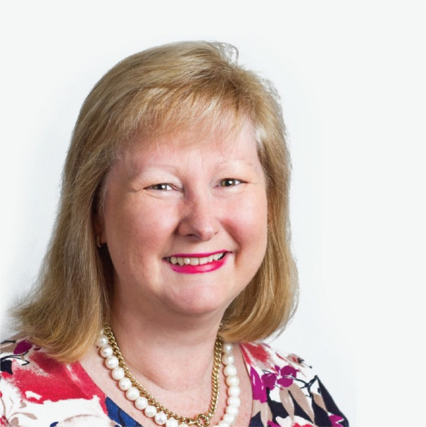

Lisa Dunlop

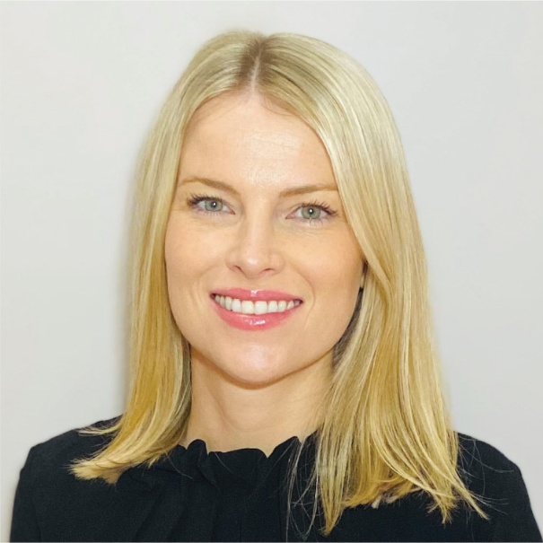

Elly Taylor

Women’s Health East is an independent, women’s health promotion organisation that works in Melbourne’s east to build an equitable and inclusive society, so that women experience their best health and wellbeing.

The past year saw significant growth in our impact on the health, safety and wellbeing of women and girls in Melbourne’s east. Our health promotion activities reached almost 4,300 people, an increase of 89 percent from the previous year.

We supported organisations to meet the requirements of the Gender Equality Act 2020 by delivering over 40 workshops to almost 380 participants, enhancing their skills in intersectional gender analysis and impact assessments. In collaboration with Women’s Health In the North, we conducted a gender impact assessment on the North Eastern Public Health Unit’s (NEPHU) Population Health Catchment Plan 2023–2029 to improve gender equality and health outcomes for the catchment’s 1.8 million residents.

We launched the Taking Action to Combat Racism Research Report, which examines the systemic racism and sexism faced by Chinese women and provides strategies for anti-racism advocacy. Additionally, we led practice innovation via initiatives to enhance safe and inclusive public spaces and build women’s leadership, financial literacy, and economic independence.

Our bicultural team delivered in-language health promotion programs to over 1,900   
Hakha-Chin speaking and Chinese women from refugee and migrant backgrounds. These programs significantly improved women’s health literacy and social inclusion and facilitated community capacity-building. We were also proud to commence Harmony Circle, a four-year program funded by the Victorian Government, to enhance Hakha-Chin speaking women’s mental health and wellbeing in Melbourne’s outer east.

The Together for Equality and Respect partnership advanced violence prevention efforts in Melbourne’s east by expanding to 34 members and launching a shared evaluation pilot. The Partnership Advocacy Platform, endorsed by 22 partners, seeks a dialogue with leaders and government decision-makers to promote the central role of regional primary prevention infrastructure in creating communities free from violence.

Women’s Health East’s flagship program, Margins to the Mainstream, concluded in June 2024. This initiative has demonstrated excellence in intersectional primary prevention practice by centring the lived experiences of women with disabilities. The project reached over 1,960 people through programs, events, and capacity-building initiatives, and 182,470 people via social media, billboards, and distributed materials over the past four years. The project highlights the need for sustained investment in scaling up tested models to drive long-term, sustainable change and advance gender and disability equality for women with disabilities in Victoria.

The Get the Go-Ahead project, in collaboration with Youth Disability Advocacy Service, involved Disabled young people co-designing resources on affirmative consent and sexual rights.

Women’s Health East is a proud partner in the Training for Respect project, funded by WorkSafe Victoria and led by Women’s Health in the South East. Launched this year, the project aims to strengthen the capacity, capability, and confidence of Victoria’s adult education sector to prevent and address work-related gendered violence.

Our primary prevention and active bystander training reached over 700 senior leaders and staff, enhancing their skills to address sexism and other forms of discrimination.

The Strategy for Equality: Action Plan 2023–2025, developed by the Sexual and Reproductive Health in Melbourne’s East partnership, outlines activities to address health gaps and promote women’s sexual and reproductive wellbeing.

Our long-term advocacy for improved abortion healthcare contributed to the establishment of surgical abortion services at a public hospital in Melbourne’s east.

We conducted capacity-building initiatives to enhance the understanding of 230 health and community workers about the sexual and reproductive health needs of women from priority populations. The new practice asset, Sexual and Reproductive Health and Women with Disabilities, informed by consultations with women with disabilities, provides guidance to healthcare professionals to improve outcomes for women with disabilities.

We continued our strong collaboration and sector advocacy with Victoria’s 11 Women’s Health Services, showcasing the economic benefits of investing in women’s health promotion. This collective advocacy secured a renewed $18.3 million to Victorian Women’s Health Services over the next two years, significantly enhancing our capacity to deliver preventative health initiatives. We thank the Allan Government and our local Members of Parliament for their continued support of Women’s Health East and the Women’s Health Service sector. Their commitment is vital in sustaining our sector, which provides the statewide infrastructure essential for promoting the wellbeing of women across Victoria.

This year’s successes are a testament to our skilled and driven staff and leadership team, who are united in our vision of equality, empowerment, health and wellbeing for all women in Melbourne’s east. We celebrated Colleen Russell’s 20 years of service and thank her for her significant contribution to Women’s Health East and our organisational success. We also extend our gratitude to Women’s Health East’s Board for their unwavering support, expertise and leadership in good governance, including Christabelle Adjoyan, whom we farewelled after six years.

We acknowledge and thank our peers and partners for working alongside us to drive practice innovation and transformative change to advance gender equality, prevent violence against women, and improve women’s sexual and reproductive health.

Recognising that achieving gender equality and effective primary prevention requires sustained investment and ongoing action, we are eager to leverage the renewed Victorian Government funding to scale up our efforts and maximise our impact. We are dedicated to driving meaningful improvements in the health and wellbeing of women in Melbourne’s east. With this strengthened foundation, we are well-positioned to advance our mission and achieve significant progress in the coming years.

Lisa Dunlop  
Chair

Elly Taylor  
Chief Executive Officer

# Our People

## Board of Governance

* Lisa Dunlop, Chair
* Ann Yeomanson, Deputy Chair
* Corinne Bowen, Secretary
* Leanna Marinucci, Treasurer
* Dilnaz Billimoria
* Belinda Li-Veldhuizen
* Sally Vuong
* Stephanie Kilpatrick
* Christabelle Adjoyan (outgoing February 2024)

## Business operations unit

* Elly Taylor, Chief Executive Officer (CEO)
* Marija Sobot, Business Operations Manager
* Jenny Peet, Finance Manager (outgoing 2024)
* Colleen Russell, Quality Project Coordinator
* Melanie Chapman, Executive and Finance Assistant
* Emily Kate Cowan, Executive Assistant (parental leave)
* Emily Raymond, Administration Officer

## Prevention of violence against women unit

* Catherine D’Arcy, Manager Prevention of Violence Against Women
* Avega Bishop, Margins to the Mainstream Coordinator
* Kochava Lilit, Health Promotion Coordinator Get the Go-Ahead
* Roshika Kumar, Health Promotion Coordinator Prevention of Violence Against Women

## Health promotion unit

* Anna Phyland, Manager Strategy and Programs
* Dr Belinda Crockett, Manager Health Promotion (outgoing 2023)
* Vanessa Czerniawski, Health Promotion Coordinator Mental Health Promotion
* Lingzhi Ruan, Health Promotion Coordinator Sexual and Reproductive Health and Bicultural Worker – Taking Action to Combat Racism
* Ada Castle, Health Promotion Coordinator Sexual and Reproductive Health (outgoing 2024)
* Samantha Wass, Marketing and Communications Coordinator (outgoing 2023)

## Gender equality unit

* Melissa O’Reilly, Manager Gender Equality
* Katie McKee, Training Coordinator
* Catherine Marty, Training Coordinator
* Sarah Fowler, Gender Equality Advisor – Training for Respect
* Deborah Wu, Gender Equality Advisor (outgoing 2024)
* Christina Taylor, Marketing and Communications Coordinator (outgoing 2024)
* Kelly Finch, Sessional Training Coordinator

## Community engagement unit

* Claire Butselaar, Team Leader Community Engagement
* Jane Brierty, Mandarin Bicultural Worker
* Esther Xu, Mandarin Bicultural Worker
* Naomi King Bol, Hakha-Chin Bicultural Worker
* Sui Cin Zah, Hakha-Chin Bicultural Worker

## Students and volunteers

* Celine Jacobs, Health Promotion Volunteer
* Kaoru Crockett-Edwards, Work Experience Student

## Community Education Support Volunteers

* Qi Chen
* Nai-Hsin Cheng
* Renee Chow
* Meixin Li
* Jun Lin
* Sirong Liu
* Xiaoqaio Peng
* Siyu Song
* Yuhan Song
* Yanqi Sun
* Maxi Xie
* Renyi Zhang
* Qingqing Zhou

# Women’s Health East Strategic Plan 2021-2025

Investing in Equality and Wellbeing for Women

## Our Vision

Equality, empowerment, health and wellbeing for all women

## Our Purpose

Women’s Health East drives action to build an equitable and inclusive society, so that all women experience their best health and wellbeing.

## Our Values

### Inclusion

We value and embrace women’s diversity in all its forms, for an inclusive society, where everyone belongs

### Respect

We are respectful, at all times, of people’s lived experiences, histories, views and opinions

### Integrity

We are honest, ethical and transparent

### Excellence

We strive for excellence and innovation, translating evidence into practice and generating creative solutions to complex issues

## Our Approach

**Our approach is underpinned by these principles:**

* Social model of health
* Health promotion
* Population health
* Human rights and social justice
* Collaboration and community connectedness
* Intersectional feminism

## Our Priorities

### Advance gender equality

**Intended outcomes:**

* Women equitably participate in our communities and experience decreased discrimination
* Women experience improved mental health and wellbeing
* Organisations have skills and knowledge to effectively advance gender equality

### Prevent violence against women

**Intended outcomes:**

* Women benefit from coordinated, evidence-informed action to prevent violence
* Organisations and their workforces have skills and knowledge to effectively prevent violence against women
* Prevention initiatives are informed by the voices of women

### Improve sexual and reproductive health

**Intended outcomes:**

* Women benefit from coordinated action to address their sexual and reproductive health and rights
* Organisations and practitioners have skills and knowledge to effectively improve women’s sexual and reproductive health
* Women have improved access to reproductive and sexual health information, services and choices

## Our Enablers

### Partnering and contribution to collaborative governance

We will continue to partner for effective action in the eastern metropolitan region and with statewide or national stakeholders

### Strong reputation and regional leadership role

We will sustain and communicate our social, environmental and economic impact

### Our staff, board and volunteers

We will continue to develop, value and support our people

### Funding

We will keep a focus on sustainable growth and diversify funding streams

# Advance gender equality

Gender inequality continues to significantly impact women’s health and wellbeing in Melbourne’s east.

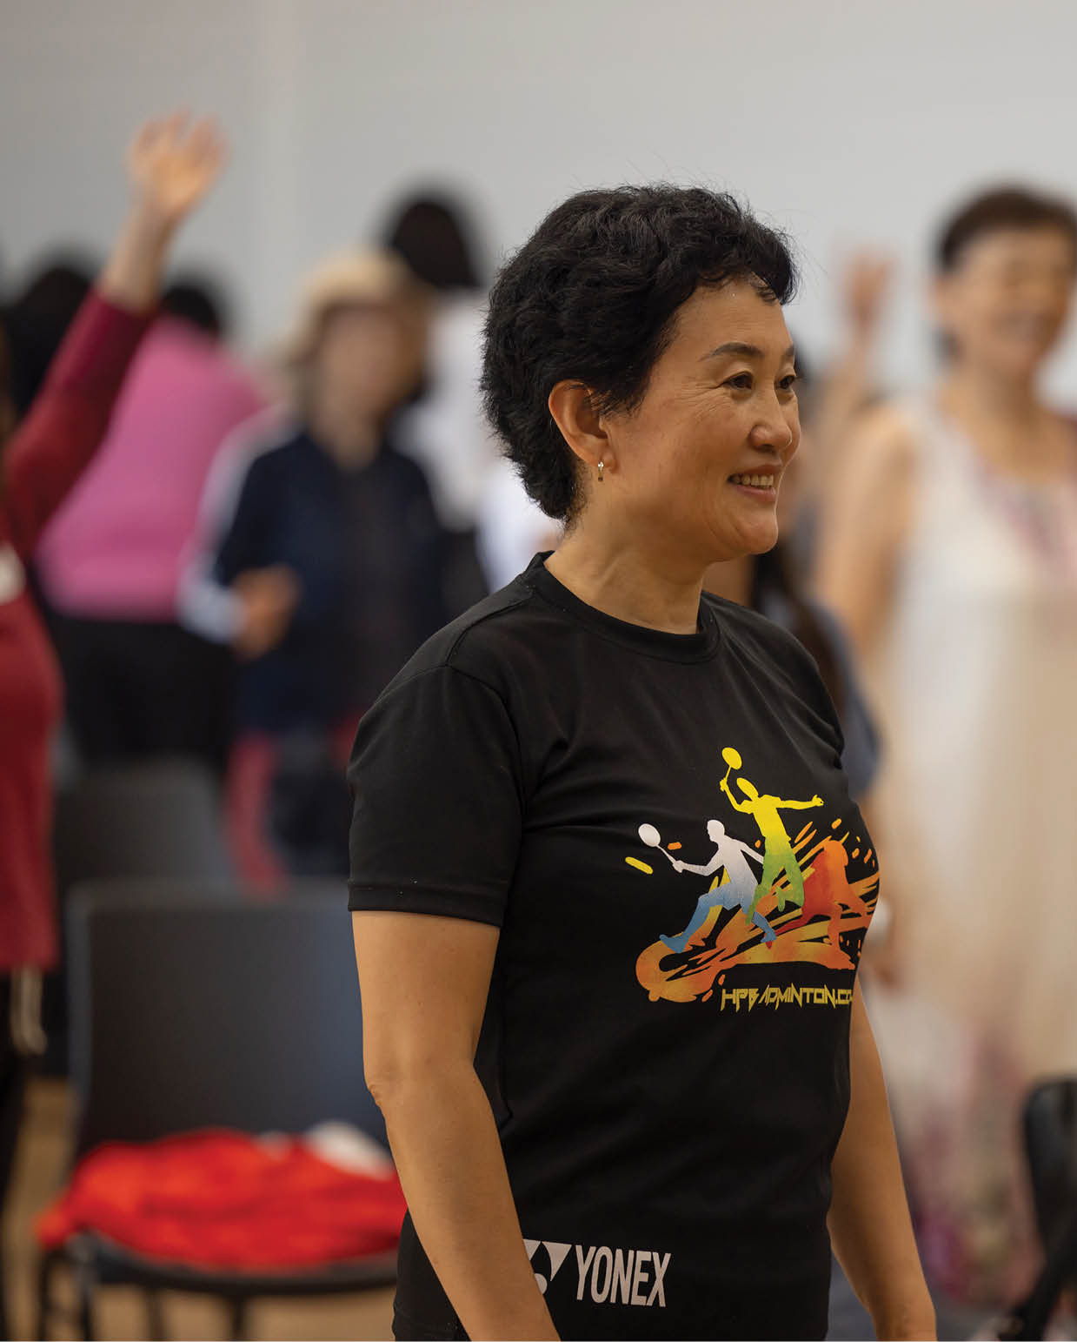

Participants at Women’s Health East’s 2024 International Women’s Day event

Entrenched gender roles, norms, and biases significantly hinder women’s social and economic participation and access to resources in Melbourne’s east. These factors not only perpetuate the gender pay gap but also contribute to women’s higher burden of unpaid domestic labour and their overrepresentation in insecure, low-paid employment. Data shows that women in Melbourne’s east experience higher rates of mental ill-health compared to men, with the rates in Yarra Ranges and Maroondah surpassing the state average. Additionally, women report feeling less safe and having more limited access to public spaces than men. Women from migrant and refugee backgrounds experience racism, which further impacts their health and wellbeing. To address these disparities, Women’s Health East works collaboratively with organisations and communities to create a more equitable society. Our efforts focus on removing barriers to women’s participation, challenging gender stereotypes, and tackling all forms of discrimination.

## Advancing gender equality via the Gender Equality Act 2020

Over the past year, we provided specialist services that helped defined entities to meet and exceed the requirements of Victoria’s Gender Equality Act 2020.

As a member of the Action for Gender Equality Partnership - a consortium of Victorian gender equity specialists - we strengthened the capabilities of statewide public sector organisations to conduct effective gender impact assessments.

We provided expert consultation and advisory services, and we developed and delivered evidence-based training programs, case studies, comprehensive gender impact assessments, gender analysis tools and templates, and other evidence-based resources that promote intersectional, gender transformative practice.

These initiatives aim to ensure that the needs and perspectives of all women and girls are fully and meaningfully integrated into the design of policies, programs, and services.

## Gender impact assessment consultancy services

Victorian public sector organisations are required, under the Gender Equality Act 2020, to complete gender impact assessments on policies, programs and services that are either new or under review. This process requires an intersectional gender analysis to ensure that the needs of people of all genders are addressed.

Over the past year, Women’s Health East supported defined entities to conduct thorough, actionable gender impact assessments that identify and address barriers to gender equality in policies, programs and services.

We worked with Box Hill Institute to undertake a gender impact assessment on their Sexual Assault and Sexual Harassment Policy. The assessment provided recommendations for preventing and responding to sexual harassment and sexual assault against people of all genders and identities.

We collaborated with the Traffic Accident Commission to develop training resources to support staff to conduct gender impact assessments on an ongoing basis.

Additionally, we partnered with Women’s Health In the North to conduct an evidence-based gender impact assessment on the NEPHU Population Health Catchment Plan 2023 – 2029. This comprehensive assessment made recommendations for inclusive and equitable health promotion and prevention strategies. With the insights from this process, NEPHU is well-positioned to advance gender equality and improve public health outcomes for its catchment of 1.8 million people.

## Gender equality capability-building training

In the past 12 months, Women’s Health East provided specialist gender equality training to organisations in Melbourne’s east and with statewide reach. We conducted 41 workshops and activities, reaching 387 participants to enhance their skills and understanding of intersectional, gender-transformative practices. This included 24 sessions for defined entities including the Department of Health, NEPHU and Yarra Ranges Council. These sessions developed the capability of staff to conduct gender impact assessments on organisational policies, programs, and services. Participants reported a significant increase in their confidence and ability to undertake gender impact assessments and apply a gender lens to their work.

We also facilitated gender equity and inclusion training for the City of Boroondara. This training, on the principles of diversity, equity and inclusion, equipped participants to identify actions to create more gender-inclusive, equitable and respectful workplaces, programs, and services.

“Understanding how to complete a gender impact assessment is very important in my work, as I engage directly with community and will be able to apply a more informed gender and intersectional equity lens to our work, practices and events.”

Training participant

## Strengthening intersectional gender analysis in community health

We developed an intersectional gender lens tool and accompanying templates for Melbourne’s inner east community health service partnership, which includes healthAbility, Access Health and Community and Link Health and Community. This tool supports the partnership to incorporate an intersectional gender perspective into their health promotion programs and planning.

These resources will be used in strategic and annual integrated health promotion planning, as well as in the development and implementation of initiatives. They will enable the partnership to advance health equity by tackling place-based gender inequality, discrimination and disadvantage. To facilitate the integration of these resources, Women’s Health East also delivered a practical workshop for the partnership’s staff.

## Gender, Space and Place: Creating safe and inclusive public spaces webinar

Women’s Health East hosted the Gender, Space and Place: Creating Safe and Inclusive Public Spaces webinar. The session was attended by approximately 100 participants from local councils, the private sector, and communities in Melbourne’s east, as well as from across Victoria and Australia. The webinar aimed to build understanding of women’s experiences of public spaces and strategies to enhance women’s safety and inclusion.

Keynote speaker Professor Nicole Kalms of the Faculty of Art, Design and Architecture, and founding director of the Monash University XYX Lab, shared the key findings from the Safe Spaces: Understanding and enhancing safety and inclusion for diverse women report. The report outlines how organisations can use participatory co-design methods to engage women in designing spaces that are safe and inclusive.

Attendees also heard from Maroondah City Council and Monash City Council representatives about their incorporation of lived experience into the design of local government public spaces.

“It was helpful to learn about applying a gendered lens in the space and place context. Looking at gender impact assessments and how they can provide practical support and guidance on ‘how’ to work towards a more inclusive space in planning and design.”

Webinar participant

## Kids, Coffee and Connection

Women’s Health East partnered with Woori Yallock Community House to deliver Kids, Coffee and Connection: Bringing Mothers Together, with funding from Yarra Ranges Council. Over eight sessions, this placed-based project brought together local mothers and their preschool-aged children with the aim of increasing mental health and wellbeing through social connection. Participants reported that the project increased their sense of connection to the other participants and the wider community.

“I most enjoyed having a local place to connect with other parents and for my child to play with peers.”

Program participant

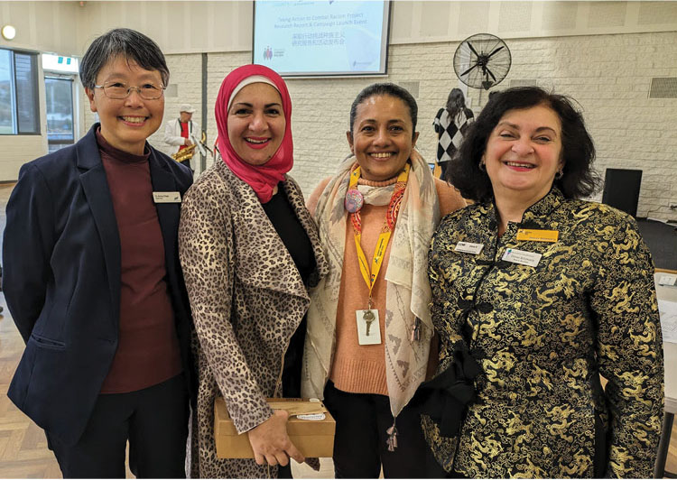

Women’s Health East Board Director Dilnaz Billimoria, with Manningham Councillor Anna Chen and colleagues.

## Taking Action to Combat Racism

Women’s Health East successfully completed the Taking Action to Combat Racism project in May 2024. Funded by Manningham City Council, this two-year initiative was designed to address the experiences of racism and sexism faced by Chinese women. It aimed to enhance social connections and improve the mental health and wellbeing of Chinese women. We   
co-designed anti-racism strategies and campaigns with Chinese Mandarin-speaking women using an intersectional gender lens.

In the project’s second year, we launched the Taking Action to Combat Racism Research Report. This report, informed by a survey and group interviews with Chinese women, explores their experiences with racism, examines its underlying drivers, and considers how they use services and supports when facing discrimination.

Additionally, nine Chinese women participated in a series of four workshops to co-design anti-racism messages for both the Chinese community and broader society.

The launch of the Taking Action to Combat Racism Research Report, and the anti-racism campaign, was attended by 33 people, including community members, Manningham City Councillors, policymakers and representatives from external organisations.

Evaluation results indicated that Chinese Mandarin-speaking women involved in the project experienced a greater sense of acceptance and belonging and felt that their voices were heard. Overall, participants gained a deeper understanding of anti-racism advocacy and the importance of incorporating racism prevention strategies into advocacy efforts.

“My confidence and capacity for anti-racism advocacy has increased.”

Advisory Group member

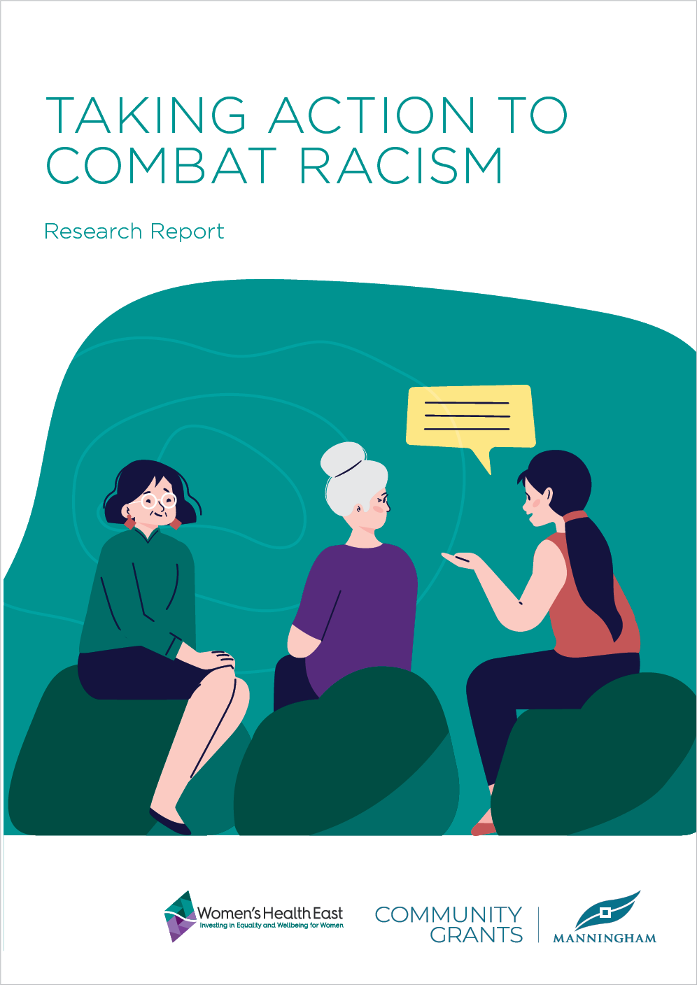

## Harmony Circle

Harmony Circle, a four-year initiative funded by the Victorian Government, aims to increase Hakha-Chin speaking women’s understanding of mental health and to address stigma and negative beliefs within the community about mental illness and other aspects of women’s health. In the past year, we conducted nine workshops for Hakha-Chin speaking women on mental health, trauma, self-care, and healthy relationships. The program also incorporated wellbeing activities such as yoga, meditation and Zumba.

Through Harmony Circle, Hakha-Chin speaking women connected over shared experiences, such as the challenges of raising young families and navigating cultural differences or culture shock associated with their experiences as refugees. Many women began the program with limited understanding of mental health, but by its conclusion, they felt empowered as ‘Mental Health Champions’ for their community.

“I am not ashamed of having or dealing with a mental issue, I feel like it’s a normal illness.”

Program participant

## Building women’s financial literacy

We delivered a four-part Money Matters financial literacy webinar series that built women’s financial knowledge and enhanced their economic independence. The webinars, attended by 91 participants, covered budgeting and saving, superannuation and insurance, and managing debt. Attendees reported improved financial literacy and increased confidence in finding financial information and support.

A series of supporting resources were also developed and published. These were translated in Hakha-Chin and will be made widely available as an in-language resource for community members.

## Advancing refugee and migrant women’s mental health and wellbeing

Women’s Health East’s bicultural team conducted 69 mental health education sessions with 1,188 Hakha-Chin and Mandarin-speaking women. Participants reported significant increases in health literacy and the confidence to access support and services, leading to positive behaviour change.

In addition to health education, our mental health programs highlighted the benefits of community engagement and capability-building. We created opportunities for social connection through activities like arts and crafts and meditation, as well as physical activities including aerobics and tai chi.

We helped participants learn how to access health services and activities and facilitated connections with local social clubs. This significantly reduced social isolation among participants, most of whom do not speak English and have limited knowledge of local services.

## SHINE

In partnership with the City of Monash, SHINE 2024 was a women’s health program aimed at improving health, wellbeing, and social connection among Chinese women living in the City of Monash. Delivered in Mandarin, the program addressed topics including menopause, emotional wellbeing, and healthy relationships. It also offered physical activities and opportunities for socialising.

The seven-week program led to significant changes in the health-seeking behaviours of the over 380 participants:

* 33 percent accessed a health service
* 50 percent started practising new physical activities
* 67 percent shared the program’s knowledge and information with family and friends
* 90 percent applied the new health information to their daily lives.

“The program has challenged and changed some of my old mindsets and beliefs. I have also learned practical ways to support my physical and mental health wellbeing. Now I feel content and happy every day.”

Program participant

## Feeling Well Together

Feeling Well Together is a six-part online wellbeing program designed for Hakha-Chin women. Delivered twice by Women’s Health East in the past year, the program engaged a total of 127 women and covered a range of topics, including:

* women’s and children’s mental health
* disaster preparedness and response
* the effects of trauma on mental health
* financial wellbeing
* sexual and reproductive health.

After completing the program, 100 percent of participants reported increased confidence in managing their mental health and accessing mental health services. Additionally, 90 percent felt more confident discussing their mental health and wellbeing openly with others.

“I have more knowledge of mental health, including that migrant and refugee women like me are more at risk of developing mental illness due to my past experiences (including military conflicts and poverty) which impact my physical and mental wellbeing.”

Program participant

## Living Well in Whitehorse

With support from Whitehorse City Council, we delivered Living Well in Whitehorse, a   
four-part mental health program designed for Mandarin-speaking mothers and caregivers. The program aimed to enhance mental health literacy and examine the social determinants impacting mental health across the life-course.

The program provided meaningful support for young Mandarin-speaking mothers experiencing isolation and significant changes in their family dynamics. Participants reported greater understanding of mental health and how to support their children. They felt more equipped to recognise when they or others are struggling with mental health issues and need to seek support. By learning and implementing more effective communication strategies with their children, participants observed that their children are now more interactive and happier.

“I have learned how gender inequality impacts migrant women’s health, how to prevent this happening in the next generation, and how to use painting to express emotions.”

Program participant

## Supporting catchment and regional planning

Women’s Health East collaborates with local governments, healthcare providers, organisations and communities to drive the institutional changes needed to create fairer, healthier and safer communities. We lead formal partnerships, strategies and networks to prevent violence against women, promote women’s sexual and reproductive health and enhance mental health. These efforts involve 69 regional and statewide organisations.

Additionally, we engaged with 148 new organisations through our capacity-building initiatives, extending our impact beyond existing partnerships. We empower organisations to implement systemic changes within their structures and broader communities by providing expertise, information and guidance. We lead the regional primary prevention system architecture in violence prevention and sexual and reproductive health promotion. This ensures effective coordination of prevention activities and maximises collaboration, impact and reach.

## International Women’s Day

Women’s Health East celebrated International Women’s Day by hosting an event for local Chinese women. The event focused on the UN Women theme of women’s economic empowerment and attracted over 50 Mandarin-speaking women. Becky Gong, a Mandarin-speaking career counsellor from Box Hill Institute, delivered a presentation on career opportunities for Mandarin-speaking women. Following the presentation, many attendees scheduled one-on-one employment counselling sessions with Becky Gong.

Participants reported a greater understanding of the barriers migrant women face in achieving economic empowerment and increased awareness of the resources and services available to support women’s economic advancement.

“I have gained a lot from this session. I hope there will be more sessions to help women aged 50+ to return to the job market after being a full-time mother.”

Event participant

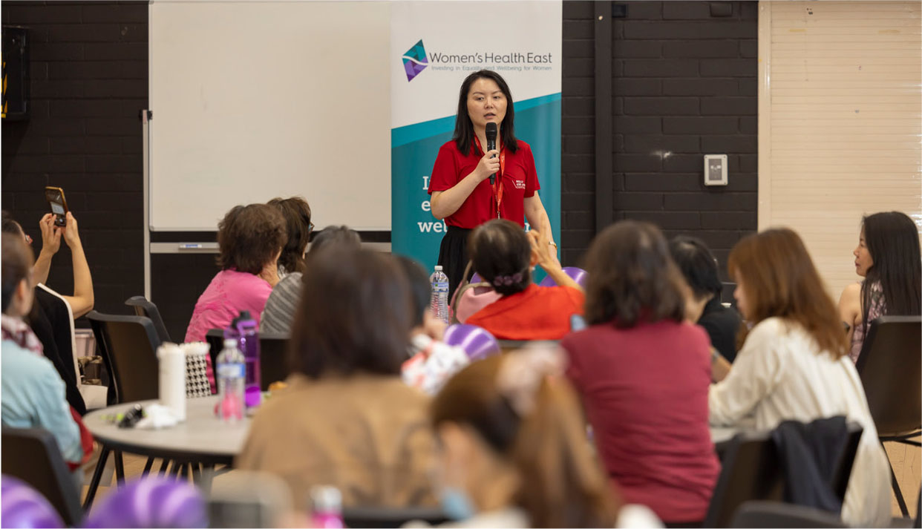

Presenter Becky Gong at Women’s Health East’s 2024 International Women’s Day event

# Prevent violence against women

Violence against women remains a pervasive and devastating social justice issue with profound consequences for women, families, and communities.

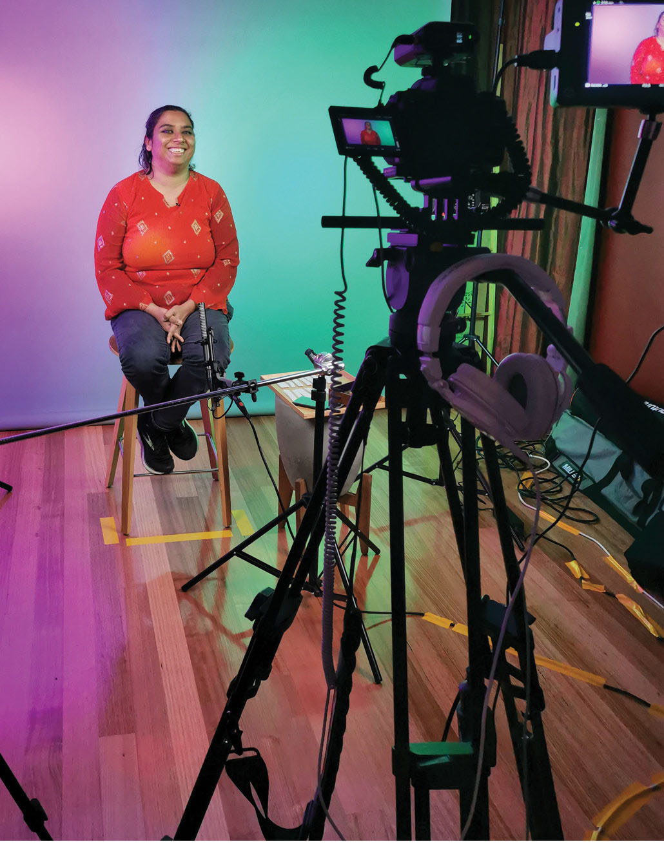

Disabled community member during filming for the Get the Go-Ahead project

Violence against women in Melbourne’s east is alarmingly prevalent and, in some areas, surpasses the state average. This crisis is deeply rooted in gender inequality and demands a comprehensive, community-wide response.

Women’s Health East is committed to leading and coordinating efforts to prevent violence against women in Melbourne’s east. By addressing the underlying drivers of violence, including gender inequality and intersecting forms of discrimination, we strive to create a safer and more equitable community for all women.

Our flagship initiative, the Together for Equality and Respect partnership, adopts a place-based approach to primary prevention of violence against women. By focusing on the unique needs of local communities, the partnership brings together over 30 organisations to drive change at a regional level. Through collaborative action and evidence-based strategies, we are building a stronger, safer future for women in Melbourne’s east.

## Together For Equality and Respect

The Together for Equality and Respect partnership has significantly advanced primary prevention of violence against women in Melbourne’s east. The partnership has achieved significant outcomes through strengthened partnership reach, strategic leadership, systems advocacy, capacity-building, and community engagement. In the past year, this included:

* **Formalising the membership structure:** The partnership implemented a two-tier membership system, allowing members to recommit to the partnership and engage with best-practice strategic and programmatic actions.
* **Expanding and strengthening the partnership:** The partnership increased to 34 members with the addition of two regional library networks, Relationships Australia Victoria, The Men’s Project of Jesuit Social Services, Youth Disability Advocacy Service, Knox Infolink and IndianCare as new members.
* **Action plan review:** We updated the partnership Action Plan with all partners, maintaining focus on intersectionality and lifespan approaches. The online plan now features 126 primary prevention initiatives— an increase of 27% from the previous period.
* **Evaluation:** We launched the partnership’s shared evaluation pilot, gathering data on 31 primary prevention activities and demonstrating increased participant confidence in understanding gendered factors that contribute to family violence.
* **Capacity-building:** We implemented targeted training programs for over 700 people across multiple sectors, building knowledge and skills to prevent violence against women.
* **Community engagement:** We reached a diverse range of communities through our tailored prevention programs and our work leading the region’s 2023 16 Days of Activism Campaign. We actively engaged with women and leaders of the Mandarin and Hakha-Chin speaking communities.
* **Knowledge and resource development:** We developed and disseminated resources to support evidence-based intersectional practice.

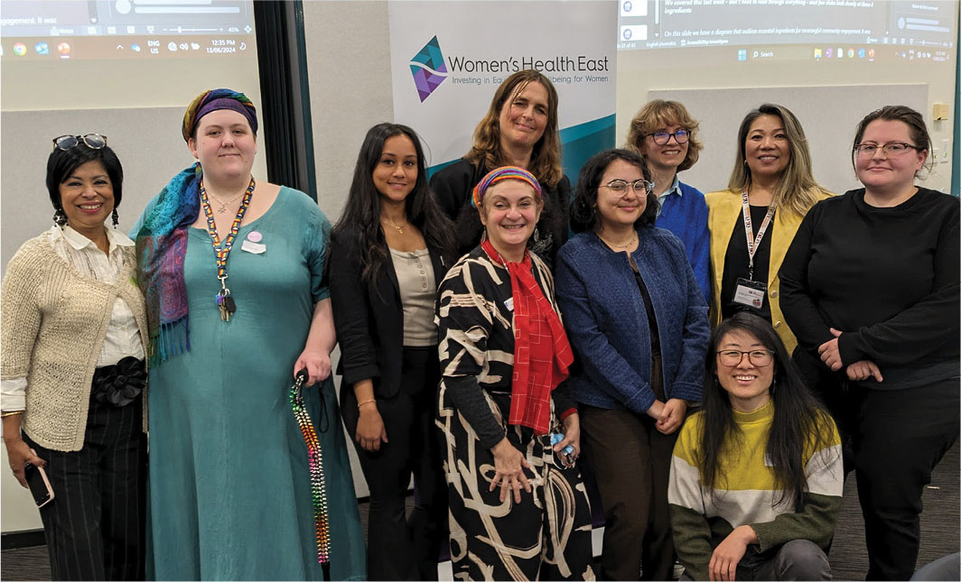

Women’s Health East staff and partners at a Together for Equality and Respect partnership forum

## Together For Equality and Respect Partnership Advocacy Platform

A key achievement of the Together for Equality and Respect partnership over the past 12 months was the November launch of the [Together For Equality and Respect Partnership Advocacy Platform](https://whe.org.au/tfer/advocacy-platform/#:~:text=The%20Together%20For%20Equality%20and%20Respect%20partnership’s%20advocacy%20platform%20seeks,free%20from%20discrimination%20and%20violence.), endorsed by 22 partners. The launch event was attended by 77 people, including MPs, mayors, deputy mayors, councillors, CEOs and executive leaders. The platform provides a basis for dialogue with leaders and government decision-makers to promote the central role of regional primary prevention infrastructure in creating communities where women and children live free from discrimination and violence.

“The evidence is clear. For prevention to be effective, it needs continued and coordinated funding for multi-sector initiatives, over a sustained period.”

Elly Taylor, CEO, Women’s Health East

## Together For Equality and Respect governance and practice mechanisms

Women’s Health East continued to support the Together For Equality and Respect Executive Governance Group. This group, comprised of executive leaders from partner organisations, met quarterly to provide strategic leadership and to advance the partnership’s goals. Key achievements include the launch of the Partnership Advocacy Platform and the endorsement of a shared evaluation pilot to measure collective impact.

To build partner capabilities and provide collaboration and knowledge-sharing opportunities, we continued to facilitate communities of practice and regional practice forums, reaching over 240 participants. Through our Margins to the Mainstream and Get the Go-Ahead: Voices for affirmative consent projects we further strengthened partners’ capacity to take evidence-based collaborative actions aligned with the national framework for the primary prevention of violence against women, Change the story.

“I will be more mindful of the language I use about older women, and I will challenge these (ageist) stereotypes more.”

Community of practice participant

## Margins to the Mainstream: Preventing violence against women with disabilities

The Margins to the Mainstream project, led by Women’s Health East in partnership with Women with Disabilities Victoria, made significant strides in preventing violence against women with disabilities through an intersectional, place-based approach. The project was funded by the Australian Department of Social Services.

Focused on amplifying the voices of women with disabilities in regional violence prevention efforts, Margins to the Mainstream enhanced the leadership and advocacy skills of women with disabilities in Melbourne’s east. This support included developing the leadership and communication skills of the Margins to the Mainstream Experts – a group of women with disabilities central to the project since 2020 – as well as offering skill-building workshops and co-design opportunities to a wider group of women with disabilities.

This year, 12 additional women with disabilities worked alongside the Experts to co-design a new resource titled [*We are the Experts: Working together as women with disabilities in advisory committees, consultation and co-design*](https://whe.org.au/tfer/margins-to-the-mainstream/wp-content/uploads/2024/08/ONLINE-10997-M2M-Companion-Guide-%E2%80%93-We-are-the-Experts.pdf). This resource provides support and encouragement to women with disabilities participating in advisory roles, consultations and co-design processes.

Margins to the Mainstream also strengthened the capacity of Together For Equality and Respect partners to prevent violence against women with disabilities. The project launched [*Asking the Experts: A guide to best practice co-design and consultation with women with disabilities*](https://whe.org.au/tfer/margins-to-the-mainstream/wp-content/uploads/2023/09/ONLINE-10663-M2M-PVAWD-How-to-Guide.pdf). This guide supports organisations to effectively engage women with disabilities in consultation and co-design processes.

The project, which concluded its funding in June 2024, reached over 1,960 people through programs, events and capacity-building initiatives and 182,470 people via social media, billboards and distributed materials over the past four years.

Margins to the Mainstream is an example of intersectional primary prevention practice that creates impact by centring the lived experiences of women with disabilities. The project’s success underscores the need for continued investment in intersectional, place-based primary prevention initiatives and ongoing collaboration between government, community organisations, and women with disabilities.

“Each person is so powerful as an individual and impactful as a collective. Speak up always and never give up.”

Margins to the Mainstream Project Expert

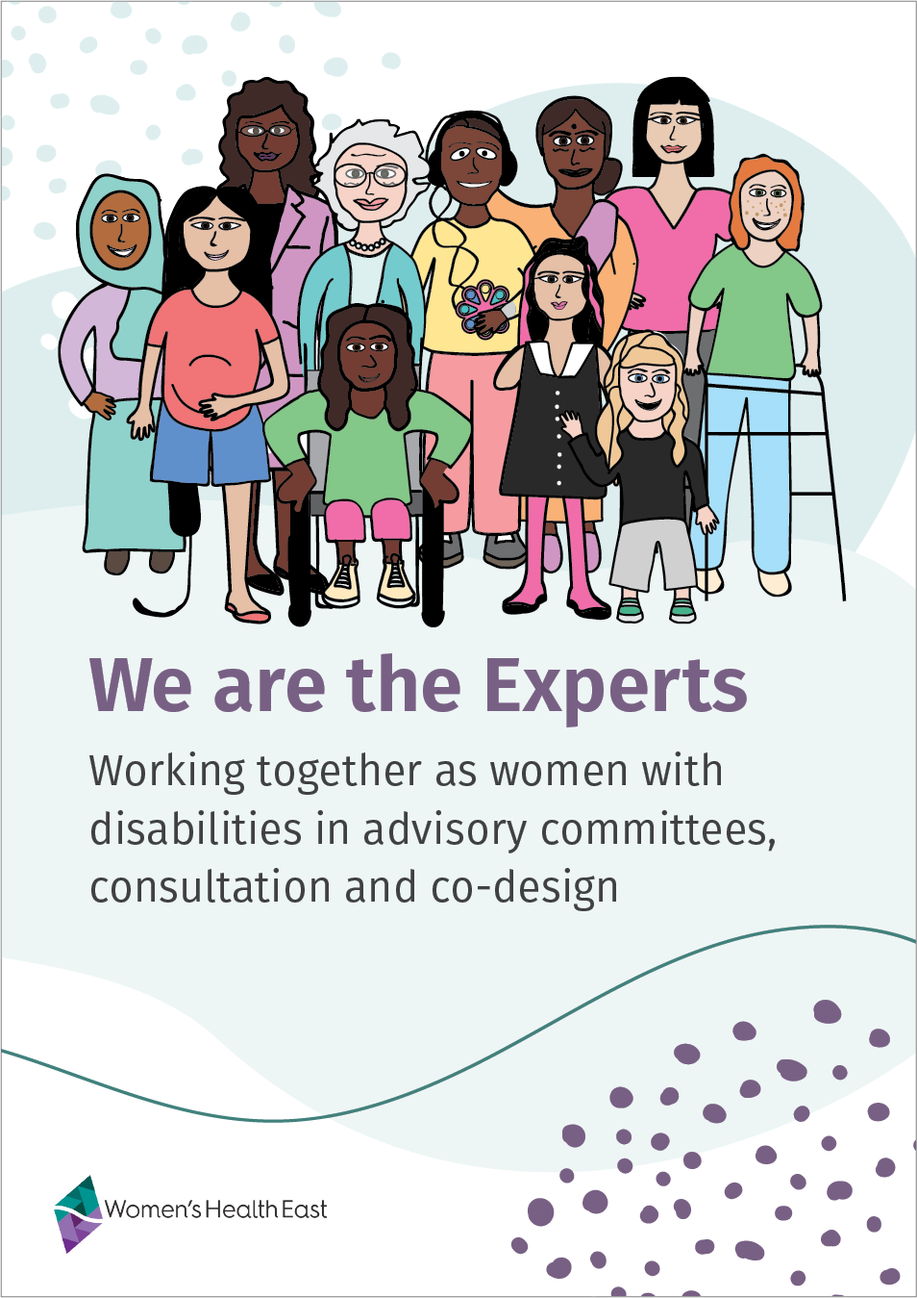

## Training for Respect

Women’s Health East is a partner in the Training for Respect project, funded by WorkSafe Victoria’s WorkWell Respect Fund. Led by Women’s Health in the South East, Training for Respect aims to improve the capacity, capability and confidence of Victoria’s adult education sector to prevent and respond to work-related gendered violence. The project focuses on establishing sustainable primary prevention infrastructure for Victorian Registered Training Organisations (RTOs).

The education and training sector is one of four industry groups that account for almost half of all reported workplace sexual harassment incidents in Australia, making targeted interventions in this sector crucial.

The project introduces tools and strategies to promote positive workplace cultures and address the root causes of gendered violence in Victorian RTOs. It features sector-specific training to build knowledge and develop strategies for eliminating workplace gendered violence, reinforced by an industry-wide campaign. The approach will be guided by a needs analysis, targeted prevalence study, and robust monitoring and evaluation framework.

The project’s key achievements in the past eight months include:

* Forming the Executive Governance Group, with Elly Taylor, CEO of Women’s Health East, as a member.
* Establishing the Stakeholder and Industry Advisory Group.
* Developing a sector survey to assess gendered violence in RTO workplaces (launching August 2024)
* Drafting an e-learning program and capacity-building training for RTO leaders (launching late 2024).

Other partners include The Men’s Project - Jesuit Social Services, Women’s Health Goulburn North East, Victorian TAFE Association, Independent Tertiary Education Council Australia and Our Watch.

## Preventing violence against women in migrant and refugee communities

Women’s Health East developed and piloted in-language prevention of violence against women workshops for Mandarin and Hakha-Chin speaking communities. These sessions featured culturally safe, community-tailored knowledge-sharing and facilitated discussions. Participants explored gender stereotypes and healthy relationships, and developed actions to promote gender equality within family relationships.

Facilitated by Women’s Health East’s bicultural workers, the three workshops reached 26 Mandarin and Hakha-Chin speaking community members. Participants reported that these workshops increased their understanding of the impacts of gendered stereotypes, the gender factors that lead to family violence and the difference between healthy and unhealthy relationships. Participants also felt more confident to challenge gender inequality and sexism.

“We subconsciously adopt others’ viewpoints, and it is difficult to step out because of family and social pressure. Cultural and social influences play a significant role in shaping our thoughts, even if it’s wrong and old.”

Workshop participant

## Get the Go-Ahead: Affirmative consent project

Resources on consent, sex and relationships rarely address the needs of Disabled people.[1] Victoria’s new affirmative consent laws highlight the importance of discussing consent, sex, and the law with Disabled young adults in ways that are engaging, build on their existing knowledge, and respect their lived experiences.

Get the Go-Ahead is a project led by Women’s Health East and Youth Disability Advocacy Service, and it is funded by the Victorian Government. The project brought together nine Disabled young people to co-design video and text resources that will equip Disabled young adults and the people who support them with essential information on affirmative consent and sexual and reproductive rights.

In the past 12 months, Women’s Health East and Youth Disability Advocacy Service wrote and delivered capacity-building workshops to upskill the co-design group on resource creation, the prevention of gendered violence, and affirmative consent. We also delivered two community workshops to further build knowledge and understanding on these topics with 30 Disabled young people and workers.

We strengthened our partnerships with Youth Disability Advocacy Service, Eastern Health, Eastern Centre Against Sexual Assault, and Sexual Health Victoria, who supported this work through the Project Advisory Group.

“I will be more intentional in my design of online and in person events, to be inclusive in all areas of intersectionality that includes disability.”

Workshop participant

## Prevention of violence against women training program

We delivered 29 primary prevention and active bystander training sessions to 702 senior leaders and staff from defined entities, including local councils, TAFEs, public service bodies, community groups, sporting clubs, and tertiary education institutions. Participating organisations included Yarra Ranges Council, Monash City Council, Holmesglen Institute, Manningham City Council, and the Environmental Protection Authority.

The sessions aimed to enhance participants’ understanding of violence against women and the gendered factors that drive this violence. Participants reported improvements in their skills and confidence to safely challenge sexism, sexual harassment, gender inequality and other forms of discrimination in the workplace and social situations.

Women’s Health East also delivered four prevention of violence against women training sessions for tertiary education students, reaching a total of 92 students. The sessions were tailored for students pursuing careers in primary prevention or related fields, providing foundational knowledge on the drivers of violence against women and strategies for prevention. Students demonstrated a significant increase in their understanding of the gendered factors that lead to violence against women.

“I now feel confident to call out any discriminatory behaviour I see or hear in the workplace, whereas before I would have second guessed whether I should or not.”

Training participant

## 16 Days of Activism against Gender-Based Violence

We led the Together For Equality and Respect partnership’s 2023 16 Days of Activism Campaign in Melbourne’s east. The campaign achieved significant growth, reaching new audiences through culturally specific resources. This targeted regional campaign focused on communities facing particular barriers and experiencing higher rates of violence against women.

The campaign featured a social media toolkit with tiles and videos created in collaboration with Aboriginal and Torres Strait Islander women, Mandarin and Hakha-Chin speaking women, and women with disabilities.

The regional approach included Together for Equality and Respect partners leading conversations with community groups to promote respect and gender equality. We developed and distributed guiding materials to facilitate these discussions. Additionally, Women’s Health East’s bicultural unit led community conversations with Mandarin and Hakha-Chin speaking groups, focusing on respectful family relationships and their role in advancing intersectional gender equality.

The regional campaign successfully engaged diverse communities, with 47 activities recorded by 19 partner organisations and an estimated 15,000 people reached through media, including social media.

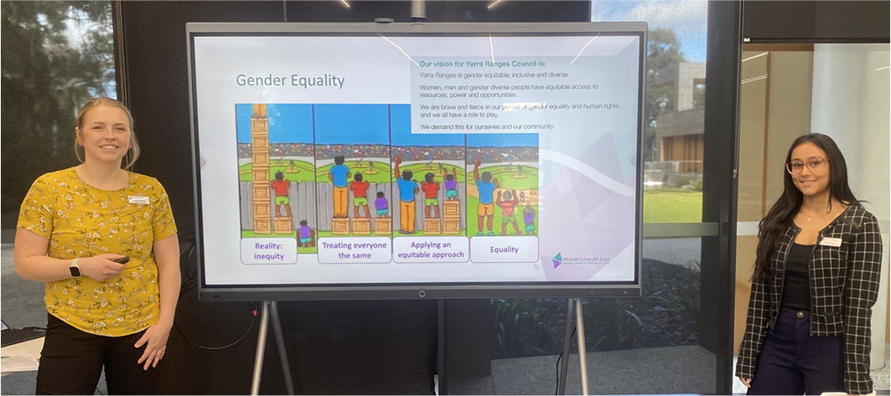

Women’s Health East staff delivering active bystander training

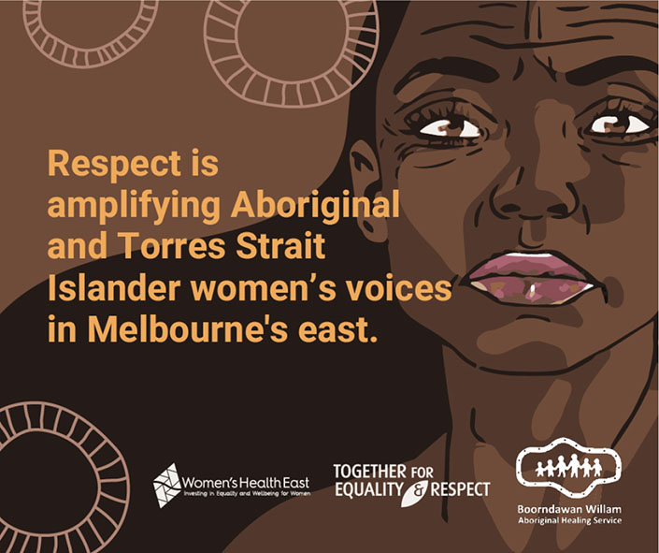

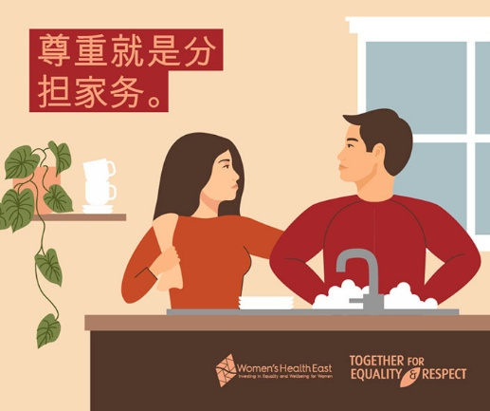

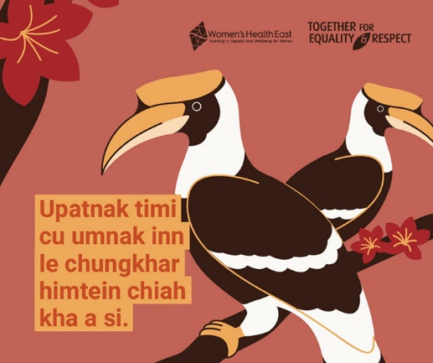

2023 16 Days of Activism Campaign materials

# Improve sexual and reproductive health

Sexual and reproductive health is a critical part of women’s overall wellbeing. For women to live healthy lives, we must move beyond stigma and eliminate disparities in sexual and reproductive health.

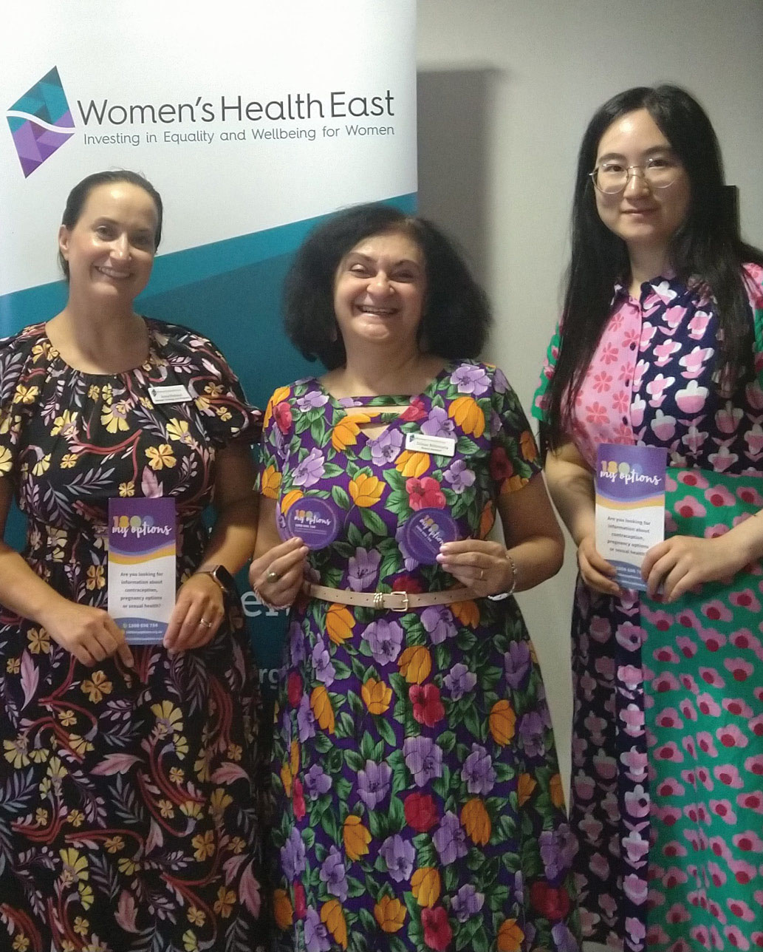

Sexual and reproductive health encompasses essential areas such as adequate access to abortion services, bodily autonomy, reproductive choice, and access to accurate information about menopause and sexually transmitted infections.

We advance women’s sexual and reproductive health through advocacy and evidence-based primary prevention initiatives. We address disparities faced by women who encounter additional barriers to optimal health, tackling the social determinants of health to reduce stigma and discrimination. Our vision is to ensure the best sexual and reproductive health outcomes for all women in Melbourne’s east.

“Access to abortion healthcare is still highly inequitable and often stigmatised. This reflects the limited role of sexual and reproductive health provision in many parts of Victoria and the systemic obstacles that create barriers to abortion access.”

Elly Taylor, CEO, Women’s Health East[2]

## A Strategy for Equality

[*A Strategy for Equality: Women’s Sexual and Reproductive Health in Melbourne’s East   
2020 – 2025*](https://whe.org.au/wp-content/uploads/WHEStrategy_Final_Digital_.pdf) is a five-year health promotion strategy led by Women’s Health East, aimed at improving the sexual and reproductive health and wellbeing of women in Melbourne’s east.

The partnership responsible for implementing the strategy was, in consultation with members, renamed Sexual and Reproductive Health in Melbourne’s East. Led by Women’s Health East, it consists of 24 organisations, including local government, community health organisations, universities, and specialist services, all sharing a common passion and vision. The partnership provides valuable opportunities for professionals to network, share insights and promote training opportunities.

## A regional action plan for women’s sexual and reproductive health

We continue to lead efforts to promote women’s sexual and reproductive health in our region through:

* regional capacity-building initiatives
* advocacy on important and emerging topics
* elevating the voices of women from priority populations
* disseminating campaign materials and practice resources
* overseeing comprehensive regional planning.

To implement the regional strategy, the *Strategy for Equality: Action Plan 2023 – 2025* was developed. It outlines the activities to be undertaken by the Sexual and Reproductive Health in Melbourne’s East partnership, with the aim of addressing health gaps and promoting sexual and reproductive wellbeing for all women in Melbourne’s east.

## Advocacy and practice innovation for improved abortion healthcare

Women’s Health East continued its advocacy to increase access to abortion healthcare. We developed data-driven regional advocacy materials demonstrating the unmet need for abortion healthcare services in Melbourne’s east and shared these with MPs and local health service executives.

These regional efforts were complemented by state-wide advocacy led by the Women’s Health Services Network, which included briefing papers and departmental and ministerial meetings.

In November 2023, a public hospital in Melbourne’s east announced the commencement of surgical abortion services, marking a significant improvement in abortion healthcare for women in the region.

We also delivered two medical abortion webinars aimed at increasing knowledge, skill and practice application of abortion service provision across Melbourne’s east.

## Sexual and reproductive health capacity-building workshops

We conducted four in-person capacity-building workshops designed to increase the sexual and reproductive health knowledge of health and community workers. These workshops were funded by the North Eastern Public Health Unit and attended by 127 participants. Each workshop focused on a specific priority population and the challenges they face in achieving optimal sexual and reproductive health and wellbeing. This included women living with HIV or hepatitis, women international students, women who have experienced incarceration, and trans and gender diverse people.

The workshops provided a valuable opportunity to amplify the voices of these priority groups and for health professionals to enhance their knowledge and build professional networks. Evaluation results showed that participants increased their confidence in applying their knowledge of women’s sexual and reproductive health in their work.

## Capacity-building webinars for migrant and refugee women’s sexual and reproductive health

Women’s Health East facilitated two capacity-building webinars to enhance health professionals’ understanding of migrant and refugee women’s sexual and reproductive health needs. In partnership with the Multicultural Health and Support Service (a division of the Centre for Culture, Ethnicity and Health) and the Multicultural Centre for Women’s Health, the first webinar explored how the intersection of gender, race, and culture impacts women’s sexual and reproductive health. The second webinar focused on the practical aspects of addressing sensitive topics within migrant and refugee communities.

The webinars were attended by 103 participants, who reported a deeper understanding of migrant and refugee women’s sexual and reproductive health needs, the intersectionality of culture, gender, and race, and effective strategies for addressing sensitive topics within migrant and refugee communities.

“This session particularly gave me food for thought. Empowering women cannot be universal – women experience disadvantage and discrimination differently.”

Webinar participant

## Sexual and Reproductive Health and Women with Disabilities

We launched a new practice asset titled [*Sexual and Reproductive Health and Women with Disabilities: A practice asset for health workers*](https://whe.org.au/wp-content/uploads/Womens-Health-East_SRHWD_Practice-Asset.pdf). This resource is designed to help healthcare professionals improve sexual and reproductive health outcomes for women and girls with disabilities. It provides a suite of recommendations based on an evidence review and consultations with women with disabilities in Melbourne’s eastern region. The recommendations emphasise co-designing responsive services, investing in practitioner training, ensuring trauma-informed care, addressing financial barriers, and prioritising the perspectives of women with disabilities.

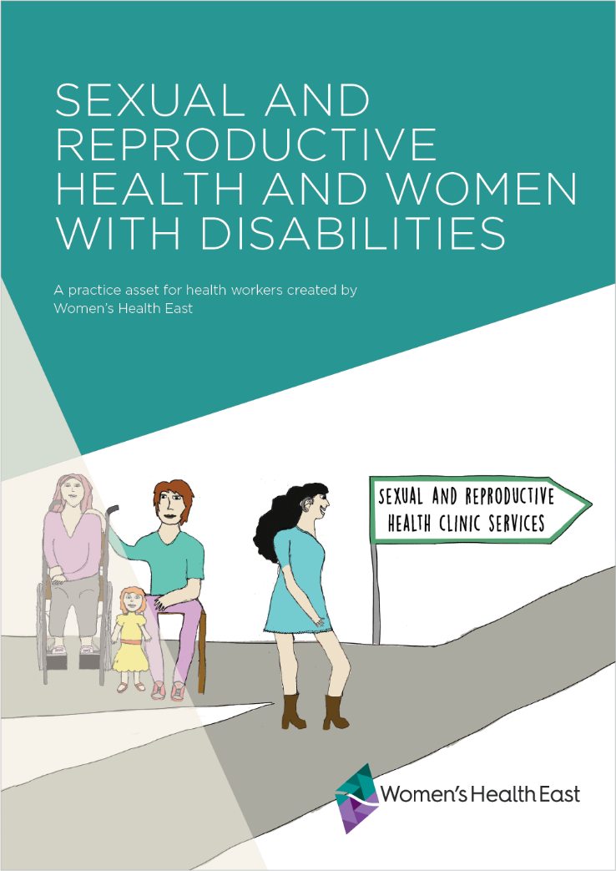

## Tackling Taboos

Tackling Taboos is an innovative program to enhance the sexual and reproductive health and wellbeing of Chinese women who are international students in Victoria.

In collaboration with Swinburne University and the Centre for Culture, Ethnicity and Health’s Multicultural Health & Support Service, and with funding from the City of Boroondara, Tackling Taboos delivered four workshops to 41 young Chinese women, some of whom were international students.

The workshops addressed gendered sexual and reproductive health and mental health concerns related to cultural norms and social stigma. Participants reported increased knowledge of women’s sexual and reproductive health and mental health and wellbeing, including increased ability to ask for and provide informed consent.

“The program is very meaningful for women in their 20s. It is necessary for young women to learn healthy relationships, and to hear this kind of knowledge before starting a relationship.”

Program participant

## In-language sexual and reproductive health education

Over the past year, our bicultural team worked with Hakha-Chin and Mandarin-speaking women to enhance sexual and reproductive health literacy across the lifespan. In total, 15 community education sessions were delivered to 197 Hakha-Chin and Mandarin-speaking women.

Participants increased their knowledge and understanding of topics such as local health services, cervical and breast cancer screening, contraception, sexually transmitted infections, pregnancy options and abortion, consent, healthy relationships, menopause, and cultural and social norms.

“I have learned how to take care of myself, and how to face and accept the natural physiological changes (associated with menopause) and adopt a more scientific approach to deal with it when it happens. In addition, I have learned how to seek others’ support when needed, as well as how to help others.”

Program participant

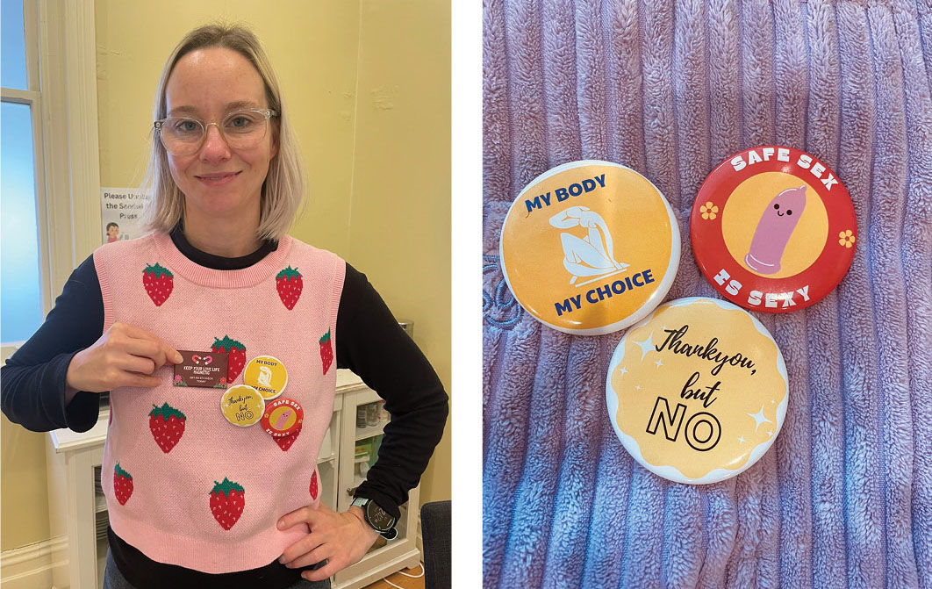

# Strengthen our dynamic and sustainable organisation

Organisational sustainability and a culture of inclusion, integrity, innovation and excellence are critical to achieving our vision.

Our staff, Board and volunteers are steadfast in our commitment to our vision of equality, health and wellbeing for all women. Our success depends on us continuing to be a dynamic and sustainable organisation that embodies our values of inclusion, respect, integrity and excellence.

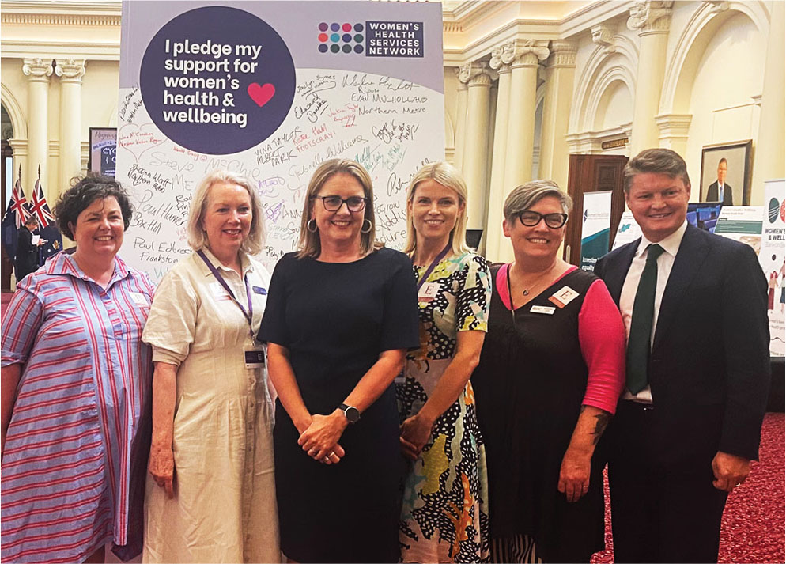

Victorian Premier the Hon. Jacinta Allan MP and Deputy Premier the Hon. Ben Carroll with   
Women’s Health East CEO Elly Taylor, and Women’s Health Services CEOs Tricia Currie,   
Amanda Kelly, and Dale Wakefield

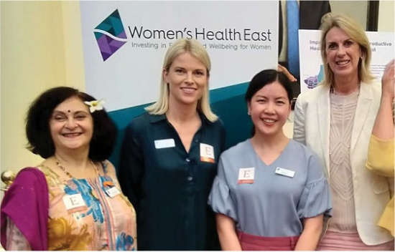

Shadow Minister for Health Georgie Crozier with Women’s Health East CEO Elly Taylor   
and Board members Dilnaz Billimoria and Belinda Li-Veldhuizen

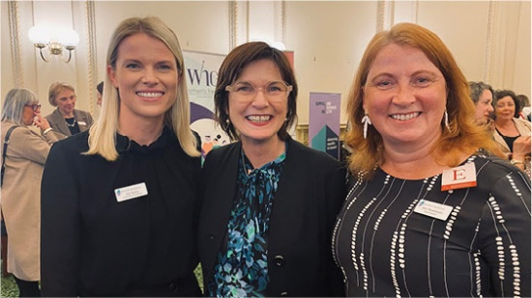

Minister for Health the Hon. Mary-Anne Thomas, with Women’s Health East CEO Elly Taylor and Board Deputy Chair Ann Yeomanson

## Political advocacy

Women’s Health East, in partnership with the Women’s Health Services Network, delivered three key events for Ministers, MPs, department executives, policy influencers and the media.

In October 2023, the sector hosted the Women’s Health in the House event at Parliament House. The event, sponsored by the Hon. Mary-Anne Thomas, Minister for Health, was attended by 65 MPs, Women’s Health Services CEOs and board members, and other sector leaders. The event formally launched the Women’s Health Services Network Small Change, Big Impact Collective Impact Report.

In November 2023, the sector held the Women’s Health Press Conference: Economic Benefits of Investing in Gender Equity for Better Health, with 90 attendees, including MPs, political advisors, the media and other sector leaders. The event formally launched the sector’s 2024 Victorian Government Budget Bid.

In February 2024, a week-long showcase event was held at Queens Hall, Parliament House, to demonstrate the value and impact of the women’s health services sector. The showcase event was sponsored by Women’s Health East’s local MP Shaun Leane and was attended by the Premier, Deputy Premier, Minister for Health, Minister for Women, Minister for Prevention of Family Violence, and local MPs from Melbourne’s east. A lunchtime event was also hosted by Kat Theophanous MP.

Additionally, our CEO Elly Taylor met with numerous Federal and State MPs and Ministers to discuss women’s health, safety and wellbeing.

The sector’s political advocacy resulted in Women’s Health East and the other Victorian Women’s Health Services welcoming renewed investment of $18.3 million of funding from the Victorian Government’s State Budget 2024-2025.

## Sharing our knowledge and specialist expertise

Our staff actively contributed their expertise and knowledge to shape public discourse by participating in forums, events, and inquiries focused on advancing the health, safety, and wellbeing of women. Over the past year, we:

* Partnered with Mums of the Hills and Pheonix Consulting on the Check Me Out Roadshow, in which local women engaged in health and wellbeing conversations, connected with local services and prioritised their health needs.
* Recognised Ageism Awareness Day by collaborating with the Eastern Elder Abuse Prevention Network to host A Question of Age: In conversation with Jacinta Parsons, an event that explored perceptions and meanings of ageing with over 100 attendees.
* Supported the This Girl Can campaign in partnership with Yarra Ranges Council, Inspiro and Eastern Health to encourage women, girls and gender diverse people to get active in the Yarra Ranges.
* Presented the Parenting in a Pandemic – Women’s mental health and wellbeing during Covid-19 poster at the Inaugural Asia-Pacific Conference on Women’s Mental Health, showcasing our lived experience research on perinatal mental health and wellbeing.
* Promoted the Taking Action to Combat Racism project at Tackling Racism, a Manningham City Council event to mark the United Nations International Day for the Elimination of Racial Discrimination, showcasing our work with Chinese women and amplifying their voices on issues of racism.
* Hosted three community roundtables for the Victorian Government’s Inquiry into Women’s Pain in June and July 2024. Participants included 48 Hakha-Chin speaking women, Chinese women, and women with disabilities. These roundtables formed the basis of Women’s Health East’s submission to the Inquiry.
* Contributed to the joint Women’s Health Services Network submission into the Victorian Government’s Inquiry into Women’s Pain.
* Presented at MiCare’s 16 Days of Activism event, United Together in Activism: An intersectional approach, emphasising the importance of applying an intersectional lens to prevention initiatives.
* Attended the Rotary Clubs of Whitehorse International Women’s Day breakfast in March 2024, where we were honoured to be recognised as the fundraising partner.
* Supported EACH and Monash City Council to develop training that promotes equity and inclusion and addresses the ableism and sexism experienced by women with disabilities. This work was informed by the Margins to the Mainstream project and involved co-design with the Margins to the Mainstream Project Experts.
* Participated in an Our Watch national consultation to inform the development of a resource to prevent violence against women in migrant and refugee communities.

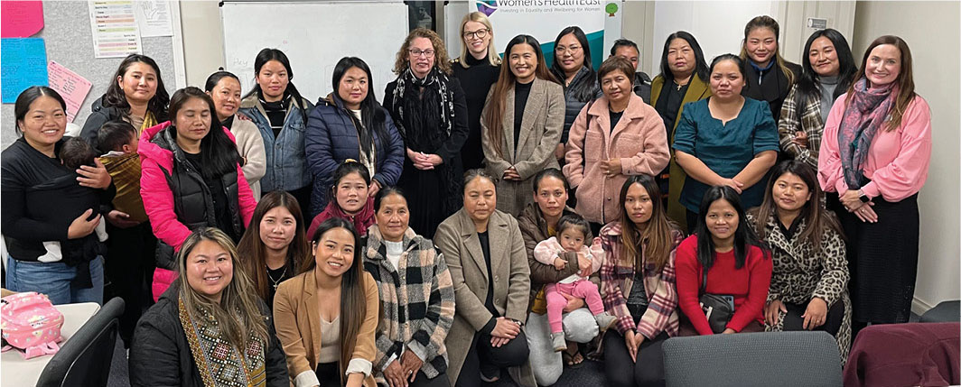

Women’s Health East staff and Hakha-Chin speaking women at the roundtable consultation into women’s pain

## Measuring Women’s Health East’s impact

* Women’s Health East implemented the Victorian Women’s Health Services’ Indicator Framework across all our programs. We continued to build staff capacity to meaningfully evaluate primary prevention and health promotion practice via a range of data collection tools. We prioritised qualitative evaluation to accurately capture the context and complexity of changes brought about by our interventions.
* We maintained active membership on the Women’s Health Services Network’s Evaluation Working Group and contributed to the development of the Victorian Women’s Health Services Network Collective Impact Report 2023-2024.

## Reconciliation Action Plan

Since its 2023 launch, we have worked hard to successfully implement and complete our inaugural Reflect Reconciliation Action Plan. Our aim has been to foster a culture of learning, growth and self-reflection to enhance our Board and staff’s understanding of Aboriginal histories, cultures, and customs.

Since we launched our Reconciliation Action Plan, we have:

* Delivered health promotion programs, initiatives and campaigns with local Aboriginal organisations and community women
* Engaged local Aboriginal organisations to deliver cultural awareness training for our staff, senior leaders, and Board members
* Conducted a comprehensive review of relevant policies and procedures, and developed an organisational cultural protocol guideline
* Celebrated significant dates in Aboriginal and Torres Strait Islander history through internal and external events and communications
* Increased our engagement with local First Nations suppliers.

We are deeply grateful for the opportunities this year to engage with Aboriginal organisations, women, and communities.

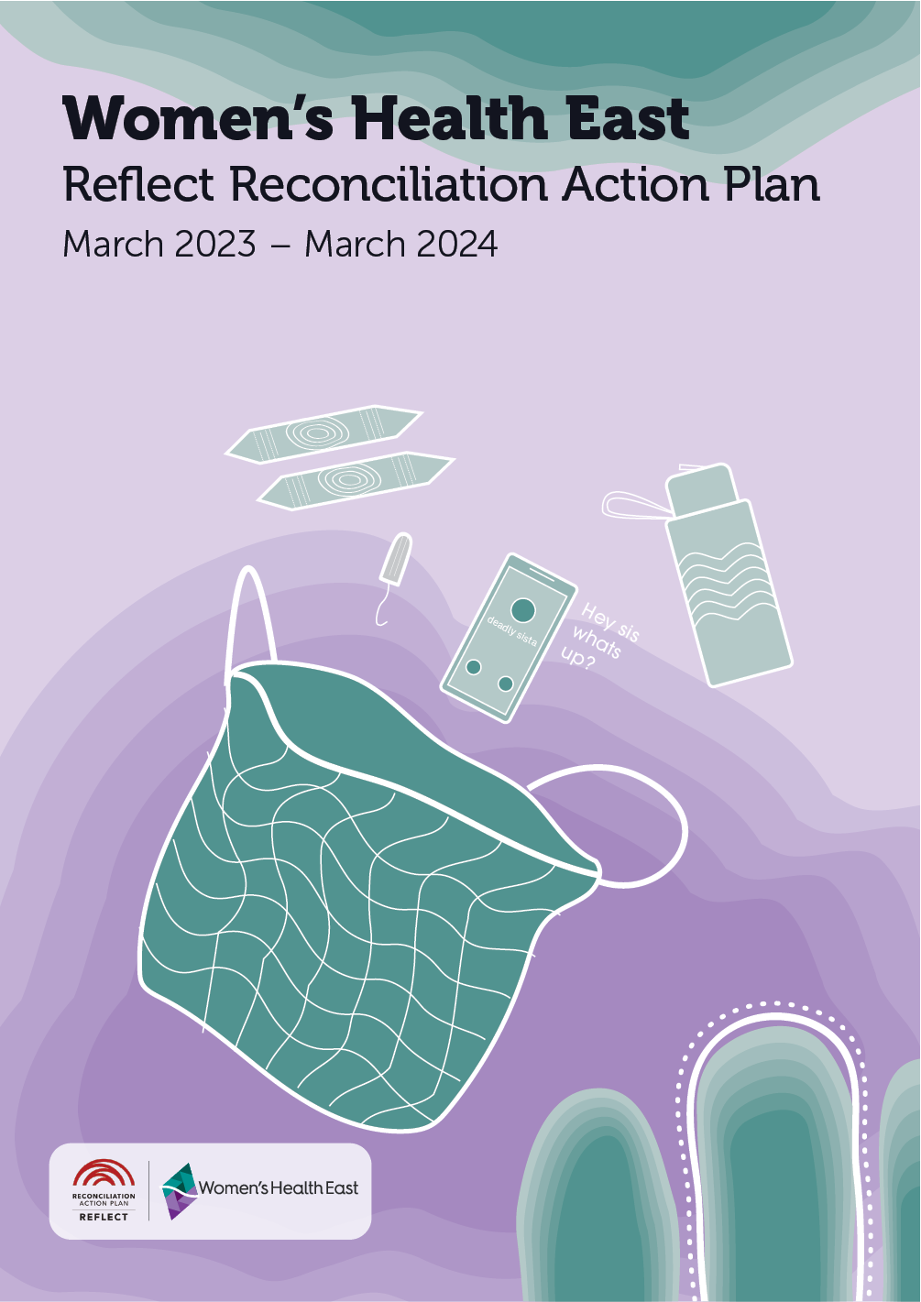

Cover of Women’s Health East’s Reflect Reconciliation Action Plan. This artwork was created by Alanna Sandy, a Tuangurung artist. The artwork showcases vibrant imagery and cultural symbols that promote a better understanding of the importance of Aboriginal women’s health. The visuals were designed to be inclusive of all Indigenous women, including Aunties, Sisters, Sistergirls, and Elders.

## Quality improvement

We continued to provide leadership support to the Victorian Women’s Health sector through coordination of the Women’s Health Services Quality Framework; facilitation of quarterly community of practice meetings for quality coordinators; and support for ongoing information and resource-sharing to strengthen our quality work.

Additionally, we developed a new Quality Improvement Plan to guide organisational systems and process enhancements over the next two years.

## Developing, valuing and supporting our people

Over the past year, our staff have enhanced their skills and practice through professional development opportunities.

We provided cultural competency training, enhancing skills in cross-cultural communication; fostering a more cohesive and supportive work environment; and strengthening the team’s ability to apply a cultural lens to their initiatives.

Additionally, our leaders benefited from leadership and management training, strengthening their ability to guide and support staff to achieve outcomes for the health and wellbeing of women.

Our staff attended trans and gender diverse inclusion training to further promote a respectful and inclusive workplace. It equipped staff with the knowledge and skills to address the underlying causes of poor health and the specific health disparities faced by trans and gender diverse people.

Training on responding to disclosures of family violence equipped staff to handle disclosures effectively and to make appropriate referrals, fostering a safe and supportive environment for program participants and our colleagues.

Finally, time management training helped staff boost productivity and reduce stress by mastering efficient work strategies.

These initiatives reflect our ongoing commitment to developing our team’s capabilities and ensuring a supportive, inclusive, and productive workplace.

# Financial summary

The following information is an overview of the finances of Women’s Health East Inc. and should be read in conjunction with the Women’s Health East Inc. Financial Statements for the year ending 30 June 2024 and their accompanying notes, which are available at www.whe.org.au. Women’s Health East prepares its financial statements in accordance with the Australian Accounting Standards, as outlined in the Independent Auditor’s Report.

Total income for the 2023-24 financial year was $2,420,758 compared to $2,152,907 in the previous year. Core recurrent funding decreased by 9.3 per cent while other income increased by 41 per cent.

Total expenditure was higher than the previous year, mainly due to employment expenses increasing by 10 per cent because of increased staffing levels associated with increased grant funding.

The result for the 2023-2024 financial year was a surplus of $5,819. Women’s Health East’s current ratio of 2.14: 1 means that the business has $2.14 in current assets to meet every $1 of current liabilities. The current ratio is a calculation performed to assist in determining financial liquidity.

## Financial overview

### Summary Income Statement

|  | 2023-24 $ | 2022-23 $ |
| --- | --- | --- |
| Income |  |  |
| Operating grants | 2,242,286 | 2,054,278 |
| Fee for Service | 122,127 | 65,822 |
| Other | 56,345 | 32,807 |
| Total Income | 2,420,758 | 2,152,907 |
| Expenditure |  |  |
| Employment expenses | 2,000,705 | 1,800,486 |
| Other | 414,234 | 317,311 |
| Total Expenditure | 2,414,939 | 2,117,797 |
| Operating Profit/(Loss) | 5,819 | 35,110 |

### Summary Balance Sheet

|  | 2023-24 $ | 2022-23 $ |
| --- | --- | --- |
| Cash & Financial Assets | 962,318 | 819,804 |
| Receivables | 55,187 | 47,218 |
| Property, plant & equipment | 28,680 | 40,962 |
| Right of Use Assets[3] | 70,010 | – |
| Total Assets | 1,116,195 | 907,984 |
| Payables | 126,052 | 66,537 |
| Income in advance | 146,284 | 160,919 |
| Provisions | 198,300 | 113,667 |
| Lease Liabilities* | 72,879 | – |
| Total Liabilities | 543,515 | 341,123 |
| Net Assets | 572,680 | 566,861 |
| Current Ratio | 2.14 : 1 | 2.54 :1 |

# Membership

Women’s Health East’s membership is free and open to anyone who identifies as a woman and who lives, works or studies in Melbourne’s eastern region, and to organisations who work with women in our region. Women’s Health East had 98 members on 30 June 2024.

## Women’s Health East membership benefits

By becoming a Women’s Health East member, you will enjoy the following benefits:

* Eligibility to stand for election to the Women’s Health East Board of Governance
* Voting rights at Women’s Health East member meetings and Board of Governance elections
* Access to the latest updates on women’s health, safety and wellbeing through   
  our e-newsletter and invitations to engage in community events and consultations
* Inclusion in a community of like-minded women dedicated to promoting equality, empowerment and the wellbeing of all women.

## How to become a member

To become a member, please complete a [membership application on our website](https://whe.org.au/support/become-a-member/) <https://whe.org.au/support/become-a-member/>. For more information, contact us at [health@whe.org.au](mailto:health%40whe.org.au?subject=). Please note that membership is contingent upon approval by the Board of Governance and is renewable every three years.

## Donate

By donating to Women’s Health East, you can help improve the health, safety and wellbeing of marginalised and disadvantaged women in Melbourne’s east. All donations of $2.00 and above are tax-deductible. To give a one-off donation, make a regular donation, or leave a bequest, please visit [Give Now – Women’s Health East](https://www.givenow.com.au/whe) <www.givenow.com.au/whe>.

# Our peers, partners and funders

## Women’s Health East’s funders

Our impact in 2023-2024 was made possible by funding and grants from:

* The Victorian Government
* The Australian Government
* City of Boroondara
* Manningham City Council
* Monash City Council
* North Eastern Public Health Unit
* Safe + Equal
* Whitehorse City Council
* Yarra Ranges Council

We extend our gratitude to the organisations that engaged our consultancy services. Proceeds from our consultancy work are reinvested into programs and projects that drive action to advance gender equality and positive social change for women and girls.

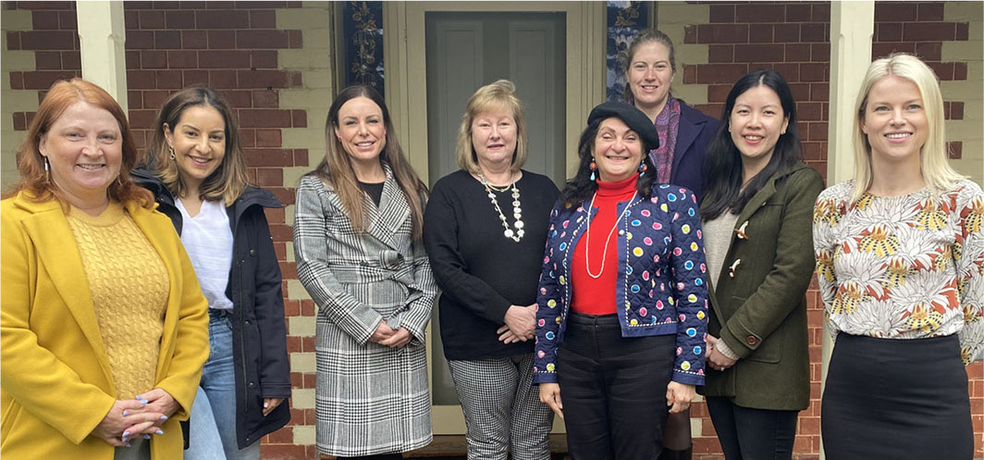

Women’s Health East’s Board of Governance with Women’s Health East CEO Elly Taylor

## Women’s Health East’s peers and partners

We acknowledge the invaluable contribution of our peers and partners to our ongoing efforts to enhance women’s health, safety and wellbeing across our region and beyond.

* Access Health and Community
* Australian Oriental Martial Arts Taichi Inc.
* Boorndawan Willam Aboriginal Healing Service
* Box Hill Institute
* BreastScreen Victoria
* CASS Care
* Centre for Culture, Ethnicity and Health
* City of Boroondara
* Community Houses in the Outer East Suburbs
* Deakin University
* Department of Education
* Department of Health
* Diabetes Victoria
* Doncare
* EACH
* Eastern Centre Against Sexual Assault
* Eastern Community Legal Centre
* Eastern Health
* Eastern Metropolitan Regional Family Violence Partnership
* Environment Protection Authority
* Feifei Curiosity
* Flat Out
* FVREE
* Gender Equity Victoria
* GenWest
* Gippsland Women’s Health Service
* healthAbility
* Hearing Australia
* Independent Tertiary Education Council Australia
* IndianCare
* Inspiro Health
* Intersex Human Rights Australia
* Knox City Council
* Knox Infolink
* Latin Stories Australia
* La Trobe University
* Latrobe Community Health Service
* Link Health and Community
* LiverWELL
* Manningham City Council
* Maroondah City Council
* MiCare
* Migrant Information Centre (Eastern Region)
* Mindspace
* Mitcham Community Group
* Monash City Council
* Monash University
* MSI Australia
* Multicultural Care Providers Association
* Multicultural Centre for Women’s Health
* Mums of the Hills Inc
* Network of Inner Eastern Community Houses
* North Eastern Public Health Unit
* Our Watch
* Positive Women Victoria
* PsycKitchen
* Relationships Australia Victoria
* Sexual Health Victoria
* Seniors Happy Life Club
* Swinburne University
* The Men’s Project - Jesuit Social Services
* The Orange Door-Inner East
* The Orange Door-Outer East
* Thorne Harbour Health
* Transport Accident Commission
* Trentwood Chinese Dance Group
* Victoria Police
* Victorian TAFE Association
* VicWISE
* Whitehorse City Council
* Whitehorse Manningham Libraries
* Women with Disabilities Victoria
* Women’s Health and Wellbeing Barwon South West
* Women’s Health Goulburn North East
* Women’s Health Grampians
* Women’s Health in the North
* Women’s Health in the South East
* Women’s Health Loddon Mallee
* Women’s Health Victoria
* Women’s Mental Health Network Victoria
* Yarra Ranges Council
* Yarra Valley Water
* Youth Disability Advocacy Service
* Zoe Belle Gender Collective

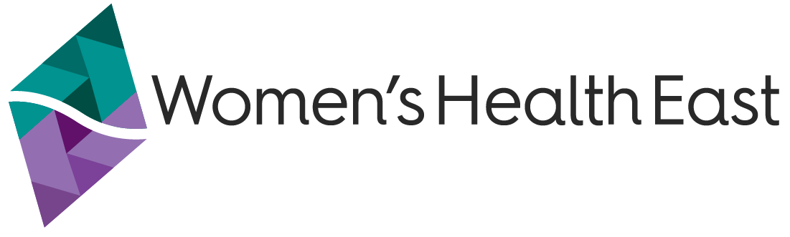

Women’s Health East

1/125 George Street, Doncaster East VIC 3109

(03) 9851 3700

[health@whe.org.au](mailto:health@whe.org.au)

[Women’s Health East website](https://www.whe.org.au) <www.whe.org.au>

Women’s Health East acknowledges the   
support of the Victorian Government.

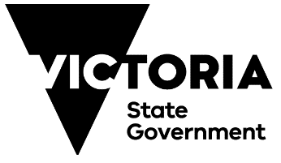

1. Preferences for identity-first language (e.g. Disabled people) versus person-first language (e.g. people with disabilities) vary among individuals and communities. Get the Go-Ahead uses identity-first language, as preferred by project partners and participants, to challenge stigma. Disabled is capitalised to respectfully recognise Disabled people as a culture, community, and identity defined by Disabled people, rather than using a medical lens. Throughout the rest of this report, Women’s Health East uses person-first language.
2. CEO Elly Taylor quoted in ABC News story [*Advocates say Victorian women are struggling to access abortion services amid conscientious objectors*](https://www.abc.net.au/news/2024-05-22/victoria-womens-health-abortion-access-conscientious-objection/103857152).
3. Compliance with AASB 16 Leases standard, which has resulted in recognition of Right Of Use Asset (representing the right to use/occupy the property) and lease liability (representing the obligation to make lease repayments)