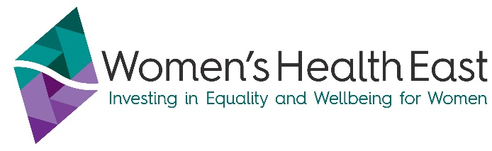
MONEY MATTERS
Superannuation and Insurance explained
This fact sheet is part of the Money Matters Series from Women’s Health East. Find out more about the project at https://whe.org.au/money-matters

Know your Super
- Look up your current balance.
- Ensure that your employer is making regular contributions.
  - https://www.ato.gov.au/calculators-and-tools/super-estimate-my-super
- Check that they are contributing the right amount.

Compare Super funds
The Australian Taxation Office (ATO) YourSuper Comparison Tool compares products and helps you choose a Super fund that meets your needs.
Visit: www.ato.gov.au/Calculators-and-tools/YourSuper-comparison-tool
How much do you need to retire?
Use the MoneySmart Retirement Planner to work out how much income you will get at retirement age, based on your current superannuation and income.
Visit: https://moneysmart.gov.au/retirement-income/retirement-planner
Super co-contributions
If you're a low or middle-income earner and make personal non-concessional (after-tax) contributions to your super fund, the government may also make a co-contribution up to a maximum of $500. The government co-contribution you receive depends on your income and how much you contribute.
Visit the ATO website for more information – www.ato.gov.au and search ‘co-contribution’.
How do I find my lost Superannuation?
- Go to you online myGov account – choose ATO, then Manage My Super; or
- Phone the ATO’s lost super search line on 32 865. You will need your Tax File Number.
Tax return
Many of us are unsure about how to do a tax return. The ATO have a free Tax Help program to assist eligible people earning $60,000 or less lodge their tax return online.
Visit: www.ato.gov.au/individuals-and-families/your-tax-return/help-and-support-to-lodge-your-tax-return/tax-help-program

What assistance is available for financial hardship?
If you are experiencing financial hardship, speak to the ‘Hardship Team’ of your credit or utility provider or talk to a financial counsellor.
Support is available, including:
- Utility Relief Grants Scheme for Electricity, Gas and Water for eligible customers.
- Flexible Support Packages are provided by local community agencies for victims of Family Violence.
- Contact the The Orange Door EMR network (contact details below)
- Some banks provide support in the form of funds/services to assist their customers experiencing Family Violence.
Why would I go to see a financial counsellor?
Financial counsellors provide assistance, advocacy and information to those who are experiencing financial difficulty or who have problems with debt.
How do I find a financial counsellor near me?
National Debt Helpline offers free and confidential advice from professional financial counsellors as well as referral to a financial counsellor near you.
Visit: www.ndh.org.au or phone 1800 007 007 (9.30am to 4.30pm, Monday to Friday).
Where can I go to get help for Family Violence or Elder Abuse (including financial abuse)?
If you or someone you know is at immediate risk of physical harm or property damage, call Victoria Police on 000.

Other free services include:
- Safe Steps on 1800 015 188 or safesteps@safesteps.org.au - 24/7 family violence response (crisis phone line and planning for your safety)
- 1800 RESPECT on 1800 737 732 (family violence) or 1800 ELDERHELP on 1800 353 374 (elder abuse) - confidential information, phone counselling and support services.
- If you live in Melbourne’s Outer East (Knox, Yarra Ranges, Maroondah) contact The Outer East Melbourne Area (OEMA) Orange Door on 1800 271 150 or OEMA@orangedoor.vic.gov.au
- If you live in Melbourne’s Inner East (Boroondara, Manningham, Whitehorse and Monash) contact The Inner East Melbourne Area (IEMA) Orange Door on 1800 354 322 or IEMA@orangedoor.vic.gov.au
- Eastern Community Legal Centre on 1300 32 52 00 or https://eclc.org.au/ – confidential legal, social and financial counselling support for people experiencing or at risk of family violence and elder abuse.
- 13 YARN on 13 92 76 - Aboriginal & Torres Strait Islanders crisis support line (24/7)
- Rainbow Door on 1800 729 367 - advice, referral and support for LGBTIQA+ Victorians

For more information please contact:
Women’s Health East - 9851 3700 or www.whe.org.au

