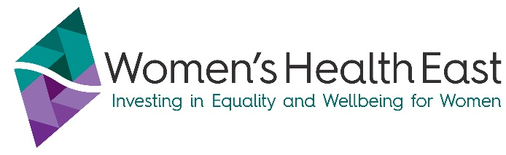
MONEY MATTERS
A guide to budgeting, bills and savings
This fact sheet is part of the Money Matters Series from Women’s Health East. Find out more about the project at https://whe.org.au/money-matters

Budgeting and saving tips
- Do a budget – work out what money comes in and goes out. Review it regularly.
- Look at your spending habits. If you’re spending more than you earn, what can you cut back or reduce?
- Start a savings habit, even if it’s a small amount.
- Pay yourself first - To pay yourself first simply means to treat your savings like a non-negotiable bill. Every payday, transfer a percentage or amount into a savings environment (e.g. a savings account, superannuation).

How do I create a money plan or budget?
Here is a simple planning tool: https://moneysmart.gov.au/budgeting/budget-planner

How do I get a competitive rate for my utility bills?
Victorian Energy Compare is an independent Victorian Government energy price comparison site - http://www.compare.energy.vic.gov.au or call 1300 026 500

Renting and your rights
Visit www.tenantsvic.org.au to find out more about your renting rights.
The Tenancy Assistance and Advocacy Program (TAAP) services help Victorians who have a private residential rental agreement and are experiencing financial disadvantage or family violence (regardless of financial circumstances).
Contact: Uniting Harrison - Inner Eastern Melbourne – phone: (03) 8870 4014. 291A Maroondah Highway, Ringwood

What assistance is available for financial hardship?
If you are experiencing financial hardship, speak to the ‘Hardship Team’ of your credit or utility provider or talk to a financial counsellor.
Support is available, including:
- Utility Relief Grants Scheme for Electricity, Gas and Water for eligible customers
- Flexible Support Packages are provided by local community agencies for victims of Family Violence.
  - Contact The Orange Door EMR network (contact details below)
- Some banks provide support in the form of funds/services to assist their customers experiencing Family Violence.
Why would I go to see a financial counsellor?
Financial counsellors provide assistance, advocacy and information to those who are experiencing financial difficulty or who have problems with debt.

How do I find a financial counsellor near me?
National Debt Helpline offers free and confidential advice from professional financial counsellors as well as referral to a financial counsellor near you.
Visit: www.ndh.org.au or phone 1800 007 007 (9.30am to 4.30pm, Monday to Friday)

Where can I go to get help for Family Violence or Elder Abuse (including financial abuse)?
If you or someone you know is at immediate risk of physical harm or property damage, call Victoria Police on 000.

Other free services include:
- Safe Steps on 1800 015 188 or safesteps@safesteps.org.au - 24/7 family violence response (crisis phone line and planning for your safety)
- 1800 RESPECT on 1800 737 732 (family violence) or 1800 ELDERHELP on 1800 353 374 (elder abuse) - confidential information, phone counselling and support services.
- If you live in Melbourne’s Outer East (Knox, Yarra Ranges, Maroondah) contact The Outer East Melbourne Area (OEMA) Orange Door on 1800 271 150 or OEMA@orangedoor.vic.gov.au
- If you live in Melbourne’s Inner East (Boroondara, Manningham, Whitehorse and Monash) contact The Inner East Melbourne Area (IEMA) Orange Door on 1800 354 322 or IEMA@orangedoor.vic.gov.au
- Eastern Community Legal Centre on 1300 32 52 00 or https://eclc.org.au/ – confidential legal, social and financial counselling support for people experiencing or at risk of family violence and elder abuse.
- 13 YARN on 13 92 76 - Aboriginal & Torres Strait Islanders crisis support line (24/7)
- Rainbow Door on 1800 729 367 - advice, referral and support for LGBTIQA+ Victorians

For more information please contact:
Women’s Health East - 9851 3700 or www.whe.org.au

