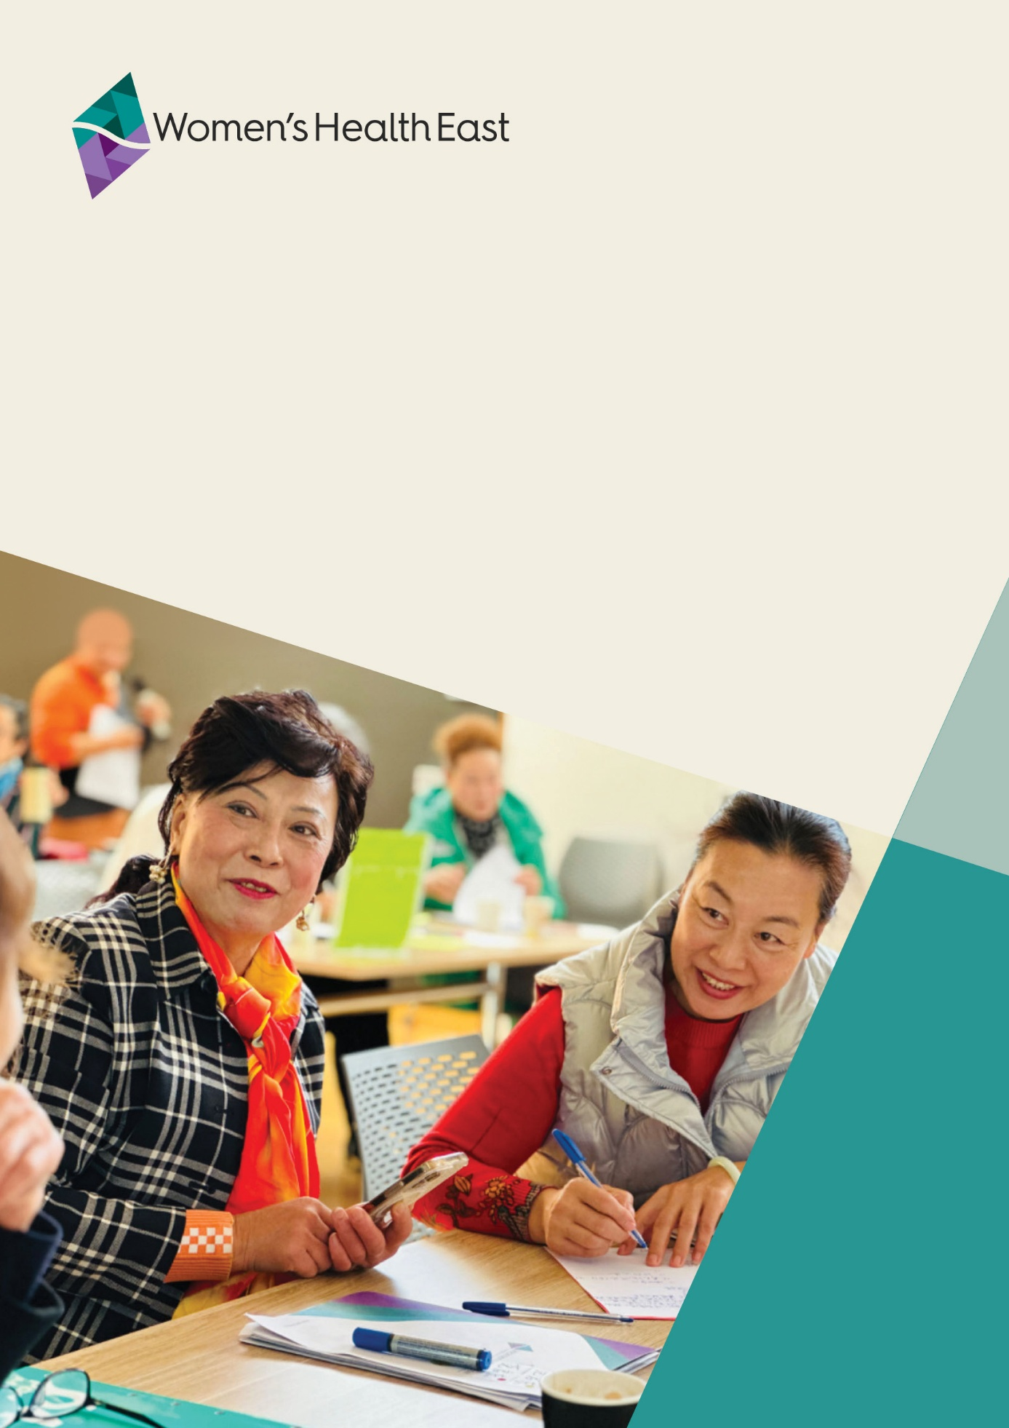
Annual Report 2022-2023

Contents
About this report 3
Acknowledgement of Country 3
Chair and Chief Executive Officer report 4
Our people 7
Women’s Health East Strategic Plan 2021-2025 9
Advance gender equality 11
Prevent violence against women 18
Improve sexual and reproductive health 24
Strengthen our dynamic and sustainable organisation 30
Financial summary 35
Membership 37
Our peers, partners and funders 38

About this report
Welcome to the Women’s Health East 2022-2023 Annual Report.
This report provides an overview of Women’s Health East’s major accomplishments, activities and financial performance for 2022-2023. Please visit our website for our complete financial statements for the year ending 30 June 2023.
For further details about Women’s Health East, please visit the Women’s Health East website <www.whe.org.au> or contact us at health@whe.org.au.

Acknowledgement of Country
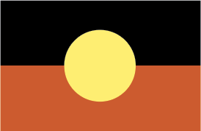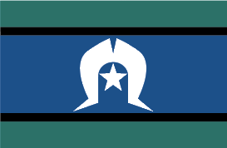
Women’s Health East acknowledges the Wurundjeri Woi-wurrung people, the Traditional Owners of the land on which we work. We pay our respects to Elders past, present and future. We affirm that sovereignty was never ceded, and that colonialism and racism continue to impact the lives of Aboriginal and Torres Strait Islander women and contribute to the high rates of violence they experience. We recognise the strength, resilience and leadership of Aboriginal and Torres Strait Islander women and express our hope for, and commitment to, reconciliation.

Chair and Chief Executive Officer report

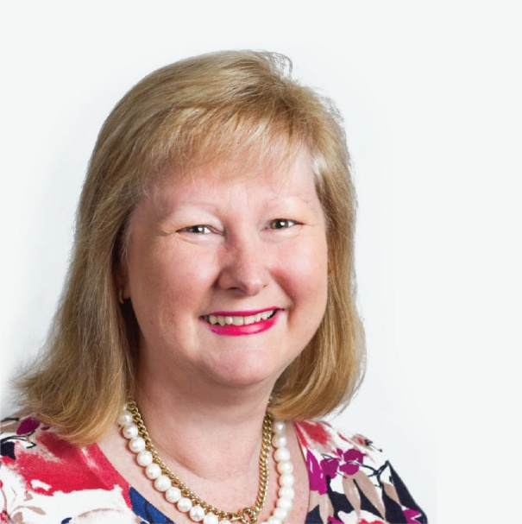
Lisa Dunlop
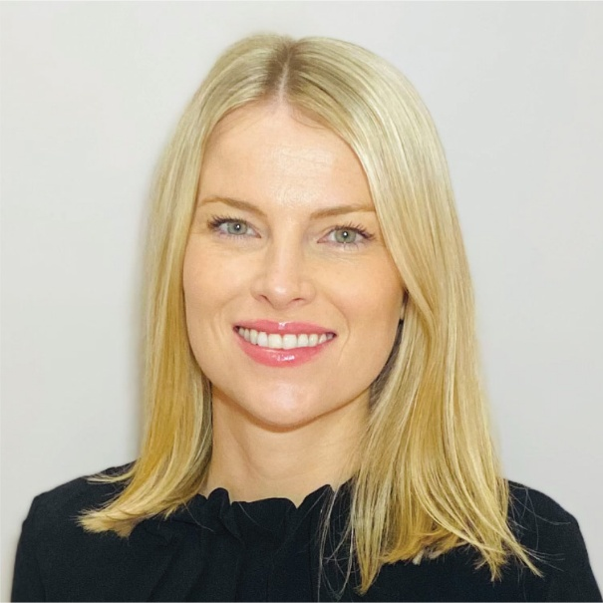
Elly Taylor

Women’s Health East is the women’s health promotion organisation for Melbourne’s eastern region. Our organisation specialises in implementing primary prevention initiatives dedicated to advancing gender equality, preventing violence against women, and improving women’s sexual and reproductive health. We place particular emphasis on improving the health outcomes of marginalised and disadvantaged women.
This year, increased State Government investment in the 12 Victorian Women’s Health Services significantly enhanced Women’s Health East’s ability to expand our operations and create greater impact on the health and wellbeing of women in our region. We were delighted that this funding enabled us to employ nine additional local women, including women from refugee and migrant backgrounds.
Throughout the year, Women’s Health East actively supported local and state-wide organisations to implement the requirements of the Gender Equality Act 2020. This support was extended through training, capacity building initiatives and advisory services, which reached 580 executive leaders, managers and practitioners. We supported organisations to undertake gender impact assessments and develop gender equitable policies, programs and services. We successfully executed multiple projects aimed at preventing race-based discrimination and improving the mental health and wellbeing of refugee and migrant women.
We worked closely with our peers and partners to ensure that catchment, regional and local health planning processes embed a gendered analysis and respond to the specific needs of women across the region.
We scaled up our work leading the Together For Equality and Respect regional primary prevention infrastructure to prevent violence against women in Melbourne’s east. We expanded our reach through capacity building activities, communities of practice, and training that reached more than 760 people. This included new and expanded projects delivered with Aboriginal women, young people with disabilities, and women with disabilities. We were proud to commence the Get the Go-Ahead project to address ableist and gendered drivers of gender-based violence and to promote healthy, safe and respectful relationships.
We continued to lead and strengthen coordinated action under A Strategy for Equality, the regional strategy and partnership to promote the sexual and reproductive health of women and girls in Melbourne’s east. We implemented sexual and reproductive health promotion programs, developed resources, and delivered capacity building workshops to over 300 people on topics such as abortion healthcare, trans and gender diverse inclusion, menopause friendly workplaces, and advancing the sexual and reproductive health and rights of women with disabilities and refugee and migrant women.
Women’s Health East’s new bicultural unit delivered in-language health education and health promotion programs to refugee and migrant women who speak Mandarin and Hakha-Chin. The team facilitated several programs reaching over 470 women with a strong focus on strengthening health literacy and community capacity building.
We conducted social media campaigns, reaching more than 34,800 community members through regional initiatives such as the 16 Days of Activism Against Gender-Based Violence, Sexual and Reproductive Health Week, and an International Women’s Day campaign.
Our efforts were dedicated to strengthening Women’s Health East as a dynamic and enduring organisation. We proudly launched our inaugural Reflect Reconciliation Action Plan to promote reconciliation by strengthening relationships, respect and trust between Women’s Health East and local Aboriginal and Torres Strait Islander women, communities and organisations.
We undertook a six-month pilot of a new state-wide indicator framework to measure impact and outcomes. We engaged in regional and state-wide advocacy, striving to influence public dialogue and policy and program initiatives to advance women’s health, safety and wellbeing. Our advocacy efforts focused on securing sustained investment from the State Government in Women’s Health East and the Women’s Health Services sector. The Victorian Women’s Health Services play a pivotal role in providing specialised expertise in intersectional gender equity and are an integral part of the state’s public health system.
The Women’s Health East Board of Governance has remained steadfast in its commitment to enhancing good governance and implementing our strategic plan within a constantly evolving external landscape. We farewelled Deputy Chair Dimity Paul and Olive Aumann who served on our Board for six years, during which time they played crucial roles in overseeing Women’s Health East’s strategic direction and governance. We also welcomed two new Board members, Sally Vuong and Stephanie Kilpatrick.
Women’s Health East’s work is gender transformative and aims to create a more inclusive and just society where women, girls and gender diverse people live free from discrimination, violence and inequality. We know that advancing gender equality and effective primary prevention demands sustained investment and persistent action to bring about meaningful change. This work is made possible due to our exceptionally devoted, professional, and skilled staff and Board, and the collaboration and commitment of our numerous peers, partners and funders. We thank you for your ongoing support.

Lisa Dunlop
Chair

Elly Taylor
Chief Executive Officer

Our people

Board of Governance
- Lisa Dunlop, Chair
- Ann Yeomanson, Deputy Chair
- Corinne Bowen, Secretary
- Leanna Marinucci, Treasurer
- Dilnaz Billimoria
- Christabelle Adjoyan
- Belinda Li
- Sally Vuong (since 2022)
- Stephanie Kilpatrick (since 2023)
- Dimity Paul, Deputy Chair (outgoing 2022)
- Olive Aumann (outgoing 2022)

Business operations unit
- Elly Taylor, Chief Executive Officer (CEO)
- Jenny Peet, Finance Manager
- Colleen Russell, Quality Project Coordinator
- Emily Kate Cowan, Executive Assistant
- Melanie Chapman, Executive and Finance Assistant
- Julie Chaplin, Finance Assistant (outgoing 2023)

Prevention of violence against women unit
- Catherine D’Arcy, Manager Prevention of Violence Against Women
- Kate Ravenscroft, Manager Prevention of Violence Against Women (outgoing 2022)
- Avega Bishop, Margins to the Mainstream Coordinator
- Kochava Lilit, Health Promotion Coordinator Get the Go-Ahead
- Roshika Kumar, Health Promotion Coordinator Prevention of Violence Against Women
- Georgina Nix, Health Promotion Coordinator Prevention of Violence Against Women (outgoing 2023)
- Georgia Bennett, Health Promotion Coordinator Prevention of Violence Against Women (outgoing 2023)

Health promotion unit
- Dr Belinda Crockett, Manager Health Promotion
- Samantha Wass, Marketing and Communications Coordinator
- Vanessa Czerniawski, Health Promotion Coordinator Mental Health Promotion
- Ada Castle, Health Promotion Coordinator Sexual and Reproductive Health

Gender equality unit
- Melissa O’Reilly, Manager Gender Equality
- Deborah Wu, Gender Equality Advisor
- Katie McKee, Training Coordinator
- Catherine Marty, Training Coordinator
- Kirsty Kain, Training Coordinator (outgoing 2022)

Community engagement unit
- Claire Butselaar, Team Leader Community Engagement
- Isabella Roxburgh, Team Leader Community Engagement (outgoing 2023)
- Jane Brierty, Mandarin Bicultural Worker
- Esther Xu, Mandarin Bicultural Worker
- Naomi King Bol, Hakha-Chin Bicultural Worker
- Sui Cin Zah, Hakha-Chin Bicultural Worker
- Lingzhi Ruan, Bicultural Worker – Taking Action to Combat Racism

Students and volunteers
- Samantha Cook
- Celine Jacobs
- Grace Carty

Women’s Health East
Strategic Plan 2021-2025
Investing in Equality and Wellbeing for Women

Our vision
Equality, empowerment, health and wellbeing for all women

Our purpose
Women’s Health East drives action to build an equitable and inclusive society,
so that all women experience their best health and wellbeing.

Our values

Inclusion
We value and embrace women’s diversity in all its forms, for an inclusive society, where everyone belongs

Respect
We are respectful, at all times, of people’s lived experiences, histories, views and opinions

Integrity
We are honest, ethical and transparent

Excellence
We strive for excellence and innovation, translating evidence into practice and generating creative solutions to complex issues

Our approach
Our approach is underpinned by these principles:
- Social model of health
- Health promotion
- Population health
- Human rights and social justice
- Collaboration and community connectedness
- Intersectional feminism

Our priorities

Advance gender equality

Intended outcomes
- Women equitably participate in our communities and experience decreased discrimination
- Women experience improved mental health and wellbeing
- Organisations have skills and knowledge to effectively advance gender equality

Prevent violence against women

Intended outcomes
- Women benefit from coordinated, evidence-informed action to prevent violence
- Organisations and their workforces have skills and knowledge to effectively prevent violence against women
- Prevention initiatives are informed by the voices of women

Improve sexual and reproductive health

Intended outcomes
- Women benefit from coordinated action to address their sexual and reproductive health and rights
- Organisations and practitioners have skills and knowledge to effectively improve women’s sexual and reproductive health
- Women have improved access to reproductive and sexual health information, services and choices

Our enablers

Partnering and contribution to collaborative governance
We will continue to partner for effective action in the eastern metropolitan region and with statewide or national stakeholders

Strong reputation and regional leadership role
We will sustain and communicate our social, environmental and economic impact

Our staff, board and volunteers
We will continue to develop, value and support our people

Funding
We will keep a focus on sustainable growth and diversify funding streams

Advance gender equality
Gender inequality continues to negatively impact
the health and wellbeing of women and girls.
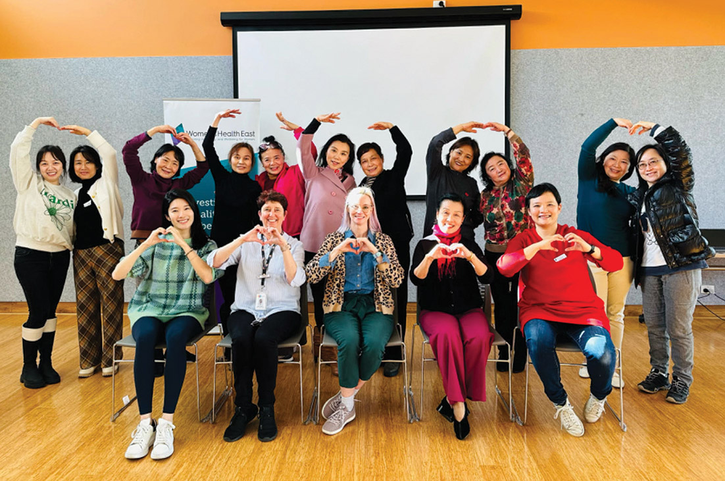
Women’s Health East staff members Claire and Esther, with participants of The Lift Program
In Melbourne’s east, women perform higher rates of unpaid labour in the home, are less likely to be in secure employment, and are underrepresented in decision-making positions, when compared with men. Women in the region experience higher rates of workplace sexual harassment and are less likely to report feeling safe when walking alone at night, when compared to men. To achieve gender equality, we must challenge rigid gender stereotypes and roles, and increase women’s social and economic participation and access to resources.

Advancing gender equality via the Gender Equality Act 2020
The public sector has an important role in promoting equality for people of all genders in Melbourne’s east. In Victoria, the Gender Equality Act 2020 requires certain public sector organisations to take action to advance gender equality in their organisations and through their work. Over the past year, Women’s Health East has actively supported a range of partners to sustainably implement the requirements of the Act through our specialist training and advisory services in intersectional, gender transformative practice. We also supported defined entities through our work as a member of the Action for Gender Equality Partnership, a consortium of gender equality specialists who are on the Commission for Gender Equality in the Public Sector’s Panel of Providers.

Gender impact assessment advisory
and consultancy services
Gender impact assessments enable organisations to analyse how their work will meet the different requirements of women, men and gender diverse people. Under the Gender Equality Act 2020, the Victorian public sector, universities and local councils, known as defined entities, must conduct gender impact assessments on their policies, programs and services that are new or up for review and that directly and significantly impact the public.
Women’s Health East was engaged by Yarra Ranges Council to undertake a review of the gender impact assessment for the Warburton Mountain Bike Destination. This world-class mountain biking destination in the Yarra Ranges is expected to create 160 new local jobs and generate $31.2 million in economic spend within the region each year. Our team provided a series of reports to support council to ensure that people of all genders can equitably share in the health, social and economic benefits of the Warburton Mountain Bike Destination.
We worked with Yarra Ranges Council to enhance the Belgrave South Recreation Reserve by conducting a gender equity walk to explore local women’s experiences, thoughts and future needs for the space. We provided council with a report outlining recommendations on the specific needs of women and girls when redesigning the reserve.
We were engaged by Box Hill Institute to undertake a gender impact assessment on their recruitment and selection policy to support equitable recruitment practices for people of all genders and intersectional attributes, and further support their commitment to diversity and inclusion in the workforce.
We also developed a gender impact assessment case study on a kerbside waste and recycling collection service for the Commission for Gender Equality in the Public Sector. This case study is part of a suite of tools available on the Commission’s website that can support defined entities to undertake gender impact assessments.

Gender equality capability building training
Women’s Health East facilitated introductory and applied gender impact assessment training to support organisations to build the capability of executive leaders, managers and practitioners to conduct intersectional gender impact assessments and implement their Gender Equality Action Plans.
Our staff delivered a webinar for Victorian defined entities to increase participant understanding, confidence and motivation to implement their organisation’s Gender Equality Action Plan. The 90 participants included staff of public entities, public service bodies and local councils.
This year, we worked with the Office for Women in Sport and Recreation on the rollout of the Fair Access Policy Roadmap through the delivery of nine gender impact assessment training sessions to approximately 250 local government staff.
We also facilitated training on gender impact assessments for over 60 staff from Yarra Ranges Council, and for staff from the Transport Accident Commission.
“This training was a tangible catalyst for starting conversations in sporting clubs with very real outcomes that provide ongoing dialogue opportunities.”
Training participant
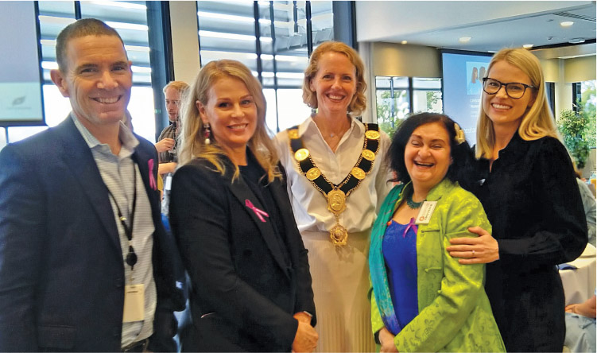
Women’s Health East staff and Board with Manningham
City Council staff and Mayor Cr Deirdre Diamante

Taking Action to Combat Racism
Taking Action to Combat Racism works with Chinese women to understand their experiences of racism and co-design strategies to prevent race-based discrimination. This initiative aims to enhance the wellbeing of Mandarin-speaking women by increasing their social connection and engagement in community life. The project delivered two workshops on racism and mental health reaching 28 Chinese women as well as five focus groups with 19 Chinese community members that will inform the co-design of an anti-discrimination campaign.
“I heard stories about racial discrimination within the community, especially during the pandemic. I wanted to bring those voices into this project and, at the same time, share my own experiences.”
Project participant

A gender transformative approach to mental health promotion practice
We delivered a two-part webinar series aimed at building the capacity and knowledge of practitioners to understand the determinants of women’s mental health and gender-transformative and culturally safe mental health promotion practice. The webinars were delivered to 74 participants.
“I appreciated being taken from an introduction to gender-transformative practice, to key issues in migrant and refugee women’s mental health and considerations for mental health services…
It was just wonderful to see how some of the health promotion principles were applied in practice.”
Webinar participant

Building gender equitable maternal and child health services
We partnered with healthAbility to deliver a forum to support maternal and child health practitioners from local councils across Melbourne’s east to explore how gender equitable practice can be embedded into postnatal maternal and child health services. This work came about through Women’s Health East’s Parenting in a Pandemic: Women’s Mental Health and Wellbeing During COVID-19 research report. This report, released in 2022, highlighted the need to integrate gender equality into postnatal maternal and child health services.

Advancing refugee and migrant women’s
mental health and wellbeing
Women’s Health East’s Bicultural Workers deliver culturally appropriate, evidence-based, in-language health promotion programs to Mandarin and Hakha-Chin speaking refugee and migrant women. These programs aim to promote the mental health and wellbeing of participants and to advance gender equality in their communities. This year our staff facilitated six capability building focus groups with 37 refugee and migrant women. This provided opportunities for women’s social participation and skill building as well as a platform for the co-design of our programs.

The Lift Program
The Lift Program worked with older Mandarin-speaking women to improve their mental health and wellbeing. The six-session in-language program was delivered to 106 participants who reported that the program increased their knowledge about mental health and wellbeing, confidence to participate in the community, and access to local mental health, ageing and family violence services.
“As a new migrant, I want to participate in the community, but I just don’t know how. Now I know where the platform is, that is, through your organisation and this program.”
Program participant

The Five Rhythms to Mental Wellbeing
This in-language program, delivered in partnership with the Migrant Information Centre, worked with older Chinese women to increase their social inclusion and reduce stigma associated with poor mental health. The six-week program was delivered to 71 participants and covered topics including mental health literacy, managing stress and self-care, healthy family relationships, and social inclusion.
“Prior to this program, I have been feeling isolated at home for years. I was so stuck and I couldn’t see hope. The program has helped me walk out of my home and start making new friends. Finally, I feel I can live again.”
Program participant
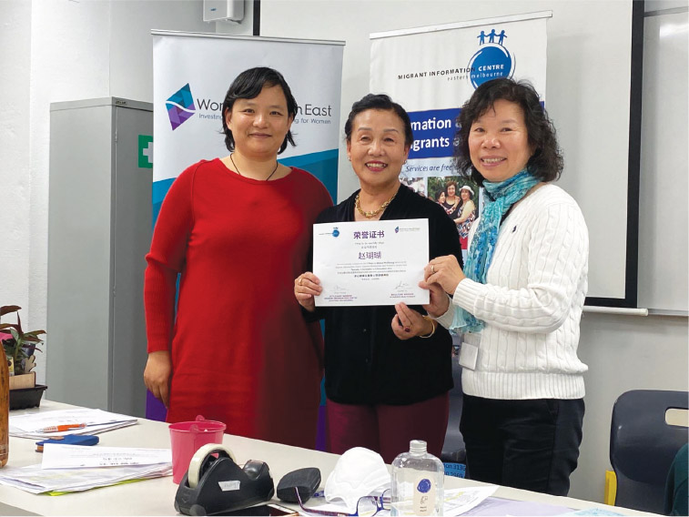
Women’s Health East staff member Esther, with participants
of the Five Rhythms to Mental Wellbeing program

Women’s mental health education and promotion programs
Our Bicultural Workers delivered multiple health education sessions for Mandarin-speaking women. This included two in-language workshops on mental health and healthy ageing delivered to 37 Mandarin-speaking women aged 60 years and over. We also delivered a four-session program to 90 Mandarin-speaking women that focused on mental health literacy, healthy ageing and self-care strategies.
Over 100 Mandarin-speaking women with children participated in our nine-session parental mental health promotion program. The program focused on mental health literacy, stages of childhood development and self-care strategies. Participants reported feeling more confident to talk about mental health and said they benefited from the social connections formed during the program.
We also delivered three in-language health education sessions to 24 Hakha-Chin speaking women. These sessions focused on mental health literacy, healthy relationships and understanding the impact of family violence and gender inequality on women’s mental health and wellbeing.
“We are glad to see that you support Hakha Chin-speaking women, especially by running mental health information sessions in our own language.”
Program participant

Supporting catchment and regional planning
Women’s Health East provided expert women’s health advice to over 35 regional and
state-wide committees and working groups, including support to local council municipal public health and wellbeing planning and committee meetings.
We partnered with the North Eastern Public Health Unit to provide specialist gender equality expertise on the development of their catchment planning process. Our team attended briefings and sector workshops, participated in surveys and listening labs, and attended the North Eastern Public Health Unit’s executive and program control groups and committees to influence the regional catchment plan and its priorities.
To ensure that catchment and regional structures and partnerships are aligned, the North Eastern Public Health Unit is also a member of several regional strategy committees and working groups led by Women’s Health East. This integration of the primary prevention system architecture enables effective coordination of primary prevention activities across the catchment and region to maximise impact and reach.

International Women’s Day
We led the Cracking the Code social media campaign on International Women’s Day. The campaign educated and inspired community members to understand how women’s and girls’ increased participation in science, technology, engineering, and mathematics (STEM) industries is critical to building an inclusive and diverse workforce. The campaign reached over 2,000 people across our social media channels.
We facilitated a workplace gender equality and bystander action workshop for Box Hill Institute staff. Our staff also attended local and regional International Women’s Day events that showcased the unique skills and knowledge of women working in STEM.

Prevent violence against women
Violence against women is a serious social problem with
devastating impacts on women, families and communities.
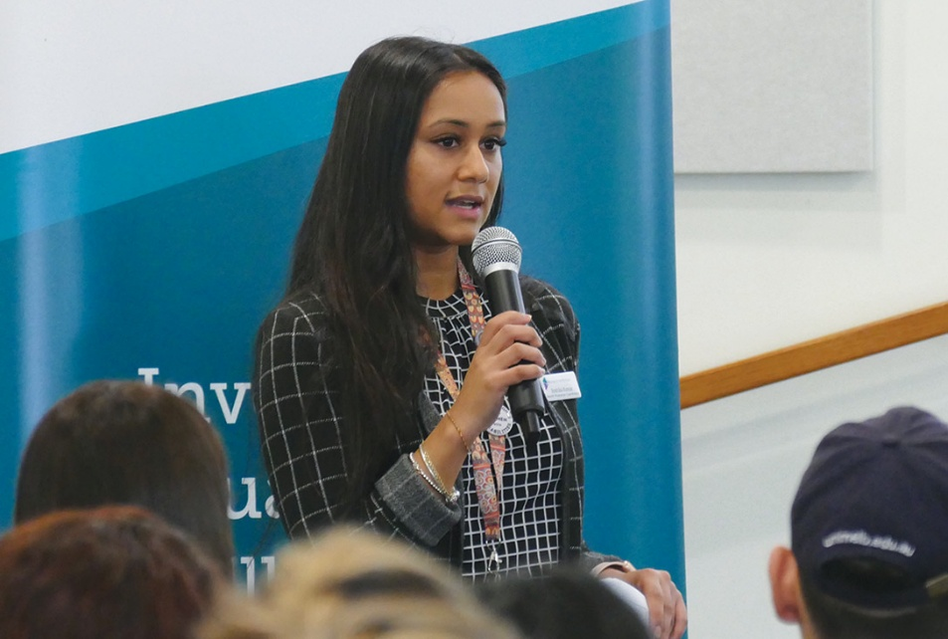
Women’s Health East staff member Roshika presenting
at a Together For Equality and Respect event
Rates of family violence continue to increase in every local government area across Melbourne’s east, which is a culturally and socio-economically diverse region. Evidence shows that women who experience intersecting forms of disadvantage and discrimination experience higher rates of gender-based violence. This trend is particularly evident in the Yarra Ranges, where specialist response services reported a significant increase in family violence incidents following the catastrophic storms of 2021 and the COVID-19 pandemic. Violence against women is preventable through sustained, coordinated and long-term efforts that target the social norms, practices and structures that produce and reinforce gender inequality and intersecting inequalities faced by specific groups of women.

Together For Equality and Respect
Together For Equality and Respect is a cross-sector partnership, led by Women’s Health East, that sees over 30 organisations work together to prevent violence against women in Melbourne’s east. The partnership provides a regional prevention infrastructure that includes a strategy, governance structure and collaborative partnership mechanisms. This infrastructure equips organisations to coordinate and integrate primary prevention activities across the region to maximise reach and impact.
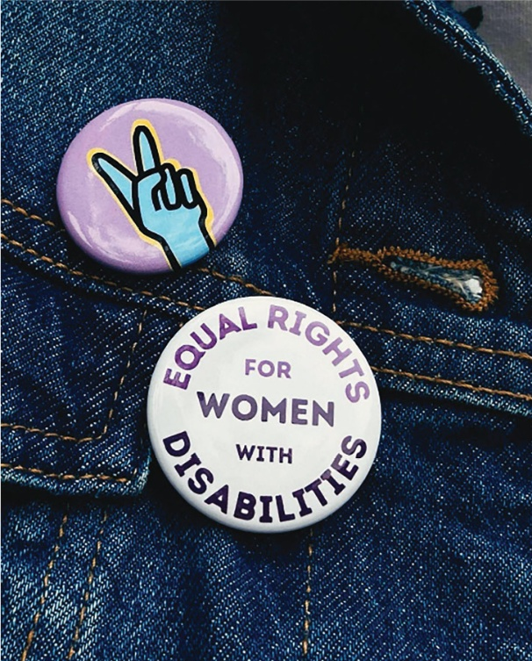

Together For Equality and Respect
governance and practice mechanisms
Women’s Health East leads several Together For Equality and Respect leadership and practice meetings and communities of practice that form the regional primary prevention infrastructure in Melbourne’s east.
In August, Women’s Health East established an Executive Governance Group. The group, which met quarterly, includes chief executive officers and directors from partner organisations who provide strategic oversight of the partnership. Over the past 12-months, we have resourced this group to:
- endorse a process for regional action planning and two priorities for collective regional action
- undertake a membership review and establish a new membership structure
- develop a Together For Equality and Respect advocacy platform
- endorse an approach to evaluating the collective impact of the partnership.
Women’s Health East led the co-design of a regional primary prevention action plan. The plan was designed via two partner surveys and two action planning workshops, with a total of 34 participants from 25 organisations. The plan, which is publicly available, includes 98 primary prevention initiatives from 19 partner organisations.
The Together For Equality and Respect communities of practice and practice forums increase the capacity, skills and knowledge of the primary prevention workforce and partner organisations to deliver evidence-informed prevention initiatives.
We delivered four communities of practice and two practice forums to 136 participants. The sessions covered topics such as lifespan approaches, the prevention of violence against women with disabilities and consultation and co-design practices. We also shared practice findings from work with faith-based communities, schools, higher education institutions and in-community educational settings.

Margins to the Mainstream: Preventing violence against women with disabilities
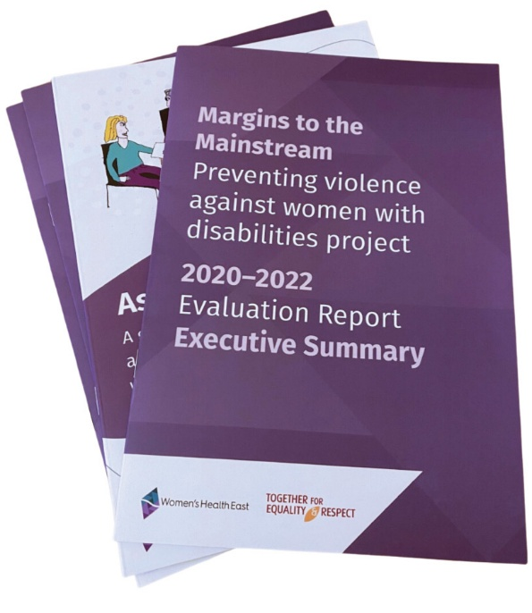
The Margins to the Mainstream project was developed in response to the significantly high rates of violence against women with disabilities. It recognises the importance of centring the input and expertise of women with disabilities in primary prevention work. The project builds the capacity of the Together For Equality and Respect partnership to promote gender and disability equality and to prevent violence against women with disabilities. The project is funded by the Australian Government Department of Social Services.
The Margins to the Mainstream Experts Group, comprised of women with disabilities, designed several resources for partner organisations and practitioners. These resources include practice guides, digital resources and marketing collateral that include calls to action to address gender inequality and ableism. Members of the Experts Group also shared their insights and expertise on how to prevent violence against women with disabilities with over 450 people at regional and state-wide events.
The Experts provided advice and insights on meaningful consultation for several Together For Equality and Respect partners. Following a consultation process with Access Health and Community, two Experts were featured in a video for an online training package. In this video, the Experts share their lived experience and insights into how early childhood educators can promote gender and disability inclusive practices with children, parents and staff.
The Experts also co-designed Asking the Experts: A guide to best practice co-design and consultation with women with disabilities, a Women’s Health East publication that will be launched in late 2023. We were also proud to publish the Margins to the Mainstream: Preventing violence against women with disabilities project 2020–2022: Evaluation Report that described the project as an example of leading edge primary prevention in a real world context.
“Although the barriers we face may differ, the discrimination and ableism we experience are the same. The Experts Group is a shining example of what women with disability can achieve when [they are] supported and have their access requirements met.”
Margins to the Mainstream Project Expert

Get the Go-Ahead: Affirmative consent project
Get the Go-Ahead is a newly established project to empower Disabled young people with information about affirmative consent, equipping them to make informed choices about their lives and bodies and to address ableist and gendered drivers of sexual assault and other forms of gender-based violence. The project embeds a youth-centred co-design process and is delivered in partnership with the Youth Disability Advocacy Service.
We recruited a Project Advisory Group and established a Young Experts Group of Disabled young people of all genders and backgrounds. We designed three capacity building workshops and developed an accessible co-design process underpinned by disability justice principles.
“I’m very excited to see what comes out of the Get the Go-Ahead project. Already, it’s been really great to see such an accessible application process, and collateral that made me feel welcome to apply as a queer disabled person.”
Get the Go-Ahead Young Experts Group member

The Hoodie and Yarn Up programs
Women’s Health East supported Boorndawan Willam Aboriginal Healing Service to deliver the Hoodie program, which supported young Aboriginal and Torres Strait Islander women to learn about respectful relationships and actions to address the intersecting drivers of violence against Aboriginal women.
We also worked with Boorndawan Willam Aboriginal Healing Service to pilot the Yarn Up violence prevention program. This program harnessed the knowledge, life experiences,
self-expression, and narratives of Aboriginal women to become leaders in promoting gender equality and shaping community attitudes about family violence.

Prevention of violence against women training program
We delivered multiple training sessions to support over 170 senior leaders, practitioners and community members in Melbourne’s east to prevent violence against women and advance gender equality. This included four active bystander workshops designed to equip participants with the skills and knowledge to challenge all forms of discrimination and disrespect. Participants included staff from local councils and TAFEs, as well as committee members and players from local sporting clubs.
We delivered a comprehensive two-part workshop for practitioners, students and community members on how to put the prevention of violence against women into practice.
We worked closely with the Inner East Community Health - Health Promotion Partnership to deliver training on how to apply an intersectional gender lens. This process included the co-development of a tool to support the partnership to apply a gender lens across their health promotion initiatives.

16 Days of Activism against Gender-Based Violence
Women’s Health East coordinated the regional 16 Days of Activism campaign with the Together For Equality and Respect partnership. Women’s Health East hosted two library events featuring the Margins to the Mainstream Experts. These events, attended by 29 participants, promoted community awareness and action to prevent violence against women with disabilities.
The social media toolkit we developed and distributed included messages and illustrations co-designed with women with disabilities to challenge sexism and ableism. The toolkit included 16 social media tiles and reached over 20,000 people when shared by regional partners and state-wide prevention organisations. The campaign also distributed 500 bookmarks, 200 posters and 2,000 postcards to over 30 organisations.
“An action I plan to take after attending this event is inquiring further in all organisations with which I am associated, about the steps they are taking to address violence and discrimination against women with disabilities.”
Event participant
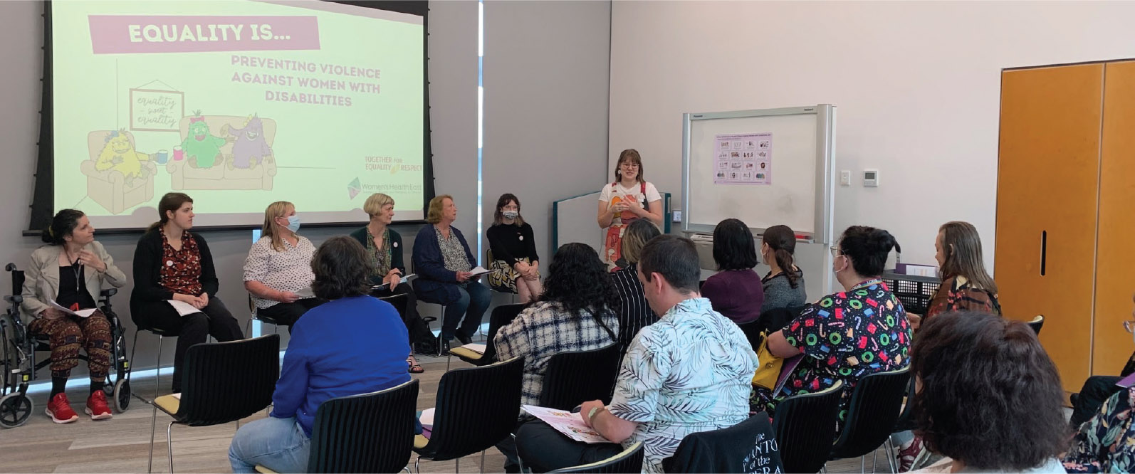
Women’s Health East’s 16 Days of Activism Margins to the Mainstream event

Improve sexual and reproductive health
Optimal sexual and reproductive health is central to women’s overall health and wellbeing, yet it remains an area of healthcare that is highly gendered and stigmatised.
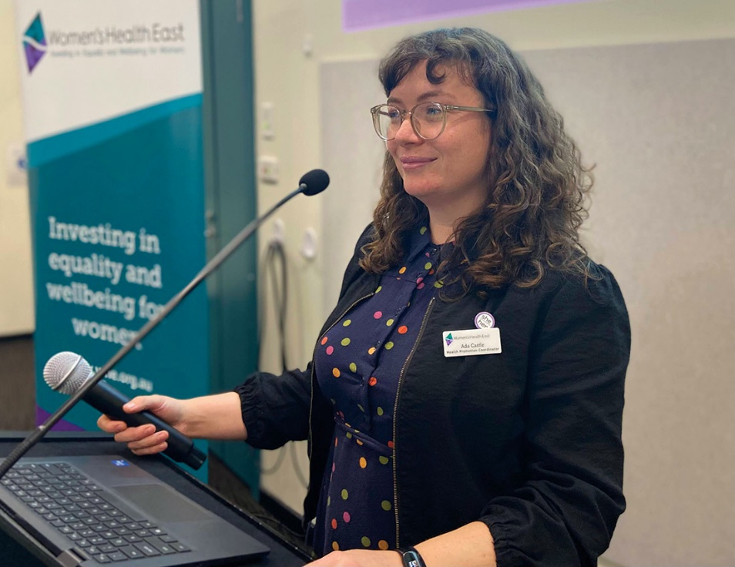
Women’s Health East staff member Ada facilitating a sexual
and reproductive health capacity building workshop
Women in Melbourne’s east experience higher rates of chlamydia and hepatitis B than the Victorian state average. They also experience a higher unmet need for abortion healthcare compared to women in the western and south-eastern suburbs of Melbourne.
Advancing women’s sexual and reproductive health rights requires policy, advocacy and primary prevention activities that redress the social determinants of sexual and reproductive health inequities. This includes initiatives that promote healthy and respectful relationships, bodily autonomy and reproductive choice, and freedom from violence, stigma and discrimination.

A Strategy for Equality
A Strategy for Equality: Women’s Sexual and Reproductive Health in Melbourne’s East 2020 – 2025 is a comprehensive five-year strategy and partnership, led by Women’s Health East, to improve the sexual and reproductive health of women in Melbourne’s east. The strategy is closely aligned with the state policy context and sets out the necessary actions to prevent women’s sexual and reproductive ill health. It includes a focus on women’s sexual and reproductive health across their life course, advocacy to increase access to health services including abortion healthcare, and primary prevention initiatives that work to redress health inequities.
Women’s Health East oversees the partnership governance structures and strategy. We also build the capability of partner organisations to promote sexual and reproductive health by leading regional capacity building initiatives, conducting comprehensive planning and evaluation, advocating for important topics, and facilitating the dissemination of practice resources.
The partnership comprises 23 partner organisations including community health, local government, universities, and other specialist services. The strategy is overseen by the Sexual and Reproductive Health Eastern Metropolitan Region Strategic Reference Group, which convened five times, and the Implementation Subcommittee, which met quarterly throughout the year.

A regional approach to improving
women’s sexual and reproductive health
We evaluated the Strategy for Equality two-year action plan, finding that collective action had been achieved and 22 prevention initiatives had been met. The evaluation also showed that partners improved their capacity to advance sexual and reproductive health due to their organisation’s involvement with the regional strategy and partnership.
Women’s Health East also began the development of the strategy’s second two-year action plan. The action plan is being co-designed with partners on the Strategic Reference Group and will be completed in late 2023.
“The Strategic Reference Group has helped me expand my professional network and meet many important stakeholders… it is a great launching pad for further collaboration [and]… as a result of the Strategic Reference Group I have successfully undertaken multiple health promotion activities with other organisations.”
Strategic Reference Group Member

Sexual and reproductive health capacity building workshops
We led three capability building workshops aimed at supporting organisations and professionals to design, deliver and evaluate evidence-based sexual and reproductive health primary prevention initiatives. The workshops were attended by 85 managers and practitioners and focused on advocacy and research, sexual and reproductive health as a public health concern, and understanding the sexual and reproductive health needs of trans and gender diverse communities.
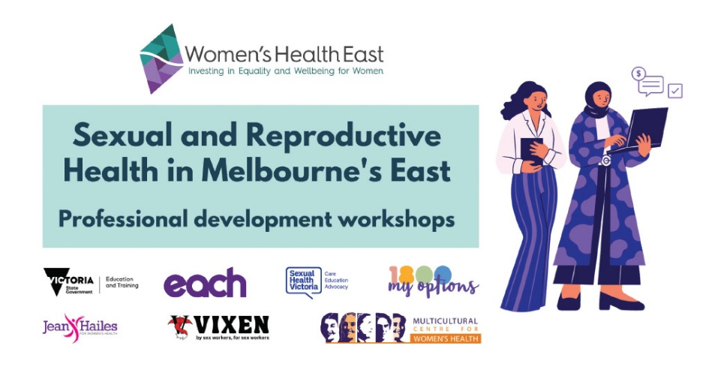

Increasing access to abortion healthcare
We undertook a data review of women’s abortion healthcare needs and service access barriers in Melbourne’s east. This analysis is featured in several reports, including Women’s Health East’s submission to the Senate Inquiry into Universal Access to Reproductive Healthcare. Our CEO, Elly Taylor, presented at a Senate Standing Committee on behalf of the Victorian Women’s Health Services Network’s submission into universal access to reproductive healthcare.
In partnership with other women’s health and clinical services, we held a webinar to increase health practitioners’ knowledge and understanding of medical abortion, including how to become a prescriber or dispenser. The webinar was attended by 86 participants, with a further 161 registering to watch the recorded webinar.
“As a pharmacist, I wasn’t aware how many issues doctors have finding pharmacies that will keep and dispense medical termination of pregnancy medications. It’s motivated me…. to get a formal process started… and let local prescribers know we are here and able to help their patients.”
Webinar participant
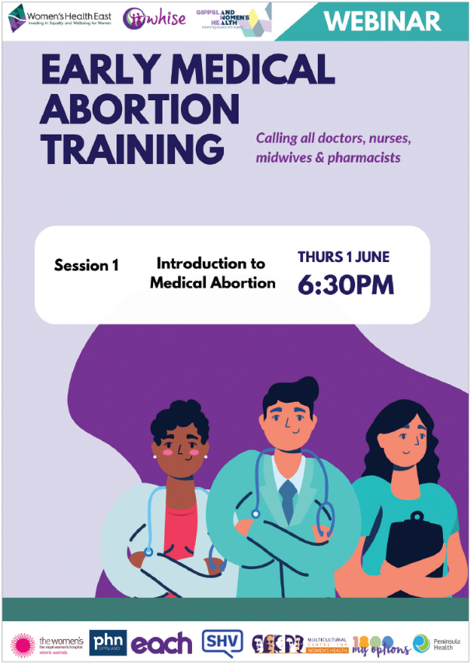

Practice resource to enhance the sexual and reproductive health of women with disabilities
We developed a practice resource that includes a literature review and environmental scan to understand the sexual and reproductive health priorities of women with disabilities. We undertook a consultation with women with disabilities on their sexual and reproductive health priorities and experiences accessing services in the region. The practice resource supports health practitioners to understand disability inclusive practices and how to improve sexual and reproductive health outcomes for women with disabilities in Melbourne’s east and beyond. This resource will be launched in late 2023.
“It’s so important, when you are dealing with a health issue concerning your body, that you don’t feel powerless and exposed by the way you are treated by health staff.”
Focus group participant

In-language sexual and reproductive health education for refugee and migrant women
Our Bicultural Workers facilitated in-language sexual and reproductive health education sessions with refugee and migrant women.
We led two in-language health education sessions on liver, cervical, breast and bowel cancer prevention that were attended by 35 Mandarin-speaking women. We delivered
an in-language session to six women who speak Mandarin about menopause and healthy ageing.
“Knowing these menopause symptoms help us to
understand ourselves as we are experiencing low
self-esteem during menopause.”
Project participant
We delivered two in-language health education sessions on cervical and bowel cancer prevention to 14 Hakha-Chin speaking women. We also delivered an in-language session to seven women who speak Hakha-Chin on pregnancy options, contraception and abortion healthcare.
“This is my first time to know that abortion is legal in Victoria.”
Project participant

Celebrating Chinese women’s health
and wellbeing during Women’s Health Week
We celebrated Women’s Health Week by delivering two health education sessions to 25 women. The first session for Mandarin-speaking women aged 50 years and over focused on the importance of mental health and social connection to healthy ageing. The second session for parents focused on how to maintain healthy and equal relationships during the transition to parenthood.
We also hosted a Mooncake festival with Chinese women and their children and grandchildren. The festival, which was attended by over 100 participants, celebrated women’s health and the importance of social connection in the Chinese community.

Practice resource on how to become
a menopause-friendly workplace
We developed How to become a menopause-friendly workplace to increase understanding of why menopause is a workplace issue and to provide a policy template and other tools and strategies to promote best-practice workplace approaches. This resource was launched via social media and shared widely with partner organisations in our region and beyond.

Sexual and Reproductive Health Week
We led a social media campaign for Sexual and Reproductive Health Week. The theme of the campaign was abortion access and reproductive rights in Victoria, and it was designed to assist community members who support women and pregnant people’s reproductive rights to take action and to advocate for increased access to abortion healthcare. The five-day campaign, delivered in collaboration with Victorian Women’s Health Services and regional partners, reached over 12,800 people and received 718 engagements across Facebook, Instagram and Twitter.
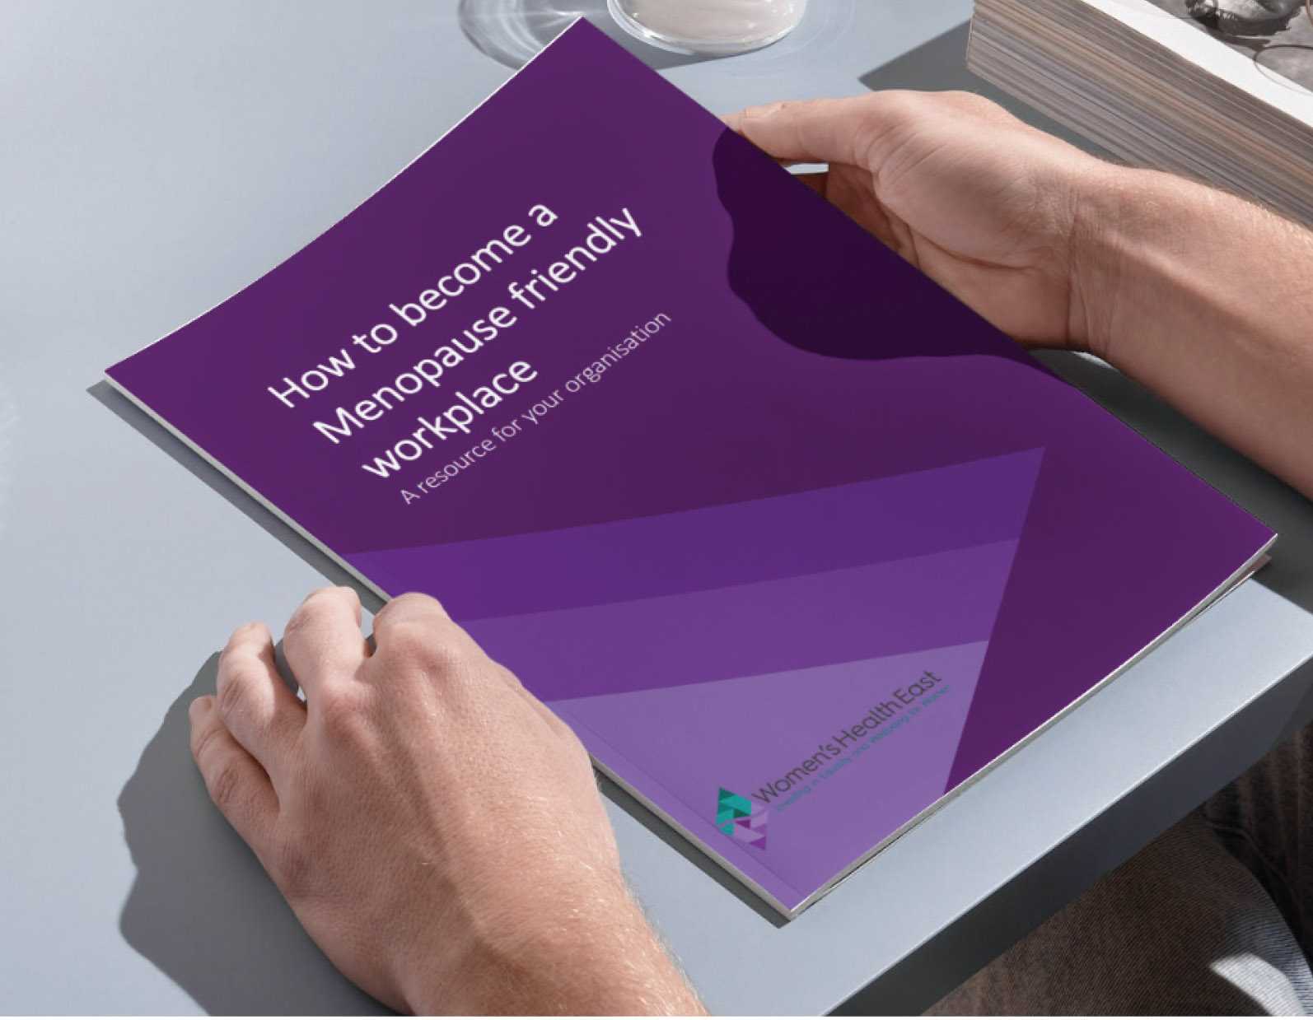

Strengthen our dynamic and sustainable organisation
Women’s Health East is dedicated to being a values driven,
innovative and sustainable organisation and employer.
Our values of inclusion, respect, integrity, and excellence drive our work with women, communities, peers, and partners. Our staff, board and volunteers enable the organisation to pursue its vision of equality, empowerment, health and wellbeing for all women.

Developing, valuing and supporting our people
Women’s Health East is committed to building a workplace culture that supports staff learning, development and growth.
Our staff participated in two in-house training sessions on allyship and preventing race-based discrimination. The first session enhanced staff understanding of the prevention of race-based discrimination, and the second session centred on creating inclusive feminist spaces and aligning our practices with this vision.
Staff also attended discrimination, bullying and harassment training. Our leadership team attended additional training in this area to ensure a safe, inclusive and respectful workplace culture.
Our staff also attended a range of professional development courses, webinars, training sessions and conferences, such as Gender Equity Victoria’s Defining Equity Conference.

Reconciliation Action Plan
Women’s Health East proudly delivered, and began implementing, its inaugural Reflect Reconciliation Action Plan. The plan aims to strengthen and cultivate respectful and trusting relationships with Aboriginal organisations, women and communities. We will work to embed culturally safe practices in our workplace and the health promotion programs we deliver to Aboriginal women to advance their health, wellbeing and self-determination. We will support our Board and staff to deepen their understanding of Aboriginal histories, cultures and customs to further foster a culture of learning and growth.
In line with our values and vision for reconciliation, and in recognition of the painful history associated with Invasion Day, our Board endorsed staff working on 26 January. We also advocated for the Yes vote in the 2023 referendum to enshrine an Aboriginal and Torres Strait Islander Voice in the Constitution, as envisaged by the Uluru Statement from the Heart.

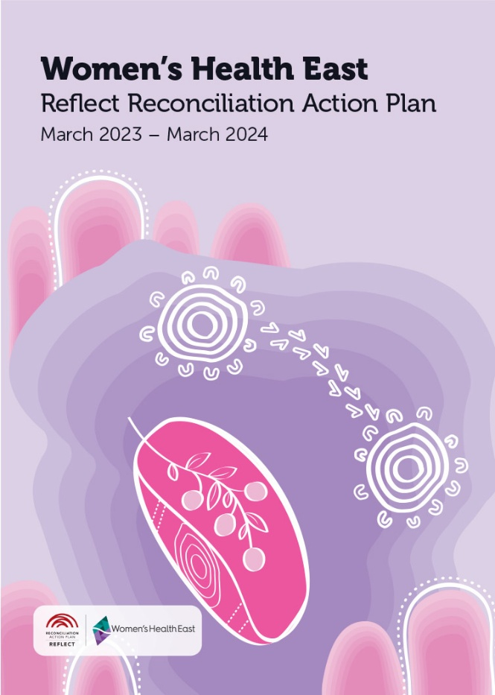
Alanna Sandy, a Tuangurung artist, created the art for Women’s Health East’s Reconciliation Action Plan. The artwork showcases vibrant imagery and cultural symbols that promote a better understanding of the importance of Aboriginal women’s health. The visuals were designed to be inclusive of all Indigenous women, including Aunties, Sisters, Sistergirls, and Elders.

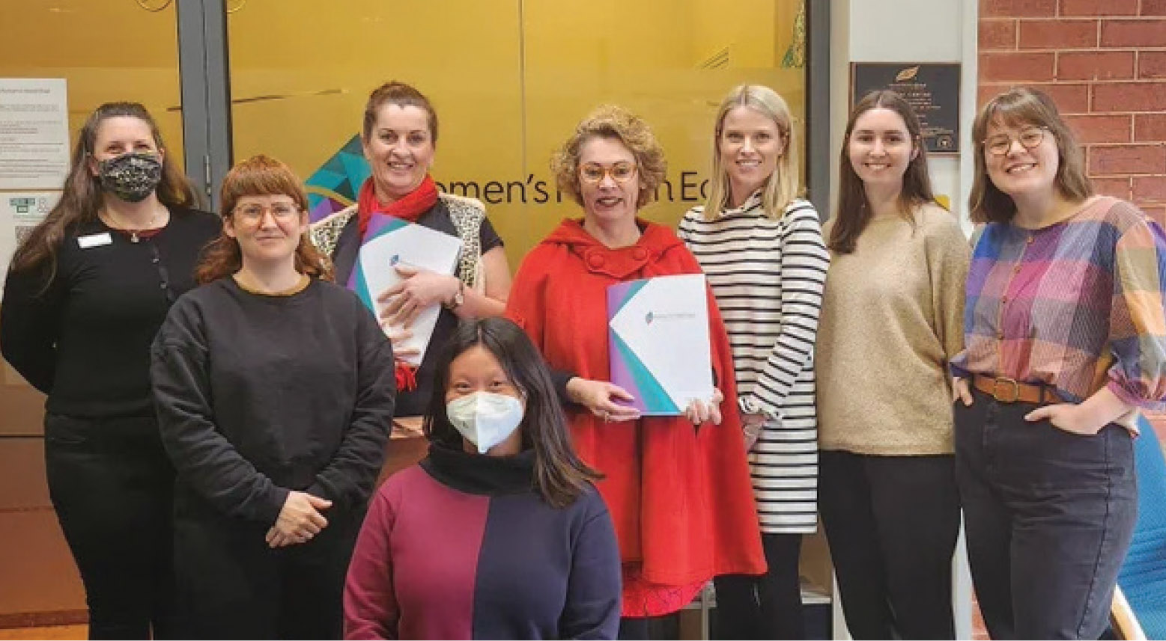
Women’s Health East staff with Sonja Terpstra MP

Quality improvement
We continued to provide leadership support to the Victorian Women’s Health sector around the Women’s Health Services Quality Framework. Quarterly community of practice meetings, attended by quality coordinators from Women’s Health Services, have been instrumental in strengthening the quality systems, knowledge and skills base, and facilitating greater information and resource sharing within the sector.

Measuring Women’s Health East’s impact
We participated in a six-month pilot of the Victorian Women’s Health Services Indicator Framework. We undertook staff training to strengthen our monitoring and evaluation practices, established systems for data collection, and ensured our evaluation approach was culturally safe, accessible and ethical. We also developed and piloted a series of sub-measures to sit alongside the standardised state-wide measures to collect more specific and meaningful localised data. We invested in qualitative evaluation to ensure that the context and complexity of change created by primary prevention and gender transformative interventions is captured. We participated in a collective impact evaluation project with the Victorian Women’s Health Services. This resulted in the Small Change, Big Impact: Women’s Health Services Network Collective Impact Report, which highlights the role and impact of the sector in advancing health and equality for Victorian women.

Political advocacy
We continued to act as strong advocates for gender equality, prevention of violence against women and advancing women’s sexual and reproductive health in partnership with other Victorian Women’s Health Services. Our CEO, Elly Taylor, met with 19 Members of Federal and State Parliament, including the Minister for Health and the Minister for Women, to discuss equitable access to abortion healthcare, women’s leadership, the Victorian budget and additional State Government investment in the Victorian Women’s Health Services.
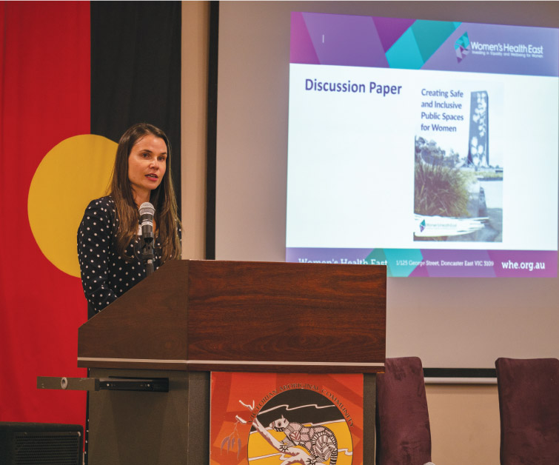
Women’s Health East staff member Vanessa presenting
at Women’s Health in the North’s A Space to Thrive forum

Sharing our knowledge and specialist expertise
Our staff actively shared their expertise and knowledge to shape public discourse, participating in various forums, events and inquiries aimed at advancing the health, safety and wellbeing of women.
- Our CEO, Elly Taylor, engaged in forums and consultations facilitated by Federal and State Members of Parliament, addressing topics such as the Jobs and Skills Summit, women’s leadership, and the establishment of structures to promote equal employment opportunities for women.
- We participated in workshops led by Respect Victoria to strengthen state-wide prevention practice and infrastructure.
- We participated in an Our Watch consultation for non-government stakeholders on priorities and actions that governments can take, in order to inform a government action plan to prevent violence against women and girls with disabilities.
- We showcased the Margins to the Mainstream Project at forums led by organisations including Women with Disabilities Victoria, Women’s Health in the South East and Women’s Health and Wellbeing Barwon South West. These forums attracted regional prevention practitioners from across Victoria. The project was also profiled at an event hosted by Yarra Ranges Council, at the Eastern Metropolitan Regional Family Violence Partnership and the Outer East Community Inclusion Alliance Network meetings.
- We partnered with Maroondah City Council and the eSafety Commissioner to pilot a social media self-defence workshop for women with disabilities that included a consultation with the Margins to the Mainstream Experts.
- We presented at the Women’s Health in the North A Space to Thrive: Applying a Gender Lens to the Design of Public Spaces forum on designing inclusive public spaces.
- We hosted The Motherload: gender equality and early parenting webinar that explored how to challenge gendered expectations and promote gender equitable parenting practices for women and their partners.
- We presented at committee meetings on how to establish a menopause-friendly workplace, providing insights and practical guidance for managers and human resource professionals.
- We presented to local government committees on topics such as women’s mental health promotion, gender equality and inclusive public spaces, and the findings of our research project about women who were pregnant and parenting during the pandemic.
- We chaired the Victorian Women’s Health Services Sexual and Reproductive Health Promotion community of practice quarterly meetings and attended other sector working groups and communities of practice relating to prevention of violence against women, gender equality, communications and advocacy, and collective impact and evaluation.

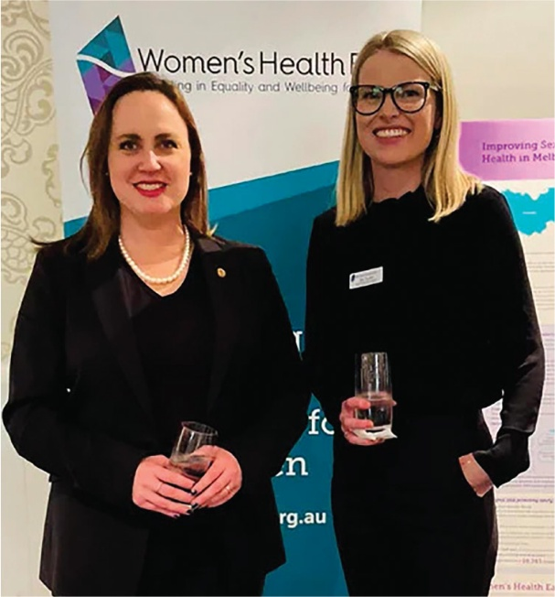
Women’s Health East CEO Elly Taylor
with Bridget Vallence MP
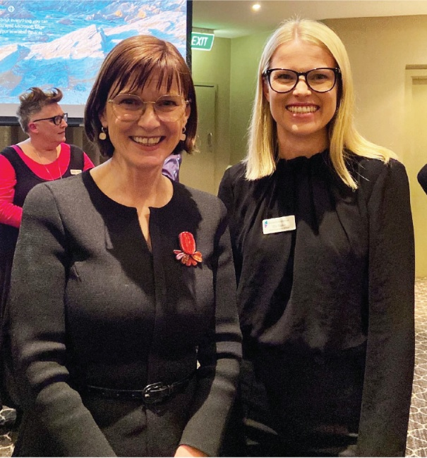
Women’s Health East CEO Elly Taylor
with the Hon. Mary-Anne Thomas,
Victorian Minister for Health

Financial summary
The following information is an overview of the finances of Women’s Health East Inc. and should be read in conjunction with the Women’s Health East Inc. Financial Statements for the year ending 30 June 2023 and their accompanying notes, which are available at www.whe.org.au. Women’s Health East prepares its financial statements in accordance with the Australian Accounting Standards, as outlined in the Independent Auditor’s Report.
Total income for the 2022-2023 financial year was $2,152,907 compared to $1,809,556 in the previous year. Core recurrent funding increased by 3.4 per cent while other income decreased by 44 per cent. There was $784,000 of additional boost funding provided by the Department of Health and the Department of Families, Fairness and Housing as part of a two-year commitment to the Victorian Women’s Health Services (2023 and 2024 financial years). Total expenditure was higher than the previous year, mainly due to employment expenses increasing by 24 per cent because of increased staffing levels associated with the boost funding. The result for the 2022-2023 financial year was a surplus of $35,110. Women’s Health East’s current ratio of 2.54: 1 means that the business has $2.54 in current assets to meet every $1 of current liabilities. The current ratio is a calculation performed to assist in determining financial liquidity.

Financial overview

Summary Income Statement
 | 2023  $ | 2022  $
Income
DH core funding | 768,814 | 743,475
Boost funding | 784,000 | 0
Other | 600,093 | 1,066,081
Total Income | 2,152,907 | 1,809,556
Expenditure
Employment expenses | 1,800,486 | 1,455,262
Other | 317,311 | 286,394
Total Expenditure | 2,117,797 | 1,741,656
Operating Profit/(Loss) | 35,110 | 67,900

Summary Balance Sheet
 | 2023  $ | 2022  $
Cash | 819,804 | 651,194
Receivables | 47,218 | 76,946
Property, plant & equipment | 40,962 | 34,626
Total Assets | 907,984 | 762,766
Payables | 66,537 | 73,080
Income in advance | 160,919 | 60,917
Provisions | 113,667 | 97,018
Total Liabilities | 341,123 | 231,015
Net Assets | 566,861 | 531,751
Current Ratio | 2.54 : 1 | 3.15 : 1

Membership
Women’s Health East’s membership is free and open to anyone who identifies as a woman and who lives, works or studies in Melbourne’s eastern region, and to organisations who work with women in our region. Women’s Health East had 102 members on 30 June 2023.

Women’s Health East membership benefits
By becoming a Women’s Health East member, you will enjoy the following benefits:
- Eligibility to stand for election to the Women’s Health East Board of Governance
- Voting rights at Women’s Health East member meetings and Board of Governance elections
- Access to the latest updates on women’s health, safety and wellbeing through
our e-newsletter
- Invitations to engage in community events and contribute to consultations
- Inclusion in a community of like-minded women dedicated to promoting equality, empowerment and the wellbeing of all women.

How to become a member
To become a member, please complete a membership application on our website www.whe.org.au. For more information, contact us at health@whe.org.au. Please note that membership is contingent upon approval by the Board of Governance and is renewable every three years.

Donate
By donating to Women’s Health East, you can help improve the health, safety and wellbeing of marginalised and disadvantaged women in Melbourne’s east. All donations of $2.00 and above are tax-deductible. To give a one-off donation, make a regular donation, or leave a bequest, please visit Give Now – Women’s Health East <www.givenow.com.au/whe>.

Our peers, partners and funders
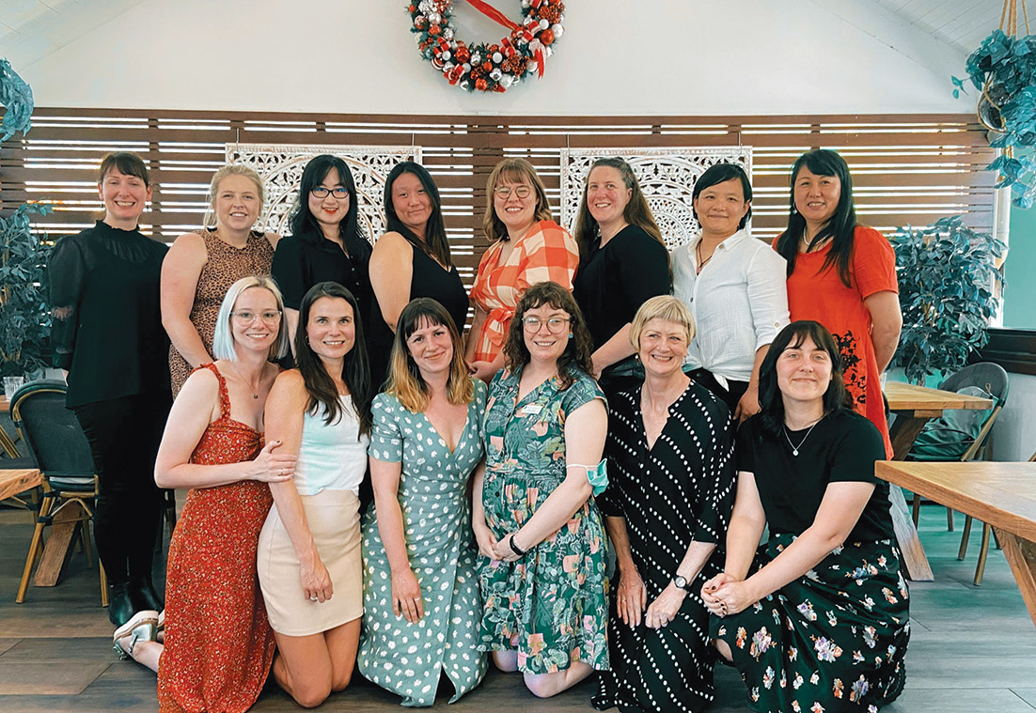
Women’s Health East Staff

Women’s Health East’s funders
Our impact in 2022-2023 was made possible by funding and grants from:
- The Victorian Government
- The Australian Government
- Manningham City Council
- Yarra Ranges Council
- Safe + Equal
We extend our gratitude to organisations who contracted consultancy services, including as part of the Action for Gender Equality Partnership. All proceeds from our consultancy work are reinvested into programs and projects that drive action to advance gender equality and positive social change for women and girls.

Women’s Health East’s peers and partners
We acknowledge the invaluable contribution of our peers and partners to our ongoing efforts to enhance women’s health, safety and wellbeing across our region and beyond.
- Access Health and Community
- Australian Chinese Early Learning Association
- Boorndawan Willam Aboriginal Healing Service
- Boroondara City Council
- Box Hill Institute
- Breast Screen Victoria
- Centre for Culture, Ethnicity and Health
- Centre for Holistic Health
- Deakin University
- Department of Education and Training
- Diabetes Victoria
- EACH
- Eastern Centre Against Sexual Assault
- Eastern Community Legal Centre
- Eastern Health
- Eastern Melbourne Primary Health Network
- Eastern Metropolitan Regional Family Violence Partnership
- Eastern Regional Libraries
- FVREE
- Gender Equity Victoria
- GenWest
- Gippsland Women’s Health Service
- Headspace Knox
- healthAbility
- Inspiro Health
- Jean Hailes
- Knox City Council
- LaoLaiLe Seniors Group
- Latrobe Community Health Service
- La Trobe University
- LiverWELL
- Manningham City Council
- Maroondah City Council
- MiCare
- Migrant Information Centre (Eastern Region)
- Mitcham Community Group
- Monash City Council
- Monash University
- MSI Australia
- Multicultural Centre for Women’s Health
- NLEC Community Care
- North Eastern Public Health Unit
- Office for Women in Sport and Recreation
- PsycKitchen
- Sexual Health Victoria
- Swinburne University
- Whitehorse Council
- Women with Disabilities Victoria
- Women’s Health and Wellbeing Barwon South West
- Women’s Health Goulburn North East
- Women’s Health Grampians
- Women’s Health in the North
- Women’s Health in the South East
- Women’s Health Loddon Mallee
- Women’s Health Victoria
- Women’s Mental Health Network Victoria
- Woori Community House
- Yarra Ranges Council
- Yarra Valley Water
- Youth Disability Advocacy Service
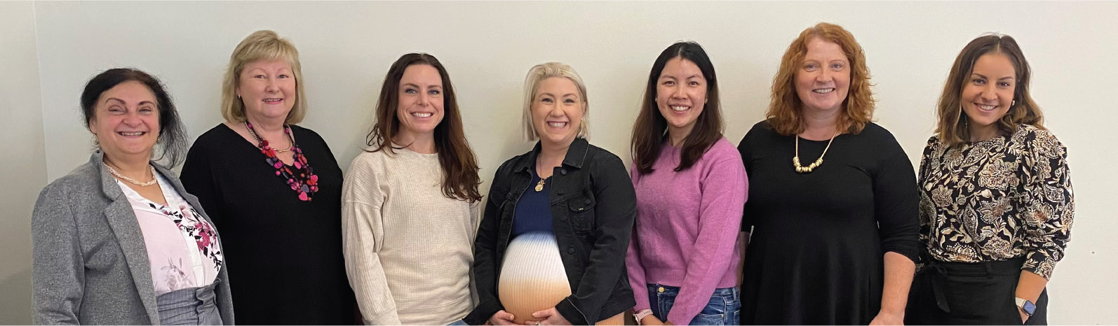
Women’s Health East Board

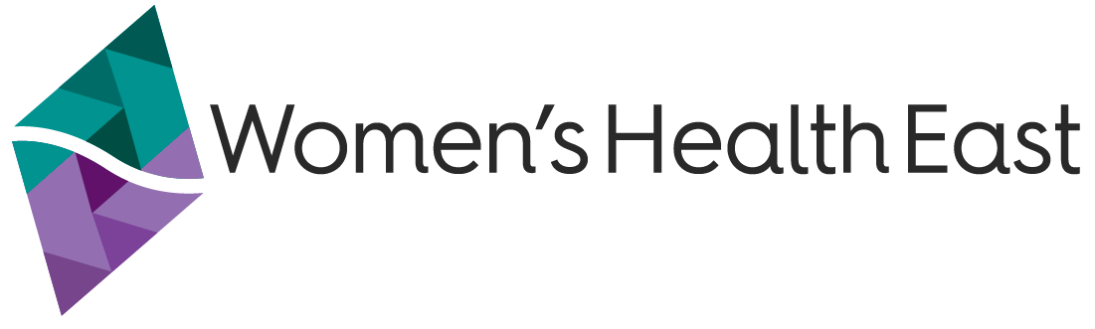
Women’s Health East
1/125 George Street, Doncaster East VIC 3109
(03) 9851 3700
health@whe.org.au
Women’s Health East website <www.whe.org.au>
Women’s Health East acknowledges the
support of the Victorian Government.
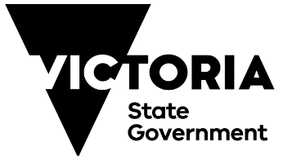

Preferences between identity-first language (Disabled people) and person-first language (people with disabilities) vary between people and communities. Get the Go-Ahead uses identity-first language as it is preferred by project partners and participants and aims to reject stigma. Disabled is capitalised to respectfully recognise Disabled people as a culture, community, and identity defined by Disabled people and not solely from a medical lens. Women’s Health East otherwise uses person-first language throughout this report.

