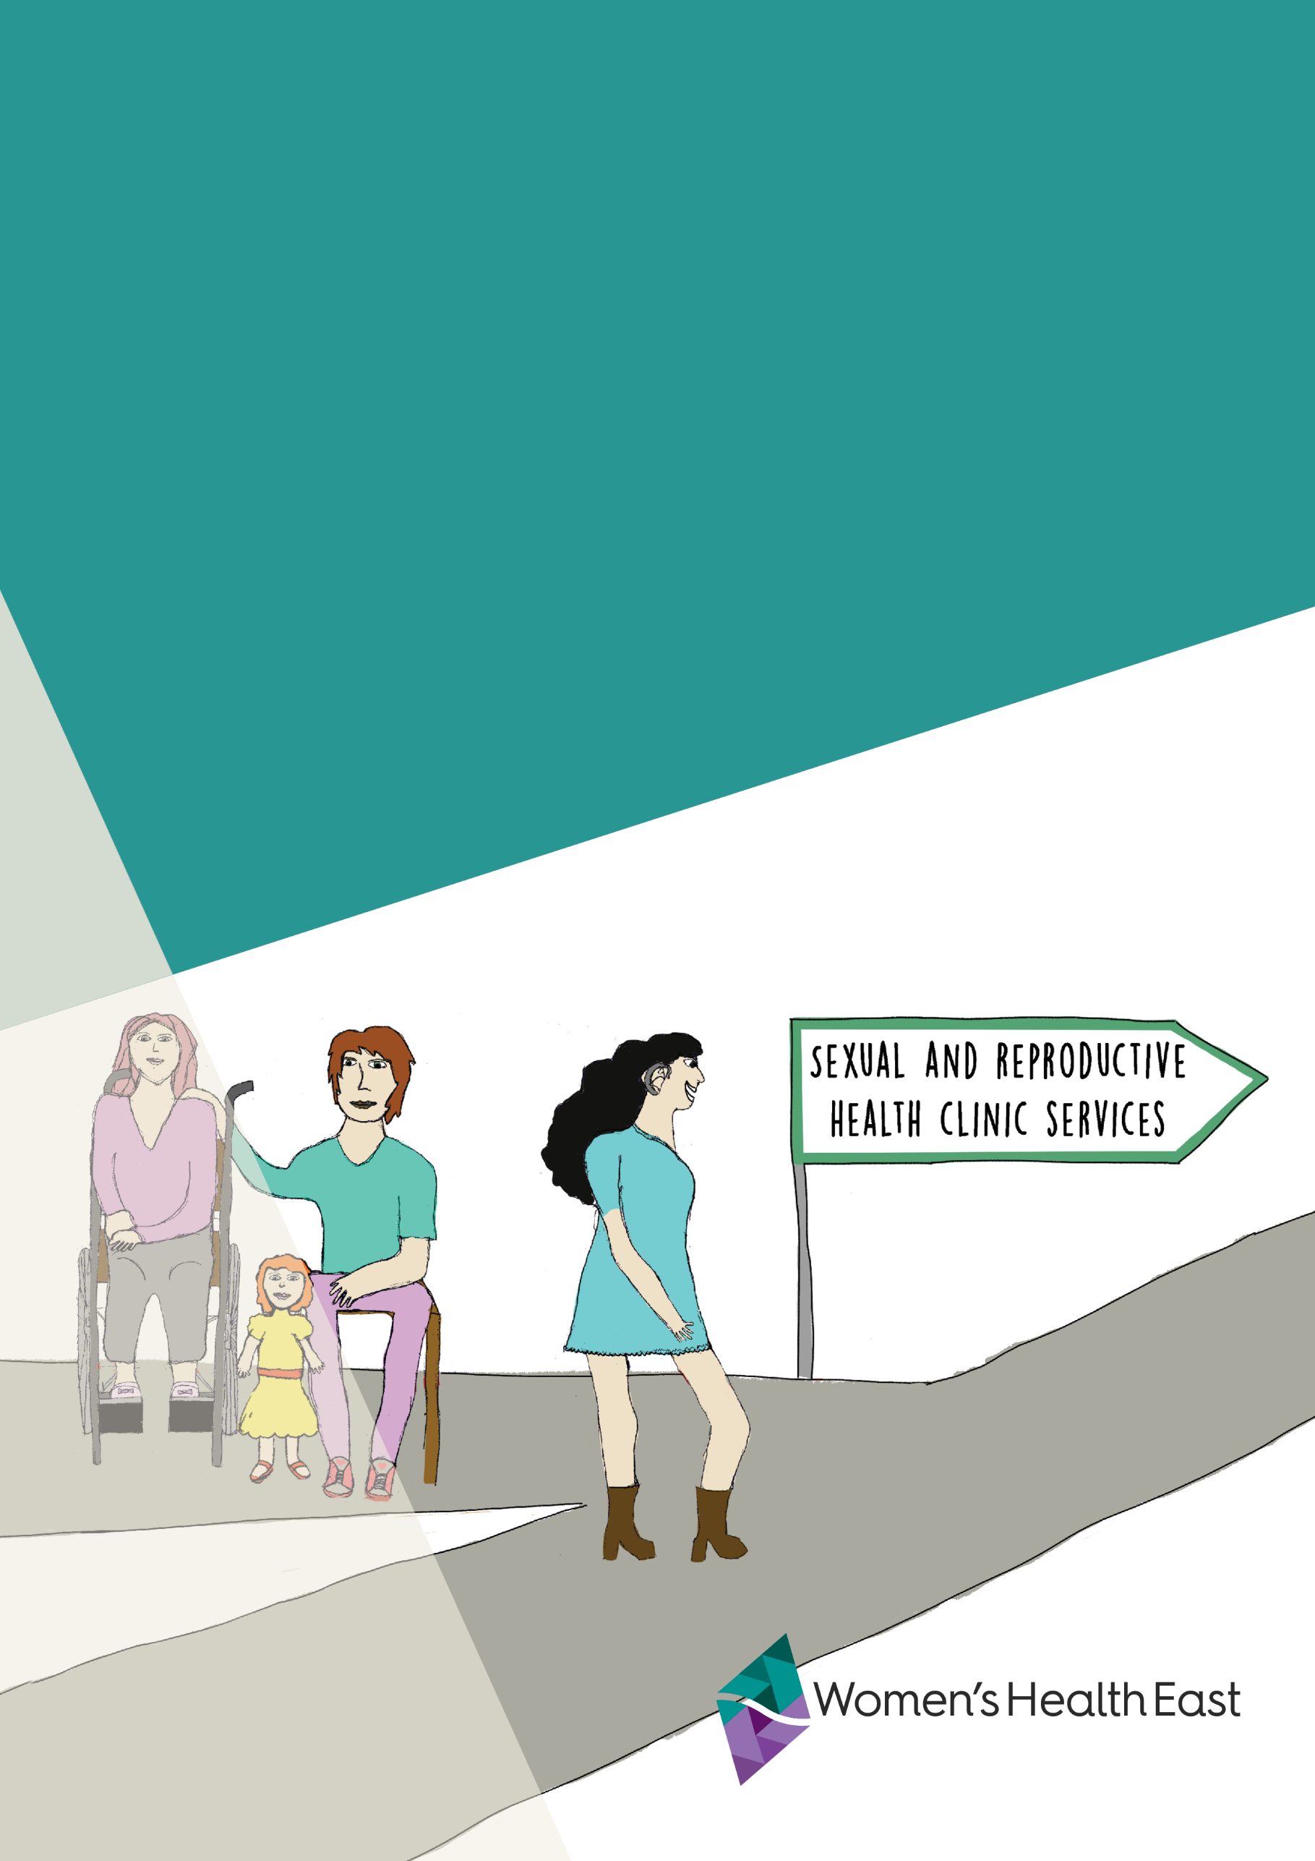
Sexual and reproductive health and women with disabilities
A practice asset for health workers
created by Women’s Health East

Contents
Acknowledgement of Country 3
Acknowledgements 3
Suggested citation 3
Introduction 4
Women’s Health East 4
Purpose of this practice asset 5
Background 5
Consultation with women with disabilities living in Melbourne’s east 7
About the Margins to the Mainstream Project 7
Issues of concern for women with disabilities 8
Summary 12
Literature review 13
What is known already? 13
Key themes 13
Summary 19
Recommendations 20
Appendix 21
Literature search parameters 21
Literature search inclusion criteria 21
References 22

Acknowledgement of Country

Women’s Health East acknowledges the Wurundjeri Woi-wurrung people, the Traditional Owners of the land on which we work. We pay our respects to Elders past, present and future. We affirm that sovereignty was never ceded, and that colonialism and racism continue to impact the lives of Aboriginal and Torres Strait Islander women and contribute to the high rates of violence they experience. We recognise the strength, resilience and leadership of Aboriginal and Torres Strait Islander women, and express our hope for and commitment to reconciliation.

Acknowledgements
Women’s Health East would like to express our gratitude and appreciation to the members of the Margins to the Mainstream Experts Group for their contributions to the development of this resource. Women’s Health East also thanks Women with Disabilities Victoria for their invaluable feedback on this resource.
All illustrations in this guide were prepared for the Margins to the Mainstream project by Blend Creative, a socially inclusive design studio. The design team includes women illustrators with disabilities. The illustrations were developed from 2021 to 2023, with input and feedback from the Experts Group. The illustrations were designed to align with this project’s key messages and represent diverse women with disabilities.
For more information about the Margins to the Mainstream project, refer to the Margins to the Mainstream website: whe.org.au/margins-to-the-mainstream

Suggested citation
Women’s Health East. (2023). Sexual and reproductive health and women with disabilities. Melbourne, Australia.
© Women’s Health East 2023

Introduction

Women’s Health East
Women’s Health East is the women’s health promotion organisation for Melbourne’s eastern region. Women’s Health East specialises in implementing primary prevention initiatives dedicated to advancing gender equality, preventing violence against women, and improving women’s sexual and reproductive health. We place particular emphasis on improving the health outcomes of marginalised and disadvantaged women.
Women’s Health East’s vision is equality, empowerment, health and wellbeing for all women, with strategic priorities of advancing gender equity, preventing violence against women, and sexual and reproductive health. Women’s Health East works to improve women’s sexual and reproductive health outcomes in alignment with our regional Strategy for Equality: Women’s Sexual and Reproductive Health in Melbourne’s East 2020–2025.
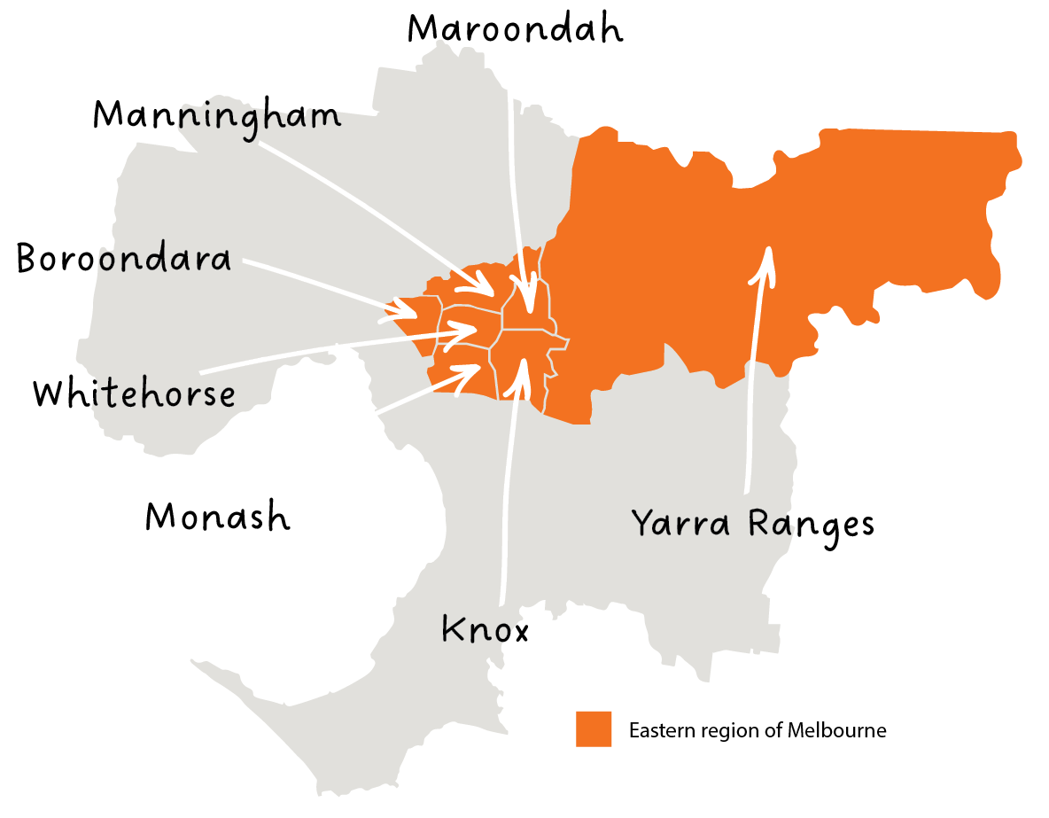

Purpose of this practice asset
This document has been designed to support the work of health workers and other professionals, particularly those working in women’s health or sexual and reproductive health. The practice asset aims to support healthcare professionals to gain an understanding of, and actively contribute to enhancing, the sexual and reproductive health outcomes of girls and women. The focus of this document is primarily, but not exclusively, on Melbourne’s eastern region.

Background
The World Health Organisation describes sexuality as a “central aspect of being human throughout life and encompasses sex, gender identities and roles, sexual orientation, eroticism, pleasure, intimacy and reproduction”. Sexual and reproductive health and rights are important determinants of an individual’s happiness and wellbeing. Yet sexual and reproductive health and rights are still under-discussed and under-researched when it comes to people with disabilities.
This resource aims to address this information gap, highlighting the voices of women with disabilities in Melbourne’s eastern region. The purpose of this practice asset is to connect health workers to current information on the sexual and reproductive health needs and rights of girls, women and gender diverse people with disabilities, with the ultimate aim of achieving sexual and reproductive health equity for this group.

Definitions
Disability is used to describe the “range of physical, cognitive, sensory, psychosocial and other disabilities people experience, including chronic illness”.
Sexual health refers to “a state of physical, emotional, mental and social well-being in relation to sexuality; it is not merely the absence of disease, dysfunction or infirmity”.
Ableism refers to attitudes that lead to harmful or discriminatory behaviour toward people with disabilities. Ableism is “more than just negative and prejudiced attitudes about people with disability. It occurs when prejudice is accompanied by the power to discriminate against, repress or limit the rights of others”.

Statistics
In Australia, around one in five people have a disability. In Victoria, 18.4 per cent of people live with disabilities, 7.7 per cent of whom are under the age of 15. Women are slightly more likely to live with disabilities than men.
The exact number of people with disabilities in Australia is likely higher than these estimates, because people with disabilities are undercounted. Undercounting occurs for many reasons, including people not wanting a diagnosis, identifying with their diagnosis, or considering themselves to have a disability. Societal stigma and shame associated with disability can cause people to avoid identifying with this term. Some people may not have access to information about disability, and some may not be able to access services to obtain a diagnosis because of financial and social barriers.
Further, diagnostic and assessment tools used by medical professionals can be culturally inappropriate and gender-biased. This can create barriers for people with disabilities from other marginalised communities who must navigate multiple forms of structural oppression.
People who face multiple forms of oppression may be more likely to live with disabilities than those in the mainstream population. In one study, the Australian Bureau of Statistics found that 24 per cent of Aboriginal and Torres Strait Islander people surveyed lived with disabilities. An Australian study of 3,853 LGBTQIA+ people found that 33 per cent of trans women lived with disabilities, and that 42 per cent of people who did not identify as male or female lived with disabilities.

Consultation with women with disabilities living in Melbourne’s east
“It’s so important, when you are dealing with a health issue concerning your body, that you don’t feel powerless and exposed by the way you are treated by health staff.”
Margins to the Mainstream Expert and woman with disability

About the Margins to the Mainstream Project
Margins to the Mainstream: Preventing violence against women with disabilities (‘Margins to the Mainstream’) is a project led by Women’s Health East, in partnership with Women with Disabilities Victoria and the Together For Equality and Respect partnership. Margins to the Mainstream commenced in March 2020 and is funded by the Australian Department of Social Services.
Margins to the Mainstream aims to:
- Elevate the voices of women with disabilities and promote their leadership and status in society.
- Challenge intersecting sexist and ableist stereotypes.
- Build the capacity of partners to prevent violence against women with disabilities.
- Contribute to the evidence base of what works to prevent violence against women with disabilities.
The Margins to the Mainstream Experts Group comprises seven women with disabilities living in Melbourne’s eastern suburbs (the Experts). In March 2023, Women’s Health East led a consultation with five of the Experts regarding their sexual and reproductive health priorities, experiences of access to services, and recommendations for improving health worker practice. The findings from this consultation are addressed below.

Issues of concern for women with disabilities
The Experts raised five overarching themes for health professionals to consider:
1 Avoid making assumptions about disabilities; ask women with disabilities what they need.
2 Understand and meet the specific needs of women with disabilities, including invisible disabilities, when providing health services.
3 Prioritise safety in sexual and reproductive health and other health services, and use trauma-informed principles.
4 Understand the appointment requirements for women with disabilities.
5 Address financial barriers to healthcare for women with disabilities.

1 Avoid making assumptions about disabilities; ask women with disabilities what they need.
The Experts referred to negative assumptions, judgements and biases held and expressed by some health professionals that they had interacted with when using the health system in Melbourne’s eastern suburbs. Several Experts felt they had been treated negatively due to looking “visibly disabled”. One Expert, who uses a wheelchair, felt that a health worker perceived her as “too difficult to deal with” when she arrived for an appointment. She was told she needed to rebook her appointment, and felt that this was because of her visible disabilities. She felt she was being overtly discriminated against and that her time and energy had been wasted. Other women with disabilities, including invisible disabilities, described similar experiences of ableism in health appointments. They expressed that this makes it harder for them to return for future appointments.
One Expert recalled other negative experiences when attending medical appointments with her adult daughter, who has disabilities. At these appointments, health workers will often speak directly to the Expert and ignore her daughter altogether. Another Expert shared that clinicians tend to assume she is non-sexual due to her disabilities. The Experts revealed that because of these types of ableist attitudes and practices, they are less likely to attend necessary medical appointments and sexual health screenings, such as cervical screening tests. These experiences of inaccessible healthcare can therefore contribute to poorer health outcomes for women with disabilities.
A major theme raised throughout the consultation was the need for health professionals to listen to women with disabilities, and to recognise their expertise and knowledge about their own health and bodies. The Experts had met with doctors who focused only on their disabilities or medical diagnosis, rather than the specific issues that they had booked an appointment to discuss. This practice is known as diagnostic overshadowing.
The Experts also spoke of occasions when they or family members with disabilities were treated well and with respect. One Expert reported that their family member, who lives with disabilities, had been treated with care, kindness and patience. The family member’s health practitioners spoke to her directly. For the Experts, this kind of experience proved to be particularly memorable and worthy of mention during the consultation as it was not usually the case. The Experts reported having far more negative and ableist experiences than positive and accessible ones when it came to accessing healthcare.

2 Understand and meet the specific needs of women with disabilities, including invisible disabilities, when providing health services.
The Experts emphasised that gender sensitivity was an important part of having their sexual and reproductive health needs met. They discussed the difference between the health-related needs of women and men, including how they differ in terms of the required approach, services, and costs. They perceived similar services as being more expensive for women than they were for men.
The Experts preferred to only interact with female healthcare workers, given the sensitive nature of sexual and reproductive health and their lived experience of violence and trauma. One Expert affirmed, “As soon as I see I’ve got a male doctor, it’s all over”. Several Experts said that as sexual violence survivors, they would not consider going to a psychiatric ward in a hospital, due to the risk of sexual violence by male patients. This is an important consideration in understanding the gendered nature of sexual and reproductive health and other areas of healthcare.
Members of the Experts Group had lodged formal complaints regarding their needs not being met when accessing health services. Typically, these complaints were not actioned by health organisations, requiring further action to escalate complaints, which the Experts felt was a waste of their time and energy. This experience demonstrates that women with disabilities’ rights to make decisions about their own bodies and health requirements are frequently ignored.

3 Prioritise safety in sexual and reproductive health and other health services, and use trauma-informed principles.
Several Experts are survivors of sexual violence. For these individuals, sexual and reproductive health was an especially sensitive and difficult subject to talk about. They spoke of the need for sexual and reproductive health services to be trauma-informed from the very first interaction, and suggested several practices for trauma-informed care.
Firstly, health professionals can show respect for women with disabilities by ensuring they read over each woman’s medical file every time she accesses medical services. This would avoid women having to retell their experiences of violence, which can be triggering and
re-traumatising.
Secondly, staff and services should provide women with disabilities adequate time to make their own choices and decisions regarding sexual and reproductive health procedures. For example, one Expert and survivor of sexual violence described feeling coerced by a doctor to have a Pap smear during a medical appointment, despite not feeling ready to do so. This was an extremely negative experience for her, and she stated that she was unlikely to return for a repeat screening.
Thirdly, doctors and other health professionals should respect the requests made by women with disabilities to have female-only service providers. An Expert described her experience when she was given a male doctor for an appointment, despite specifically requesting a female doctor. When she raised this, the doctor told her that it was appropriate for him to carry out the appointment because the examination she was to have was “not internal”. This caused her to feel dismissed and disrespected, describing the process as being “very triggering”. The Experts provided many examples of their right to choice and decision-making about their healthcare not being upheld, as medical staff ignored and dismissed their needs and explicit requests.
Lastly, an area needing improvement in some clinics is the level of respect and consideration given to the personal information of women with disabilities. The Experts highlighted that attention to privacy and confidentiality is an essential requirement for medical and sexual and reproductive health services. The Experts spoke of having their personal information discussed publicly in front of strangers, especially in shared facilities in hospitals. For example, one participant said that she was asked to provide details about her experience of rape in front of a group of people she didn’t know. Another Expert, who uses a wheelchair, was asked to provide some personal information by a worker sitting at a desk. When she went around the side of the desk to have a more private conversation with the worker, the worker told her to move away from the area as she was “getting in (her) space”.

4 Understand the appointment requirements for women with disabilities.
The Experts noted that they and other women with disabilities often require medical and sexual and reproductive health appointments that are longer than the standard length, but that this was not always possible due to clinical constraints. The Experts stated that longer appointments allow enough time to be adequately informed about an issue and to make their own decisions without being rushed, allowing for equity in health access and information. This was especially true for Pap smears or cervical screening tests. Members of the Experts Group had asked for longer appointment times for these tests but reported that health practitioners often displayed annoyance or frustration at this, which was described as off-putting. This is a systemic issue; health professionals have significant time pressure placed on them with limitations on the time they can spend with each patient, as well as additional complications such as understaffing and COVID-19 risks affecting patient experience.
The Experts noted that client forms provided by medical clinics were not currently meeting their needs. Some changes were suggested to both the format of the forms and the process for filling in these forms, which would improve the experiences of women with disabilities. The Experts suggested that options should be provided for patients to review or fill out paperwork before arriving at their appointment. This would allow them to do this in their own time and in the comfort of their own home. It would also enable women who use screen readers or other assistive technologies to do this more easily and completely. This would reduce the feeling of being rushed to complete forms when at a clinic or requiring support workers, family members or staff to do this, reducing the autonomy of women with disabilities.
The Experts also noted that the space allocated on forms for providing details of medications was often inadequate, as women with disabilities often take a number of medications. Clinic forms do not typically provide space to disclose disabilities or other information that women with disabilities may feel is relevant, if they choose to do so. One Expert referred to a new patient form that asked her to list any diseases she experienced. As autism isn’t a disease, she did not include this when completing the medical form. This may then have negatively impacted her future health experiences and outcomes, as clinicians could not then meet any of her relevant health needs or accessibility requirements.
These experiences – individually and in combination – can result in women with disabilities feeling ostracised and excluded. This can reinforce previous negative experiences they have had in which health services have not adequately responded or catered to their needs.

5 Address financial barriers to healthcare for women with disabilities.
The Experts stated that cost was a major barrier to accessing sexual and reproductive health and other health services. Experts discussed the stark differences between the quality of healthcare at private and public services, in terms of privacy, autonomy, and safety within facilities and services. They strongly preferred private services but were only able to access these when someone else was paying for them, for example, an insurance provider after an accident. Ideally, all services across public and private healthcare should provide the same level of dignity, respect, and safety for patients, including women with disabilities.

Summary
The Margins to the Mainstream Experts described sexual and reproductive health as an important and sensitive component of women’s overall health and wellbeing. Various barriers – including ableist attitudes and practices among staff and organisations – continue to be experienced by the Experts, no doubt reflecting the experiences of other women with disabilities in Melbourne’s east. These barriers impact the quality and effectiveness of services received and contribute to inequity in health outcomes. The Experts generously shared a wealth of feedback and ideas to support sexual and reproductive health workers in providing excellent and equitable healthcare for women with disabilities.

Literature review

What is known already?
In Australia, women with disabilities...
- have poorer sexual and reproductive health outcomes compared to women without disabilities.
- are less likely to receive appropriate sexual and reproductive health support compared to women without disabilities due to discrimination and ableism, including negative attitudes from healthcare workers, inaccessible information and communication, and physical barriers to services.
Gender is an important lens through which to view the sexual and reproductive health and rights of people with disabilities. Women and men experience disabilities differently; women with disabilities face additional disadvantage due to overlapping forms of stigma and marginalisation associated with gender and disability discrimination. In Australia, despite a slightly higher percentage of women living with disabilities than men, women are less likely to be connected with disability services. Women with disabilities are often excluded from romantic relationships, active sexuality, and opportunities for motherhood due to ableist attitudes and prejudices held by Australian society. Although an increasing number of international and national frameworks and policies exist enshrining the human rights of women with disabilities, including the United Nations’ Convention on the Rights of Persons with Disabilities, women with disabilities in Australia continue to experience high rates of systemic violence and discrimination.

Key themes
Several key themes emerged in reviewing the literature on the sexual health priorities of women with disabilities.
These include:
- ableist assumptions and stereotypes directly causing poorer health outcomes
- women’s needs not prioritised by the disability sector
- limited sex education and dismissal of pleasure.

Stereotypes, assumptions, ableism and violence
Women with disabilities experience stereotyping and paternalistic attitudes towards their sexuality and relationships. This includes the misconception that they have less need for sexual and emotional intimacy, and even that they feel less pleasure or pain than women without disabilities. Misconceptions of women with disabilities as non-sexual contributes to the exclusion of this group from sexual health service design and delivery, resulting in significantly poorer health outcomes.
Internationally, people with disabilities have lower levels of contraceptive use, higher rates of sexually transmitted infections and an increased likelihood of unwanted pregnancies when compared to people without disabilities; this is especially true for young people with intellectual disabilities. For example, only 17 per cent of women with intellectual disabilities in Australia have had a cervical screening test, compared to 84 per cent without intellectual disabilities, increasing the chances of cervical cancer in this group. When consulted on this issue, women with disabilities wanted access to relevant information in judgement-free, accessible formats that reflect their rights and desires. Excluding women and girls with disabilities from discussions on their sexual health has significant consequences for their sexual and reproductive health and reduces their empowerment and sexual safety.
Many forms of sexual and reproductive health violence are enacted against women and girls with disabilities. These include, but are not limited to, practices of forced and/or coerced contraception, abortion, and menstrual and sexual suppression, as well as restrictions over pregnancy and child-raising choices. Australia’s Royal Commission into Violence, Abuse, Neglect and Exploitation of People with Disability also heard that women and girls with disabilities continue to be subjected to forced and/or coerced sterilisation, which is irreversible surgery that permanently prevents reproduction. In a report prepared for this Royal Commission, Professor Ron McCallum concluded that the laws of some Australian states and territories need to be urgently changed to prohibit forced or coerced sterilisation.
According to Women with Disabilities Australia, the rights of women with disabilities to make decisions about pregnancy, including abortion healthcare and assisted reproductive technology, and about child-raising, including parenting, adoption, foster care and kinship care, are routinely restricted. This practice is underpinned by a history of eugenics and the assumption that women with disabilities are not fit to be mothers. Currently, the Australian legal, policy and social support environment contributes to the removal of children from parents with disabilities at ten times the rate of parents without disabilities. Internationally, due to the impacts of discrimination, mothers with intellectual disabilities face far higher rates of pregnancy-related distress and custody loss directly after giving birth.
Women and girls with disabilities also experience violence more often, in more settings and perpetrated by a greater range of people, than women and girls without disabilities. Australian research has found that women with disabilities are more than twice as likely to have experienced physical violence in the last 12 months, and twice as likely to experience sexual violence over their lifetime than women without disabilities. Women with disabilities experience many forms of violence related to their gender and disability, including restrictive practices, violence perpetrated by family and carers, and violence in disability services. Violence against women and girls with disabilities is driven by intersecting forms of ableism and gender inequality, including restrictions on women with disabilities’ decision-making and independence, and negative stereotypes, attitudes and assumptions about women with disabilities. Violence against women with disabilities is compounded for women who belong to multiple marginalised groups, requiring an intersectional analysis beyond gender and disability.

Carers as gatekeepers of relationships and rights
Women with disabilities have the same rights and needs as women without disabilities in sexual health and relationships, but they face barriers to enjoying the same outcomes. Most people with disabilities have rewarding intimate, romantic and sexual relationships; some people may need additional support to achieve this. Yet due to stigma or ‘risk aversion’, the sexuality and sexual health of people with disabilities can be deprioritised or ignored by their family and carers. In the disability sector, standardised and non-sexual ‘activities of daily living’ are prioritised and funded, but the sensual or sexual desires of women with disabilities are often disregarded. Privacy and opportunities for sex and relationship building are limited in such heavily regulated spaces. Yet when people with disabilities in Australia were consulted on this topic, they asked to be recognised as “people first, in need of relationships and … support to develop and maintain relationships including … more intimate relationships”. For people with intellectual disabilities in particular, the biggest barriers to enjoyable sexuality and sexual health are biases held by others that lead to restrictions of their sexual expression.
It is vital that girls, women and gender diverse people are provided sufficient and relevant information and resources on their sexual health, as this directly relates to their individual agency. Access to sexual health and sexuality education is a gendered issue, with information and research commonly more available on the sexuality of men with disabilities compared to women with disabilities. There is even less information available on the sexual health needs of trans and gender diverse people. When information is available on the sexual health of women with disabilities, it is often not in accessible formats.
Many people with disabilities are made dependent on others to advise them about their sexual health and rights and what this means in practice. When family and carers avoid discussing this topic, people with disabilities may remain unaware of their human rights. Young people with disabilities are more likely to source information about sex and sexual health from families and carers compared to young people without disabilities. This increases the power of family and carers to act as information gatekeepers, and demonstrates the need for open and honest conversations on this topic.
Already, people with disabilities face intersecting structural stigma and marginalisation in violation of their human rights. Yet the realisation of human rights is directly connected to one’s health. Social support, sexuality education and self-advocacy are the strongest factors in increasing sexual agency for people with disabilities, emphasising the need for this group to be leading and involved in discussions around their sexual health and rights. Young people with intellectual disabilities, for example, have many ideas for increasing their sexual health knowledge and have a lot of skills and knowledge to offer as peer educators.
Women with Disabilities Australia argues that the use of a sexual and reproductive rights framework alone is insufficient for creating meaningful systemic change and equity for women with disabilities. They describe this framework as primarily focused on protecting individual legal rights to sexual and reproductive health services, such as the right to abortion healthcare. This does not necessarily result in the creation of services that are
non-coercive, accessible and equitably distributed. Reproductive justice is a suggested alternative that demands “sexual autonomy and gender freedom for every human being”. This is a holistic framework that places “gender, disabilities and other forms of social justice at its centre” and champions equity in sexual health and rights for women with disabilities. Currently, reproductive justice is a concept frequently discussed in the United States of America but is still emerging in Australia.

Pleasure and sexuality
When families, carers and medical professionals do discuss sexuality and sexual health with women and girls with disabilities, this is usually focused on self-protection, biology and hygiene rather than positive aspects of sex. Conversations are usually deficit-focused, limited to a heterosexual and/or patriarchal perspective, and do not address pleasure or creativity. Women with disabilities are often denied the opportunity to explore their own sexuality, as the standard belief is that this does not exist, which is a bias described as ‘sexual ableism’. A study by Women with Disabilities Australia found that where women with disabilities did receive school-based health education, this was severely lacking in relevant and comprehensive information for people with disabilities. Ninety-eight per cent of respondents said that there was a lack of information on menstrual management relevant to them as people with disabilities. Other Australian research has found that school girls with intellectual disabilities are often taught a version of sexuality based on ‘rules’, rather than the topics they describe as important to them, such as masturbation, gender, and LGBTQIA+ identities. Carers may also shy away from these topics due to stigma.
Access to comprehensive sexual health education is integral in normalising sex for people with disabilities and improving body image; an issue described by women with spinal injury as the biggest barrier to a positive sexual identity after injury. Where women with disabilities are not sufficiently educated about sexuality, many find self-empowerment through sourcing their own information. Women with disabilities described having positive sexual experiences as integral to healing, confidence building, sexual discovery and feelings of freedom. Suggestions for improving sexual health education offered to girls with disabilities include: facilitating a ‘girl’s space’ by a knowledgeable person (not a teacher or parent); consulting students with disabilities about their needs; and creating and prioritising opportunities to explore relationship building. Some adult women with disabilities describe finding peer-based information useful, while others prefer information in books or online written by health professionals.

Summary
Women and girls with disabilities want to learn about their sexual health and rights in ways that are accessible to them, comprehensive, free of shame, and relevant to their individual needs and desires. When families, carers and healthcare workers avoid this topic, this negatively affects the health and wellbeing of women with disabilities and can restrict their human rights. Women and girls with disabilities need to be listened to and respected as experts in their own health and wellbeing.
An increasing number of research papers and projects already record the priorities and desires of women with disabilities regarding their sexual health. Yet there has not been sufficient action on these recommendations. The time has come for Australians without disabilities to regard the sexual health priorities of women with disabilities with the respect and seriousness this deserves.
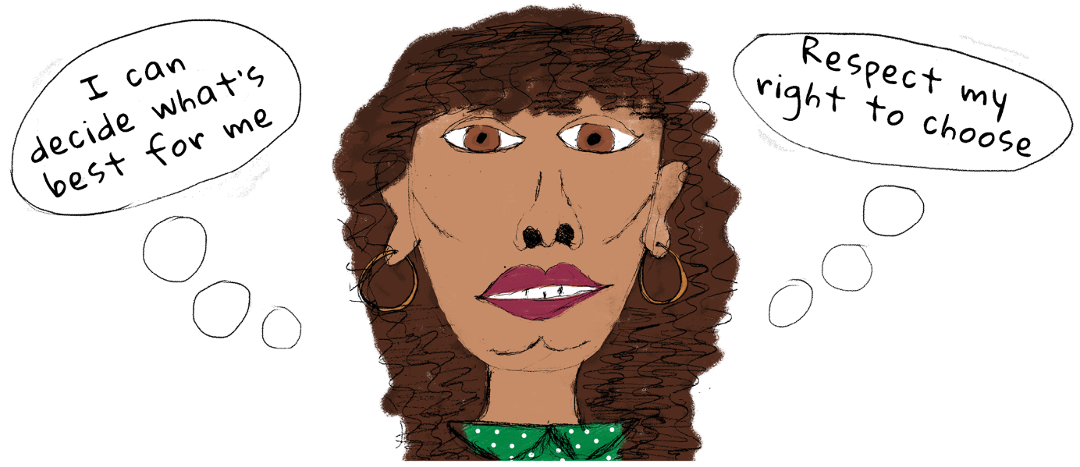

Recommendations
The following recommendations are designed to support healthcare professionals to contribute to the improved sexual and reproductive health outcomes of women and girls with disabilities. These recommendations draw on the findings of the literature review and consultation with women with disabilities in Melbourne’s eastern region.
- Consult on and co-design sexual and reproductive health services and health promotion programs that are responsive to the needs of women with disabilities.
- Invest and train healthcare practitioners and services in accessibility and safety for women with disabilities.
- Contribute to the evidence base on best practice sexual and reproductive health services.
- Ask women and girls with disabilities, including invisible disabilities, about their health needs and priorities, recognising that they are the experts in their own health and wellbeing.
- Ensure that sexual and reproductive health services are trauma-informed and prioritise the safety of women with disabilities.
- Address financial barriers to healthcare for women with disabilities.

Appendix

Literature search parameters
Women’s Health East used the La Trobe University online library and Google Scholar to conduct a literature search. Search terms used to identify relevant material included “women” OR “girls”, AND “disab*”, AND “sex*”, AND “health”. The initial search also included “Australia”; however, this was later removed to increase the literature available.

Literature search inclusion criteria
Material was included if it was in English and focused on the sexual and reproductive health of people or women with disabilities, with publication dates from 2013 to 2023. Findings specific to Victoria and Australia were selected where possible. Literature written by women with disabilities or which highlighted the input of people or women with disabilities were prioritised. In total, 19 papers were included for review. Fifteen are peer-reviewed published journal articles, and four are ‘grey literature’ published by leading organisations in the disability and women’s health sectors.
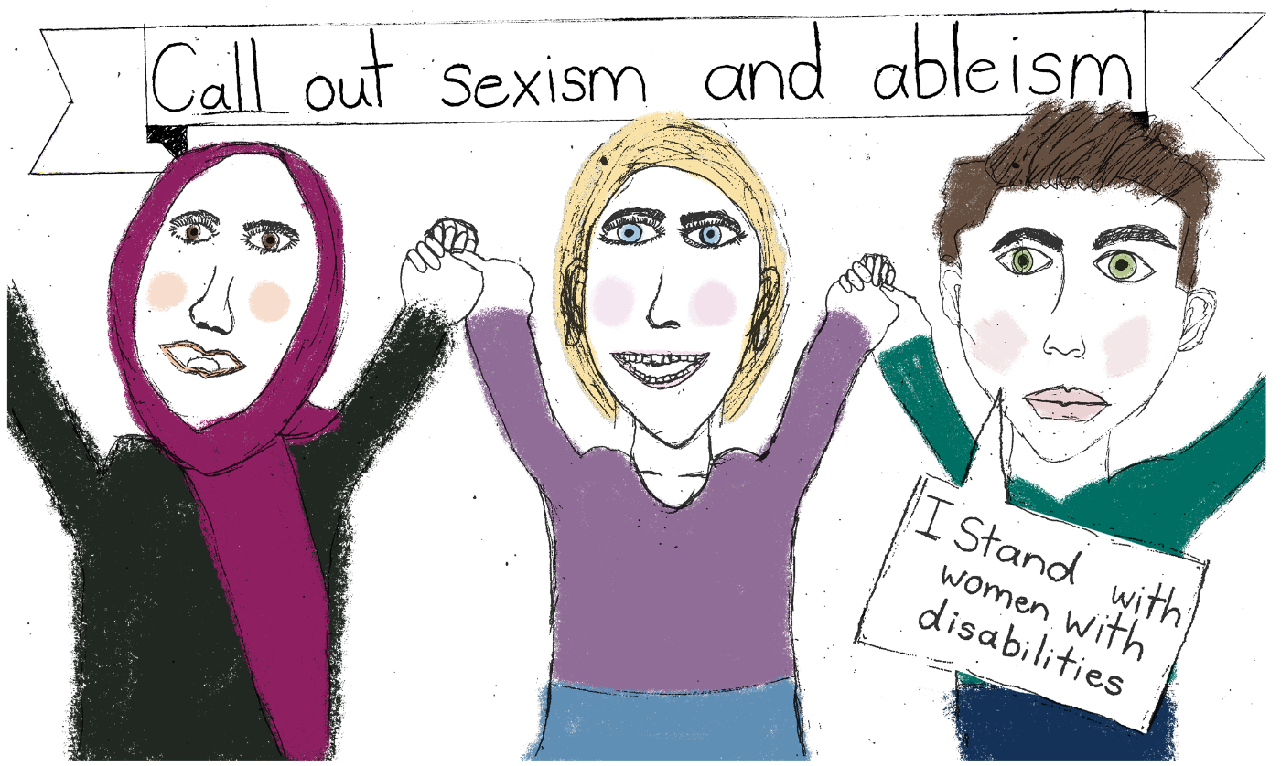

References
Addlakha, R., Price, J., & Heidari, S. (2017). Disability and sexuality: claiming sexual and reproductive rights. Reproductive Health Matters, 25(50), 4-9.
Alexander, N., & Taylor Gomez, M. (2017). Pleasure, sex, prohibition, intellectual disability, and dangerous ideas. Reproductive Health Matters, 25(50), 114-120.
Australian Bureau of Statistics. (2019). Disability, ageing and carers, Australia: Summary of findings. Available from <https://www.abs.gov.au/statistics/health/disability/disability-ageing-and-carers-australia-summary-findings/latest-release>.
Australian Bureau of Statistics. (2021). Aboriginal and Torres Strait Islander people with disability. Available from <https://www.abs.gov.au/articles/aboriginal-and-torres-strait-islander-people-disability>.
Beckwith, A., & Yau, M. K. S. (2013). Sexual recovery: experiences of women with spinal injury reconstructing a positive sexual identity. Sexuality and Disability, 31(4), 313-324.
Bradford, N. J., & Spencer, K. (2020). Sexual pleasure in transgender and gender diverse individuals: An update on recent advances in the field. Current Sexual Health Reports, 12, 314-319.
Carter, A., Strnadová, I., Watfern, C., Pebdani, R., Bateson, D., Loblinzk, J., & Newman, C. (2022). The sexual and reproductive health and rights of young people with intellectual disability: a scoping review. Sexuality Research and Social Policy, 19(1), 372-390.
Centre of Research Excellence in Disability and Health. (2020). Prevalence of violence and abuse of people with disability in Australia.
Commonwealth of Australia. (2023). Royal Commission into violence, abuse, neglect and exploitation of people with disability: Executive summary, our vision for an inclusive Australia and recommendations, final report. September 2023. Available from <https://disability.royalcommission.gov.au/publications/final-report-executive-summary-our-vision-inclusive-australia-and-recommendations>.
Frawley, P., & O’Shea, A. (2020). ‘Nothing about us without us’: sex education by and for people with intellectual disability in Australia. Sex Education, 20(4), 413-424.
Frawley, P., & Wilson, N. J. (2016). Young people with intellectual disability talking about sexuality education and information. Sexuality and Disability, 34(4), 469-484.
Frawley, P., Wilson, N. J., David, J., O’Shea, A., & Areskoug Josefsson, K. (2022). Access to Sexual Health Services and Support for People with Intellectual and Developmental Disabilities: an Australian Cross-sector Survey. Sexuality Research and Social Policy, 1-9.
Frohmader, C. & Ortoleva, S. (2014, July). The sexual and reproductive rights of women and girls with disabilities. In ICPD International Conference on Population and Development Beyond.
James, M. H., Porter, J. E., Kattel, S., Prokopiv, V., & Hopwood, P. (2022). Peer educators in the facilitation of sexuality and respectful relationship education for people with an intellectual disability: A scoping review and narrative synthesis. Sexuality and Disability, 1-16.
Leonard, W., & Mann, R. (2018). The everyday experiences of lesbian, gay, bisexual, transgender and intersex (LGBTI) people living with disability. Rainbow Health Victoria.
Lokot, M. & Avakyan, Y. (2020). Intersectionality as a lens to the COVID-19 pandemic: implications for sexual and reproductive health in development and humanitarian contexts. Sexual and Reproductive Health Matters, 28(1), 1764748.
Maher, J. M., Spivakovsky, C., McCulloch, J., McGowan, J., Beavis, K., Lea, M., Cadwallader, J., & Sands, T. (2018). Women, and violence: Barriers to accessing justice: Final report (ANROWS Horizons, 02/2018). Sydney: ANROWS.
Miller, A. (24 July 2023). In Australian mental health units, women are drugged up, dehydrated and retraumatised. Now they’re speaking out. ABC News. Available from <https://www.abc.net.au/news/2023-07-24/australian-mental-health-units-women-patients-retraumatised/102415280>.
Molloy, R., Munro, I., & Pope, N. (2021). Understanding the experience of diagnostic overshadowing associated with severe mental illness from the consumer and health professional perspective: A qualitative systematic review protocol. JBI Evidence Synthesis, 19(6), 1362-1368.
O’Shea, A. & Frawley, P. (2020). Gender, sexuality and relationships for young Australian women with intellectual disability. Disability & Society, 35(4), 654-675.
Our Watch & Women with Disabilities Victoria. (2022). Changing the landscape: A national resource to prevent violence against women and girls with disabilities. Melbourne, Australia: Our Watch.
Sexual Health Victoria. (n.d.). Cognitive Disability and Sexuality. Available from <https://shvic.org.au/for-you/people-with-a-disability/cognitive-disability-and-sexuality>.
Starrs, A. M., Ezeh, A. C., Barker, G., Basu, A., Bertrand, J. T., Blum, R., et al. (2018). Accelerate progress: Sexual and reproductive health and rights for all: report of the Guttmacher-Lancet Commission. The Lancet, 391(10140), 2642–2692.
State Government of Victoria. (2022a). ‘Framework for trauma-informed practice Supporting children, young people and their families’. Department of Families, Fairness and Housing, Melbourne. November 2022. Available from <https://www.dffh.vic.gov.au/framework-trauma-informed-practice>.
State Government of Victoria. (2022b). About people with disability. Updated March 2022. Available from <https://www.vic.gov.au/state-disability-plan/about-plan/about-people-disability>.
State Government of Victoria. (2023). People with a disability in Victoria.
Department of Families, Fairness and Housing, Melbourne. March 2023.
Retrieved from <https://providers.dffh.vic.gov.au/people-disability-victoria#:~:text=People%20with%20a%20disability%20form%2018.4%20per%20cent%20of%20the%20Victorian%20population>.
Strnadová, I., Danker, J., & Carter, A. (2021). Scoping review on sex education for high school-aged students with intellectual disability and/or on the autism spectrum: parents’, teachers’ and students’ perspectives, attitudes and experiences, Sex Education, 22(3),
361-378.
Treacy, A. C., Taylor, S. S., & Abernathy, T. V. (2018). Sexual health education for individuals with disabilities: A call to action. American Journal of Sexuality Education, 13(1), 65-93.
Women’s Health East. (2023). Asking the Experts: A guide to best practice co-design and consultation with women with disabilities. Melbourne, Australia.
World Health Organisation. (2002). Defining sexual health: Report of a technical consultation on sexual health. In vol. 2010. vol. 25 April. Geneva.
World Health Organisation. (2023). Sexual health: definitions. Available from <https://www.who.int/health-topics/sexual-health#tab=tab_2> accessed 5 January 2023.
Women With Disabilities Australia. (2022). Towards Reproductive Justice for young women, girls, feminine identifying, and non-binary people with disability (YWGwD): Report from the YWGwD National Survey. Published November 2022. WWDA: Hobart, Tasmania. Available from <https://wwda.org.au/publication/youth-sexual-health-and-reproductive-rights-report-and-resources/>.
Women with Disabilities Victoria. (2021). Sexual and Reproductive Health: Accesex. Available from <https://www.wdv.org.au/our-work/our-work-with-organisations/sexual-and-reproductive-health-2/> accessed 20 December 2022.
Yates, S., Carey, G., Hargrave, J., Malbon, E., & Green, C. (2021). Women’s experiences of accessing individualized disability supports: gender inequality and Australia’s National Insurance Scheme. International Journal for Equity in Health, 20(1), 243–243.


Women’s Health East
Wurundjeri Country
1/125 George Street, Doncaster East VIC 3109
(03) 9851 3700
health@whe.org.au
Women’s Health East website <www.whe.org.au>
Women’s Health East acknowledges the
support of the Victorian Government.


World Health Organisation 2002, p. 4.
Starrs et al. 2018.
Treacy et al. 2018.
Our Watch & Women with Disabilities Victoria 2022, p. 20.
World Health Organisation 2023, p. 28.
Commonwealth of Australia 2023.
Australian Bureau of Statistics 2019.
State Government of Victoria 2023; State Government of Victoria 2022b.
Australian Bureau of Statistics 2019.
Our Watch & Women with Disabilities Victoria 2022.
Australian Bureau of Statistics 2021.
Leonard & Mann 2018.
Women‘s Health East 2023, p. 3.
More information on the Margins to the Mainstream project and Experts Group can be found in the Women’s Health East resource Asking the Experts: A guide to best practice co-design and consultation with women with disabilities (2023).
Women with Disabilities Victoria 2021.
Molloy et al. 2021.
This is echoed by Dr Astha Tomar, chair of the Royal Australian New Zealand College of Psychiatrists Victorian Branch, who states that “mixed-gender units increase a woman’s risk of gender-based violence” (Miller, 2023).
Trauma-informed practice is an “approach that recognises that trauma is common and that people accessing services and people delivering services may be affected by trauma. Trauma-informed practice is an approach that is holistic, empowering, strengths-focused, collaborative and reflective. It promotes physical, emotional, spiritual and cultural safety” (State Government of Victoria, 2022a, p. 9).
Women with Disabilities Victoria 2021.
Women with Disabilities Victoria 2021.
Frohmader & Ortoleva 2014.
Yates et al. 2021.
Addlakha et al. 2017.
Women with Disabilities Australia 2022.
Literature search parameters and inclusion criteria can be found in the Appendix.
Alexander & Gomez 2017; Beckwith & Yau 2013.
Carter et al. 2022; Treacy et al. 2018; Addlakha et al. 2017.
Women with Disabilities Victoria 2021.
Beckwith & Yau 2013; O’Shea & Frawley 2020.
Treacy et al. 2018; Maher et al. 2018; Carter et al. 2022.
Women with Disabilities Australia 2022, p. 1.
Forced sterilisation refers to the “performance of a procedure which results in sterilisation in the absence of the prior, free, and informed consent of the individual who undergoes the procedure”. Coerced sterilisation occurs when “financial or other incentives, misinformation, misrepresentation, undue influences, pressure, and/or intimidation tactics are used to compel an individual to undergo the procedure” (Women with Disabilities Australia, 2022).
Commonwealth of Australia 2023.
Women with Disabilities Australia 2022, p. 19.
Alexander & Gomez 2017.
Women with Disabilities Australia 2022, p. 19.
Brown et al. in Carter et al. 2022.
Our Watch & Women with Disabilities Victoria 2022.
Centre of Research Excellence in Disability and Health 2020.
Our Watch & Women with Disabilities Victoria 2022; Addlakha et al. 2017; Frohmader & Ortoleva 2014; Commonwealth of Australia 2023.
Our Watch & Women with Disabilities Victoria 2022.
Women with Disabilities Australia 2022; Lokot & Avakyan 2020; Alexander & Gomez 2017.
Carter et al. 2022; O’Shea & Frawley 2020.
Sexual Health Victoria n.d.
Commonwealth of Australia 2023.
Addlakha et al. 2017; Alexander & Gomez 2017.
Beckwith & Yau 2013; Frawley & Wilson 2016; Sexual Health Victoria n.d.; Treacy et al. 2018.
Alexander & Gomez 2017, p. 116.
Frawley et al. 2022.
Women with Disabilities Australia 2022; Maher et al. 2018.
Beckwith & Yau 2013.
Bradford & Spencer 2020; Leonard & Mann 2018.
Women with Disabilities Victoria 2021.
Alexander & Gomez 2017.
Carter et al. 2022; Frawley & Wilson 2016.
Carter et al. 2022.
Carter et al. 2022.
Carter et al. 2022.
Carter et al. 2022; Frawley & O’Shea 2020.
Carter et al. 2022; James et al. 2022.
Women with Disabilities Australia 2022, p. 45.
Women with Disabilities Australia 2022, p. 45.
Ross in Women with Disabilities Australia 2022, p. 8.
Women with Disabilities Australia 2022, p. 45.
Women with Disabilities Australia 2022.
Alexander & Gomez 2017; Beckwith & Yau 2013; Frawley & Wilson 2016.
Leonard & Mann 2018.
Addlakha et al. 2017; Women with Disabilities Australia 2022; Alexander & Gomez 2017; Women with Disabilities Victoria 2021.
Gill in Frawley & O’Shea 2020; Addlakha et al. 2017.
Women with Disabilities Australia 2022.
Women with Disabilities Australia 2022, p. 34.
Frawley & Wilson 2016.
Alexander & Gomez 2017.
Treacy et al. 2018; Sexual Health Victoria n.d.
Beckwith & Yau 2013.
Beckwith & Yau 2013; Frawley & Wilson 2016.
Beckwith & Yau 2013; Addlakha et al. 2017.
Frawley & Wilson 2016; Strnadová et al. 2021.
Beckwith & Yau 2013.
Maher et al. 2018.

