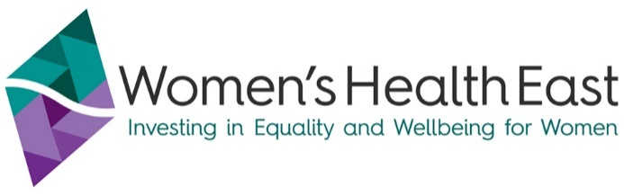

Closure of Speaking Out Program: Advocacy To End Family Violence & Sexual Assault
It is with great sadness, Women’s Health East advise the innovative and powerfully effective Speaking Out Program will close at the end of August 2020.
The Speaking Out Program has been elevating the voices of women who have experienced family violence and or sexual assault since its inception in 2011, with an aim to shift the public discourse and public policy about violence against women and its prevention.
Unfortunately our time limited grant supporting the Speaking Out Program in recent times has come to an end and Women’s Health East has had to make the very difficult decision to wind up the program.
Women’s Health East and our partners, EDVOS and the Eastern Centre Against Sexual Assault, are extremely proud of the many achievement of this program, thanks to the incredible women who share their stories to build community understanding of violence against women, how to prevent it, and how to improve our service systems.
Over the life of the program, 55 women have been trained and supported to become change agents, 30 of who remain actively engaged today. These courageous advocates have been speaking out in the community for almost 10 years, undertaking over 1000 advocacy engagements. These have included public speaking, media interviews, sitting on family violence committees and co-designing programs and services as a part of government reforms.
The program was initially established to respond to concerns about the way in which violence against women was portrayed in the media. Since its inception we have seen significant improvement in the language used in reporting, in the linking of family violence to the broader societal issue of gender equality, in the centring of people with lived experience in articles and the following of ethical reporting guidelines. We know this program has played an important part in this change through the incorporation of women’s stories and through our education of journalists and the broader community.
Speaking Out advocates have played a significant role in shaping government reforms and community level programs and services. A selection of highlights are included at the end of this statement.
We would like to sincerely thank all of the women who have been involved in the program, for your courage and generosity in sharing your stories, for your time and commitment and your invaluable knowledge that you have shared so powerfully to affect change.
Thank you also to those who have accessed the program and provided opportunities for women to speak out – journalists, organisations, corporations, essential services, courts, politicians, and government departments, to name a few.
Undoubtedly the program has left a legacy that will inform the elevation of the voices of victim survivors in the future. This includes the Voices for Change manual which outlines how to run a media advocacy program for the prevention of violence against women, and contributing to the recently released Family Violence Experts by Experience Framework.
Women’s Health East recognises that violence against women remains a significant societal issue, and that the risk of violence against women has increased during the pandemic. We know there is much work to be done and our commitment does not wane. We will continue to lead the Together For Equality & Respect regional partnership for the prevention of violence against women. The prevention of family violence and sexual abuse will continue to be one of our core priorities.
Kristine Olaris
Chief Executive Officer

If you, or anyone you know if experiencing family violence please call 1800RESPECT (1800 737 7320) 24hrs.
In an emergency please call Police on 000.
For crisis support across Victoria 24/7 days a week, contact safe steps Family Violence Response Centre on 1800 015 188, or visit the website: www.safesteps.org.au
A selection of Speaking Out highlights:
- Support to media reporting of violence against women (print, radio, television)
- Speaking to secondary schools on the important issue of consent from the perspective of a victim survivor
- Listening Day in parliament, organised by the late Fiona Richardson, where advocates spoke of their experiences to politicians and others
- Advocates standing alongside the Premier presenting the reports of the Royal Commission into family violence
- A round table consultation with the UN Special Rapporteur on Violence Against Women
- A video for Victoria Police to build understandings of family violence
- Participation in the Victim Survivor Advisory Council, and other committees of government, and boards and committees at local levels ensuring a victim centric approach
- ‘Busting the myths to change the story’ video
- Magistrates Court Victoria consultation on the potential introduction of new ways to assist victims with access to information whilst in the court building
- Thriving Communities Partnerships Family Violence Roundtable where more than 170 participants engaged with 13 advocates to consider ways in which businesses could better respond to people impacted by family violence and build a better understanding of prevention
- Eleven advocates working with CBA and Good Shepherd to inform the development of a responsive financial advice program for women who have experienced financial abuse

