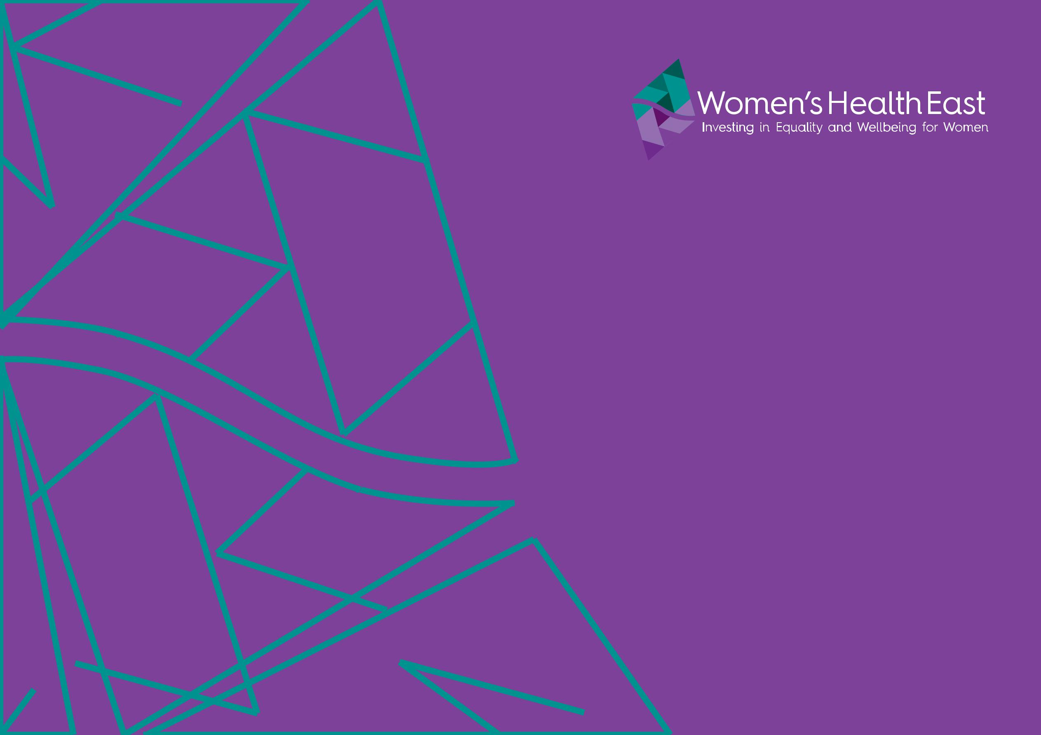

Strategic Plan

2017-2021

Women’s Health East | Strategic Plan 2017-2021 1


Contents

Introduction by the chair |  | 3
Who we are |  | 4
What we do |  | 5
Our region |  | 6
Our context |  | 8
Our strategic priorities |  | 10
1. | Advance gender equality | 12
2. | Prevent violence against women | 15
3. | Improve women’s sexual and | 18
 | reproductive health
4. | Strengthen our dynamic and | 21
 | sustainable organisation

Women’s Health East acknowledges the Wurundjeri people, the traditional owners of the land on which we work.

Women's Health East

acknowledges the support of

the Victorian Government.

2 Women’s Health East | Strategic Plan 2017-2021

Introduction by the Chair

This strategic plan comes at a time of unprecedented change and reform in Victoria.


There is a clear and pressing need in our region for continued attention in many areas of women’s health promotion. It is evident, however, that the priority issues for women have not changed. While women continue to face discrimination because they are women, while barriers continue to exist to women’s choice, freedom and control regarding their sexual and reproductive health, and while women’s lives continue to be marred by violence, we know there is still important work to be done.

Women’s Health East is proud of our achievements over the last four years. The recognition of Women’s Health East as leaders and experts in women’s health and wellbeing, and the trusting and solid partnerships we have fostered, mean that Women’s Health East is well prepared to meet the challenges and opportunities that will arise over the next four years.

The Women’s Health East Board of Governance has identified four strategic priorities for the next four years, on which we will focus our efforts and resources. These are to:

- advance gender equality;

- prevent violence against women;

- improve women’s sexual and reproductive health; and

- strengthen our dynamic and sustainable organisation.

We are undertaking our strategic plan within an outcomes framework, to better plan for and measure the achievement of the real and lasting impacts we seek to have on women’s lives. We are committed to reviewing this strategic plan annually, to respond flexibly to new and emerging evidence and opportunities as they arise.

Lisa Dunlop

Chair

Women’s Health East | Strategic Plan 2017-2021 3

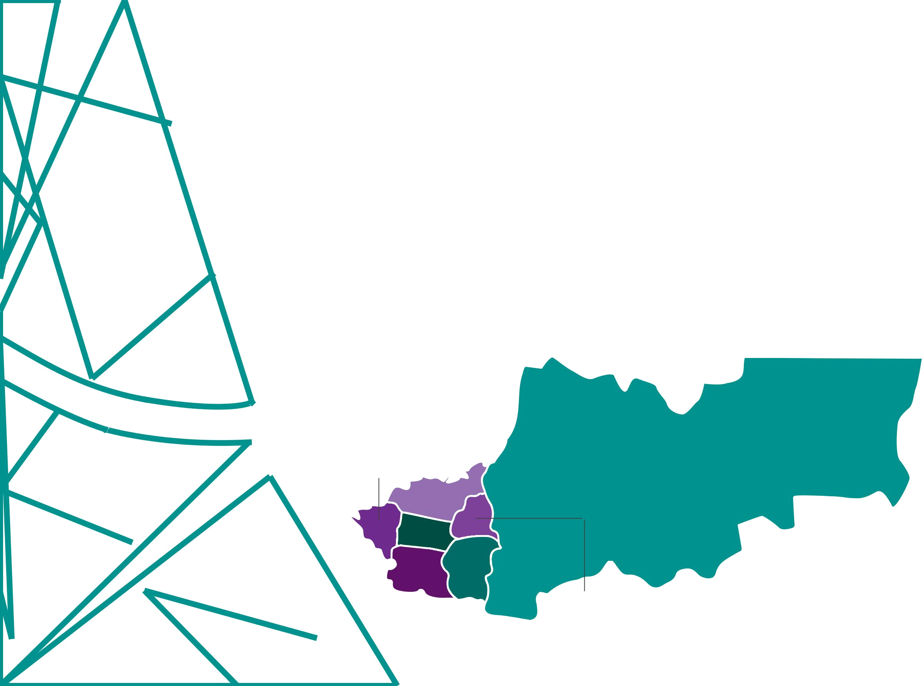
Who we are Our vision

Women’s Health East is the women’s health promotion

agency for the Eastern Metropolitan Region (EMR) of

Melbourne. We improve health outcomes for women

across the seven local government areas of Yarra Ranges,

Knox, Maroondah, Manningham, Monash, Whitehorse and

Boroondara. Women’s Health East also influences women’s

health and wellbeing at a statewide and national level.

Women’s Health East is a part of the women’s health

sector. We are one of nine regional women’s health services

who together have reach across the entire state.

We also partner in our work with the three statewide

services, Women’s Health Victoria, Women with Disabilities

Victoria and the Multicultural Centre for Women’s Health.

Boroondara

Manningham

Whitehorse

Monash ^{Knox}

Maroondah

Equality, empowerment, health and wellbeing for all women.

Our purpose

Women’s Health East drives action to build an equitable society. Guided by evidence and informed by women’s lived experiences, we strengthen the capacity of the community to improve women’s health and wellbeing.

Yarra Ranges

4 Women’s Health East | Strategic Plan 2017-2021

What we do

Working within a feminist framework, Women’s Health East address the social, cultural, economic, political and environmental factors impacting on the health, safety and wellbeing of women in the region. We build the capacity of organisations, services and programs in the region to optimally address issues affecting women.

To achieve this, we partner with state and local governments, health and community organisations, and others with a role in improving health outcomes for women.

With a focus on our region we:

- Provide leadership, expertise and support to initiatives addressing our key priorities;

- Facilitate collaborative, integrated

responses to our key priorities;

- Implement and support an intersectional approach to women’s health promotion;

- Enhance the capacity of our partners to improve service system access and responsiveness for all women;

- Shape responses to women’s health and wellbeing needs through the translation of evidence into practice, advocacy, consultancy and research;

- Influence public policy and the public discourse on issues relevant to improving health outcomes for women; and

- Deliver training and education programs, opportunities for collective learning, resources and support to build workforce and organisational excellence in women’s health and wellbeing.


Women’s Health East | Strategic Plan 2017-2021 5


Our region

The Eastern Metropolitan Region had an estimated population of 1,077,573 in 2016.

The Eastern Metropolitan Region of Melbourne spans some

3000 square kilometres. The estimated population of the

Eastern Metropolitan Region in 2016 was 1,077,573. The

estimated number of females in the region was 548,756,

making up approximately 51% of the population.

The total population in all local government areas and for

the region overall is set to increase over the next 15 years to

1,230,780 people. It is expected that Monash and Whitehorse

will see the largest increases in population. The population

of women is expected to continue to age, with the largest

increases being in the 65 years and over age group.

The region has diverse ethnic, socio-economic groups within

the population, with varied access to resources and support

across Melbourne’s East. The region is predominantly urban

however the municipality of Yarra Ranges includes many

rural areas which face significant service access issues.

The largest female populations of those identifying as

Aboriginal or Torres Strait Islander reside in the Yarra

Ranges, followed by Maroondah and Knox. Settlement

reports show that China and India are among the top five

countries of birth of females who have recently settled into

the region’s local government areas, with large numbers

residing in Monash, Whitehorse and Boroondara.

Of females arriving through the humanitarian migration stream, the greatest proportion were born in Burma, with most settling in Maroondah and Yarra Ranges.

The region is generally considered one of relative advantage. While this is true there are significant pockets of disadvantage in every municipality. Within our community and the broader society there are some groups of women who face greater levels of disadvantage and discrimination. These include Aboriginal women, immigrant and refugee women, women of diverse sexual and gender identities, women experiencing socio-economic disadvantage and women with a disability. There are around 38,844 lone-parent households in the region, predominantly headed by females. Single mothers remain one of the most economically disadvantaged groups in Australia.

The region has many natural attributes – parks, national parks, state forests. Many areas of the region have limited public transport options. Major employers are retail, manufacturing, health care and social assistance, and property and business services industries. Agriculture and tourism are important industries in the Yarra Ranges. Family violence, social exclusion and affordable housing are priority issues which have been jointly identified for collective action by the Eastern Metropolitan Social Issues Council.

6 Women’s Health East | Strategic Plan 2017-2021

18% of Victoria’s population live in the Eastern Metropolitan Region.

Its population will grow to 1,230,780 by 2031.
3,977 people
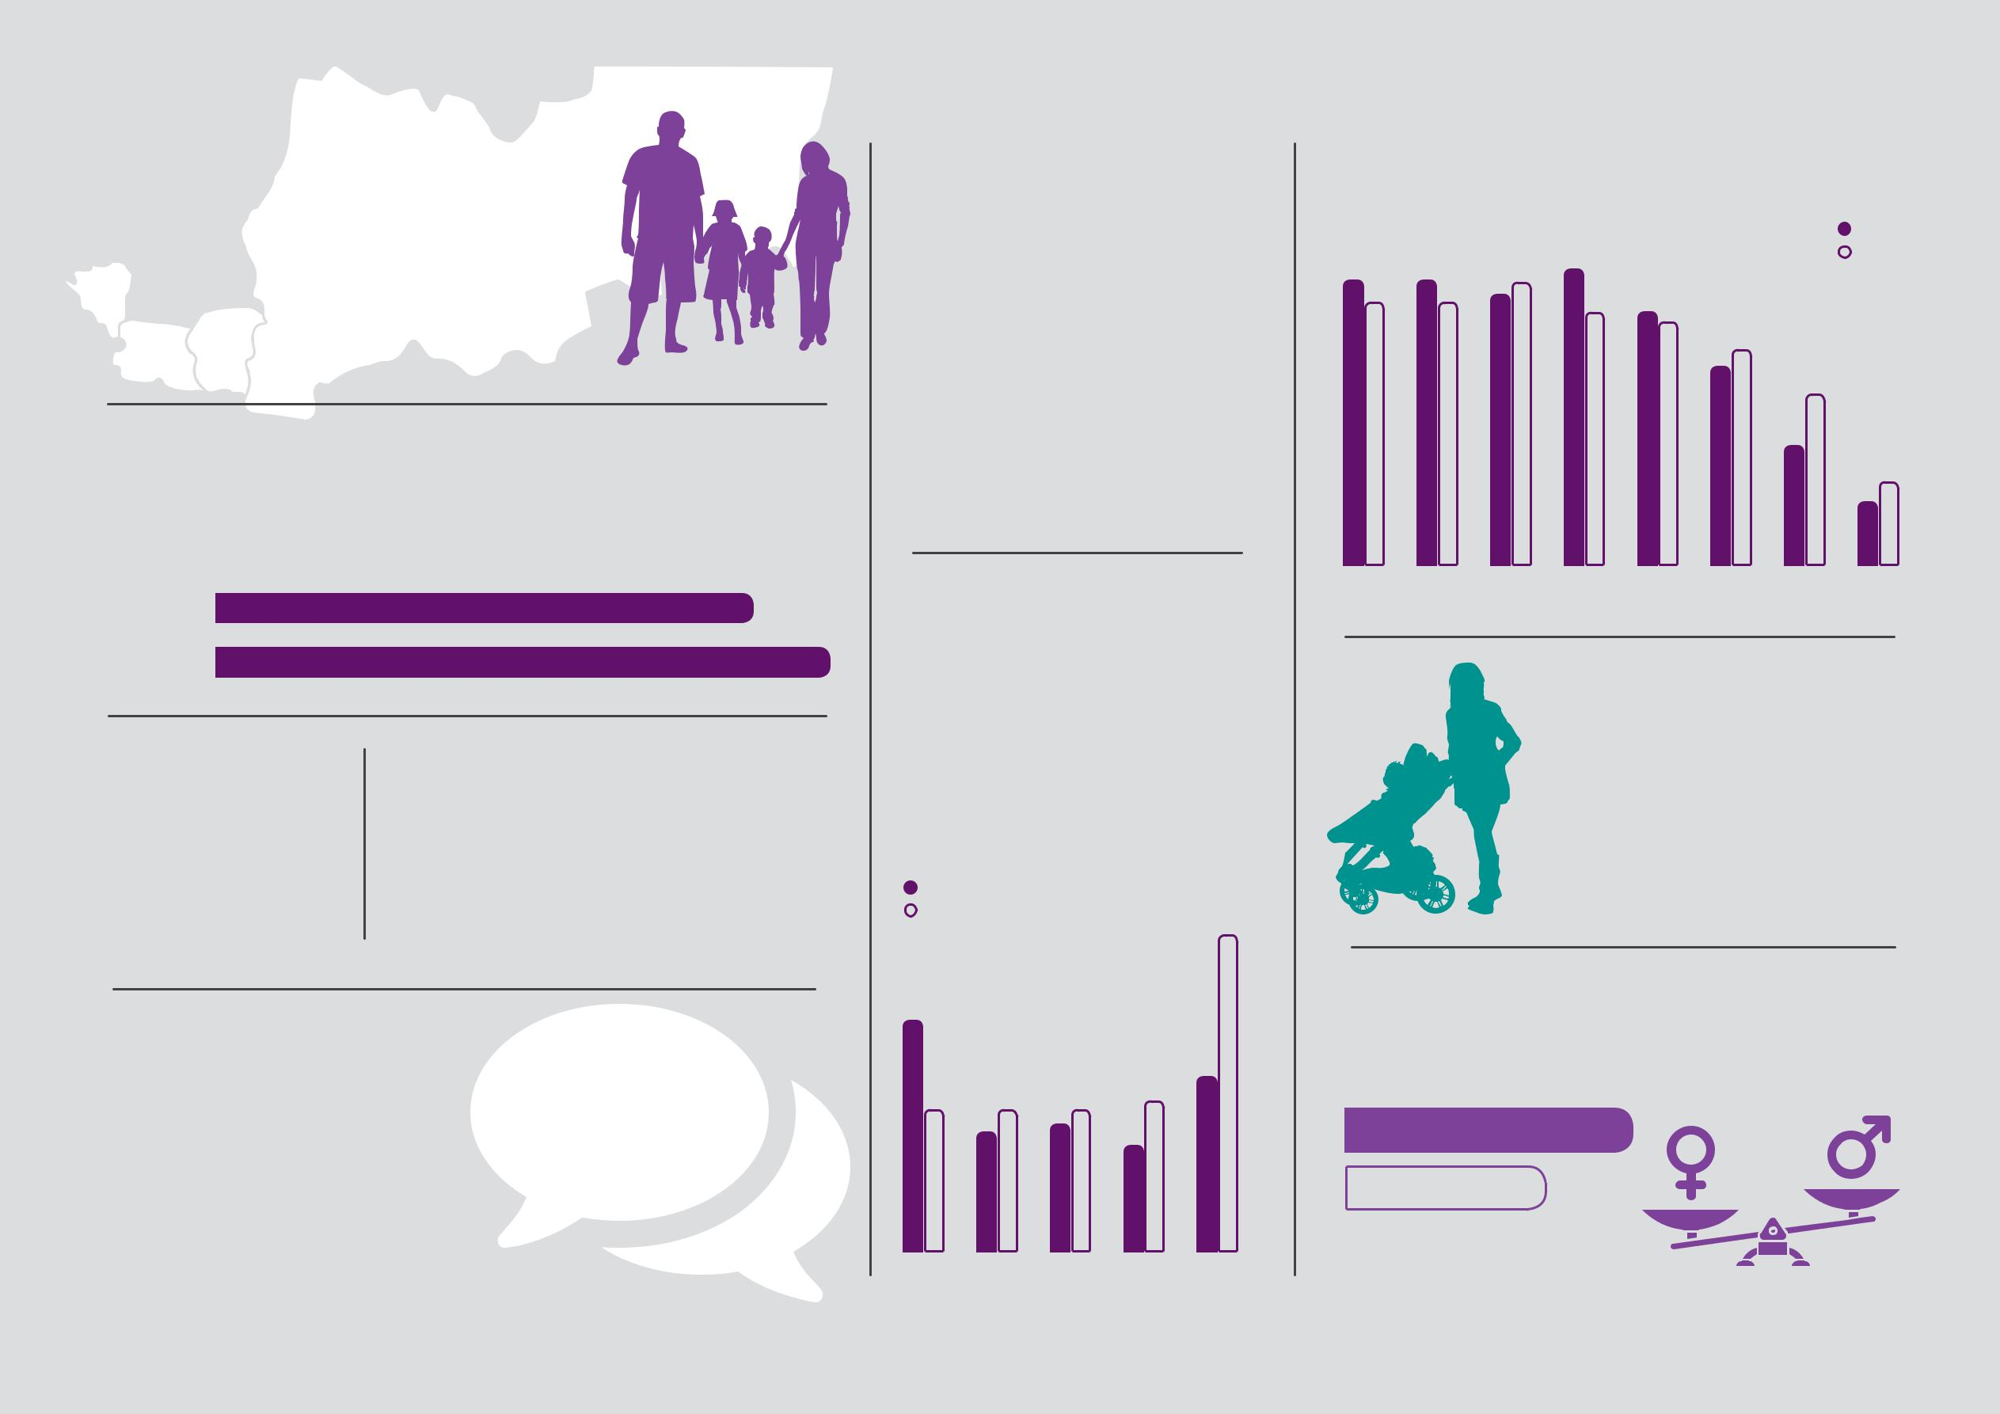
identify as

Aboriginal and/

or Torres Strait

Islander. 34%

live in the Yarra

Ranges.

Age structure of females 15 years and over in the Eastern Metropolitan Region.

13.5%5%12. | 13.6%12.5% | 12.8%13.4% | 14%12% | 12%6%11. | 9.4%3%10. | 2016
 |  |  |  |  |  | 1%8.
 |  |  |  |  |  | 2031

4% 3% 7%5.

2016

2031

At least 25% of the EMR’s population born overseas

in a non English speaking country.

Population ageing is expected over the next 15 years, with the age structure shifting more towards the 65 years and older age groups.

Age structure of females 15 years and over who identified as Indigenous in the Eastern Metropolitan Region in comparison to those who identified as non-Indigenous.

ATSI-indentified | 9%29.
Non-Indigenous | 9%29.
21.4%

15-24 25-34 35-44 45-54 55-64 65-74 75-84 85+

There are 38,844 lone-parent households, with the majority (82%) headed by women.

Main languages other than English spoken at home are Mandarin, Cantonese, Greek, Italian and Sinhalese

13.3% | 11.1%13.1% | 4%11.13.3% | 1%10.2%14. | 16.3%

15-24 25-34 35-44 45-54 55+
Females and males in the Eastern Metropolitan Region with a total personal income of less that $650 per week.

53.3%

37.8%

Females
Males

Women’s Health East | Strategic Plan 2017-2021 7

Our context

This strategic plan has been developed during an exciting time of immense change and transition in Victoria.

This rapidly evolving environment brings numerous

opportunities and some challenges to Women’s Health

East and our partners.

Many major statewide health plans and reforms have a

direct alignment with the priorities of Women’s Health

East, thereby offering a myriad of opportunities for

improving women’s health and wellbeing. These

include the Victorian Public Health and Wellbeing Plan

2015–2019, Women’s Sexual and Reproductive Health:

Key Priorities 2017-2020, the recommendations of the

Royal Commission into Family Violence, Ending Family

Violence: Victoria’s Plan for Change, Safe and Strong: A

Victorian Gender Equality Strategy, and Free From Violence:

Victoria’s strategy to prevent family violence and all forms

of violence against women.

The increased focus on intersectionality in these

policies and plans - that is the recognition of the

complex and compounding impacts of the various forms

of discrimination - provides a rich area for leadership

for Women’s Health East in our region, in all of our

priority areas.

The impending establishment of a statewide Prevention

Agency will drive an enduring and coordinated

approach to the prevention of violence against women

and family violence and the promotion of gender

equality across the state. This is something we have been advocating for in this region. We anticipate that this reform will result in investment and support to local and regional efforts to prevent violence against women and promote gender equality.

While the engagement of local governments in the prevention of violence against women in this region is strong, the family violence reforms have also resulted in a new requirement for local governments to include a focus on family violence prevention and response in their 2017-2021 Municipal Public Health and Wellbeing Plans. Indeed, the commitment to the prevention of violence against women and promotion of gender equality remains clear in organisations and communities across the Eastern Metropolitan Region, underlining the importance of our ongoing role in leading the Together for Equality and Respect Partnership (TFER), and in supporting work to promote gender equality.

A key challenge of the expanding interest and engagement in the prevention of violence against women is the development of a growing workforce with skills and capabilities to implement this work.

Women’s Health East’s role in capacity building will be important to build and support the prevention workforce in our region.

8 Women’s Health East | Strategic Plan 2017-2021

The unprecedented investment and reforms in family violence is also resulting in significant growth and change in the manner in which services respond

to family violence and should result in important improvements for women experiencing violence. The Speaking Out program, led by Women’s Health East, is adding value to the co-design of prevention and response reforms and ensuring that the voices of women who have experienced violence are central to change processes. Speaking Out advocates are actively engaged in state government and local committees developing new ways of addressing this serious and prevalent issue.

Interest and engagement in improving women’s sexual and reproductive health is also on the agenda of organisations across the region, supported by Women’s Health East’s regional needs analysis and the prioritising of this area of women’s health by the state government. We anticipate that this will be a burgeoning area of focus in the region over the next four years.

Other key policies include Victoria’s 10-year Mental Health Plan, Roadmap for Reform: Strong Families, Safe Children, Victoria’s Multicultural Policy Statement: Victorian and Proud of It, and Koolin Balit: Victorian Government Strategic Directions for Aboriginal Health 2012-2022.

A variety of other sector reforms have been underway and continue into this planning cycle, impacting on the services with whom we work and the community. These include a shift away from Government as a deliverer of services, a move to more consumer driven models of care, reform and consolidation of the community, aged care, mental health sectors and the National Disability Insurance Scheme.

While some of these policies and reforms acknowledge the role of gender and gender inequities in shaping the different experiences of health and the health sector, the application of a gender lens requires greater attention. This reinforces the need for Women’s Health East to continue to advocate for a gendered focus on all areas of health policy and its implementation.

Regionally, there are also changes in the landscape and boundaries of formal partnerships, including Primary Health Networks and the Metropolitan Partnerships, and an increasing emphasis on ‘places’ and ‘people’ to drive solutions to community problems at the local level.

The growing use of digital technology in the field of health promotion is another area of opportunity for promoting women’s health and wellbeing.

The rapidly changing online environment and technologies provide an array of avenues for communicating about key issues for women and for expanding our reach.

The context in which we have developed the Women’s Health East Strategic Plan 2017 – 2021

is clearly one of rich opportunities. In this environment of significant change there are also uncertainties and challenges. At Women’s Health East we believe

that our solid reputation, demonstrated expertise, ability to be nimble and flexible, and the strength of our partnerships will enable us to capitalise on this environment to advance women’s health and wellbeing.

Women’s Health East | Strategic Plan 2017-2021 9

Our strategic priorities

There is a clear and pressing need for continued attention in many areas of women’s health promotion in our region.

Women’s Health East has a large geographical remit

and growing and diverse population. With the current

policy context, and the challenging and fluid environment

in which we are operating, it is vital that we can be nimble

and direct our limited resources to where we can have

the maximum impact on women’s health outcomes.

Accordingly, the Women’s Health East Board has set four

strategic priorities for the organisation’s work over the

next four years. These are to:

These four strategic priorities will enable Women’s Health East to respond to the challenges and opportunities in the current environment and maximise our influence and impact.

- Advance gender equality

- Prevent violence against women

- Improve women’s sexual and reproductive health

- Strengthen our dynamic and sustainable organisation

10 Women’s Health East | Strategic Plan 2017-2021

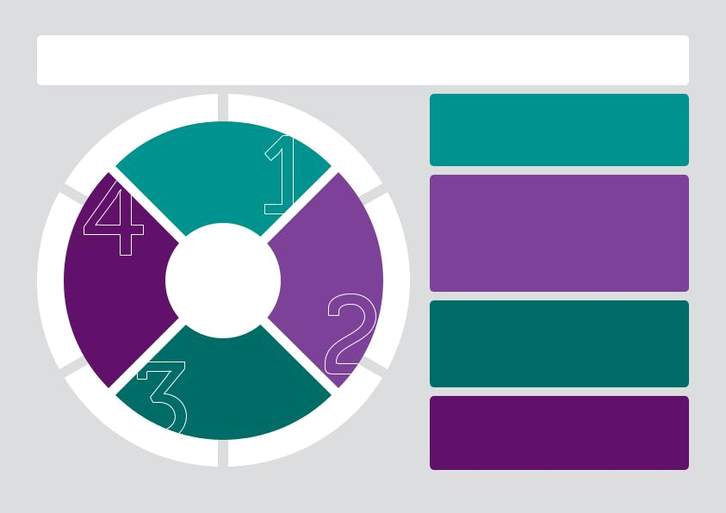
Women’s Health East drives action to build an equitable society. Guided by evidence and informed by women’s lived experiences, we strengthen the capacity of the community to improve women’s health and wellbeing.

S
T
H
I G
R
N
A
M
U

H

S O C I A L

J U
S T I C
E

Outcomes of priority one

Women experience increased equity and decreased discrimination.

Women can equitably participate in inclusive and liveable communities.

T
C
E

P
S
E
R

Advance gender

equality

Strengthen our | Our vision
Strengthen our | Equality,
dynamic & | Equality, | Prevent violence
dynamic & | empowerment, | Prevent violence
sustainable | empowerment, | against women
sustainable | health & wellbeing | against women
organisation | health & wellbeing
organisation | for all women.

 |  |  |  |  | Improve |  |  |  |  |  |  |  |  |  |  |  |  | N
 |  |  |  |  | women’s sexual |  |  |  |  |  |  |  |  |  |  |  | O | N
 |  |  |  |  | & reproductive |  |  |  |  |  |  |  |  |  |  | I | O
 |  |  |  |  |  |  |  |  |  |  |  |  |  |  | T
 |  |  |  |  |  |  |  |  |  |  |  |  |  | A
 |  |  |  |  | health |  |  |  |  |  |  |  | R
I |  |  |  |  | health |  |  |  |  |  |  |  | O
I |  |  |  |  |  |  |  |  |  |  |  |  | B
N |  |  |  |  |  |  |  |  |  |  |  |  | B
N |  |  |  |  |  |  |  |  |  |  |  | A
N
N |  |  |  |  |  |  |  |  |  |  |  | L
O |  |  |  |  |  |  |  |  |  |  |  | L
 |  |  |  |  |  |  |  |  |  |  |  | L
 |  |  |  |  |  |  |  |  |  |  |  | O
 | V
 |  | A |  |  |  |  |  |  |  |  |  | C
 |  | T |  |  |  |  |  |  |  |  |  | &
 |  |  | I |  |  |  |  |  |  |  | P
 |  |  |  | O
 |  |  |  |  | N |  |  |  |  |  | I | S
 |  |  |  |  |  |  |  |  |  | H
 |  |  |  |  |  |  |  |  | S
 |  |  |  |  |  |  |  | R
 |  |  |  |  |  |  | E
 |  |  |  |  |  | N
 |  |  |  |  | RT
 |  |  |  |  | PA

D
I
V
E
R
S
I
T
Y
&
I
N
C
L
U
S
O I

N

Outcomes of priority two

Women benefit from coordinated, evidence informed action to prevent violence.

Organisations and their workforces have skills and knowledge to effectively prevent violence against women.

Prevention initiatives are informed by voices of women.

Outcomes of priority three

Women in the EMR benefit from coordinated action to address their sexual and reproductive health and rights.

Women in EMR have improved access to reproductive choices.

Outcomes of priority four

Women’s Health East is a leader in women’s health.

Women’s Health East is a strong and sustainable organisation.

Women’sWomen’s HealthHealth EastEast || StrategicStrategic PlanPlan 20172017--20212021 1111


Advance gender equality

Advancing gender equality underpins all of our work at Women’s Health East.

The World Health Organisation identifies

social position as the factor that most

determines health inequities, and

discrimination based on gender as one

of the key factors influencing social

position. This makes gender equality an

essential focus of effective population

health practice.

Addressing discrimination based on gender

impacts on the various social and economic

factors affecting women’s health. Advances

in gender equality lead to improved health

outcomes for women across the broad

gamut of social and health areas.

Gender inequality is the driver of violence

against women. Promoting and normalising

gender equality in public and private life

is an essential action in the prevention of

violence. Improving women’s sexual and

reproductive health and rights is also well

recognised as a key action in achieving

gender equality.

The disparity in income levels and

superannuation savings between men and

women, the many barriers to achieving

work and family balance for all people,

the low levels of women in leadership

positions and the unacceptable rates of violence against women are just some of the key challenges to women achieving gender equality.

It is widely accepted that an important means of improving the health of families and communities is to improve the access to, and delivery of health care to women. Yet consideration of the specific needs of women, through women’s voices in priority setting, policy development and the design and delivery of health services, have often been limited or absent.

In this next four year period, Women’s Health East will continue to promote a gender equity approach to addressing gender inequality. This approach recognises that our society does not operate from

a level playing field; it recognises the inequalities that exist and aims to redress these by action that advances women’s position in relation to men.

Women’s Health East will remain vocal in influencing and advocating for gender equality in legislation, public policy and plans, and in facilitating a service sector that is sensitive to women’s health needs.

We will support the use of a gender lens in the planning, delivery and evaluation of programs and services in our region, and the implementation of gender equity audits and gender equity plans within partner organisations. Working with our partners, we will build a stronger understanding of the intersecting forms of discrimination, such as racism, colonialism, ableism, ageism, homophobia and transphobia, which mean that some women have greater barriers to equality than others.

Women’s Health East commits to supporting and adding value to the implementation of Safe & Strong: A Victorian Gender Equality Strategy in our region.

We will lead or partner in the delivery of programs that promote gender equality in areas such as women’s leadership and women’s financial and economic security, and in increasing women’s participation and inclusion in our community. We will focus this work through an array of settings such as workplaces, schools, sports and the arts. We will build the capacity of our partners through training, resources and tools.

12 Women’s Health East | Strategic Plan 2017-2021

For most women, gender inequality is compounded by other forms of discrimination and disadvantage such as racism, ageism, and ableism. Gender inequality impacts differently on women.

Gender equality prevents violence against women and girls.

Most Australians support gender equality in the public arena.
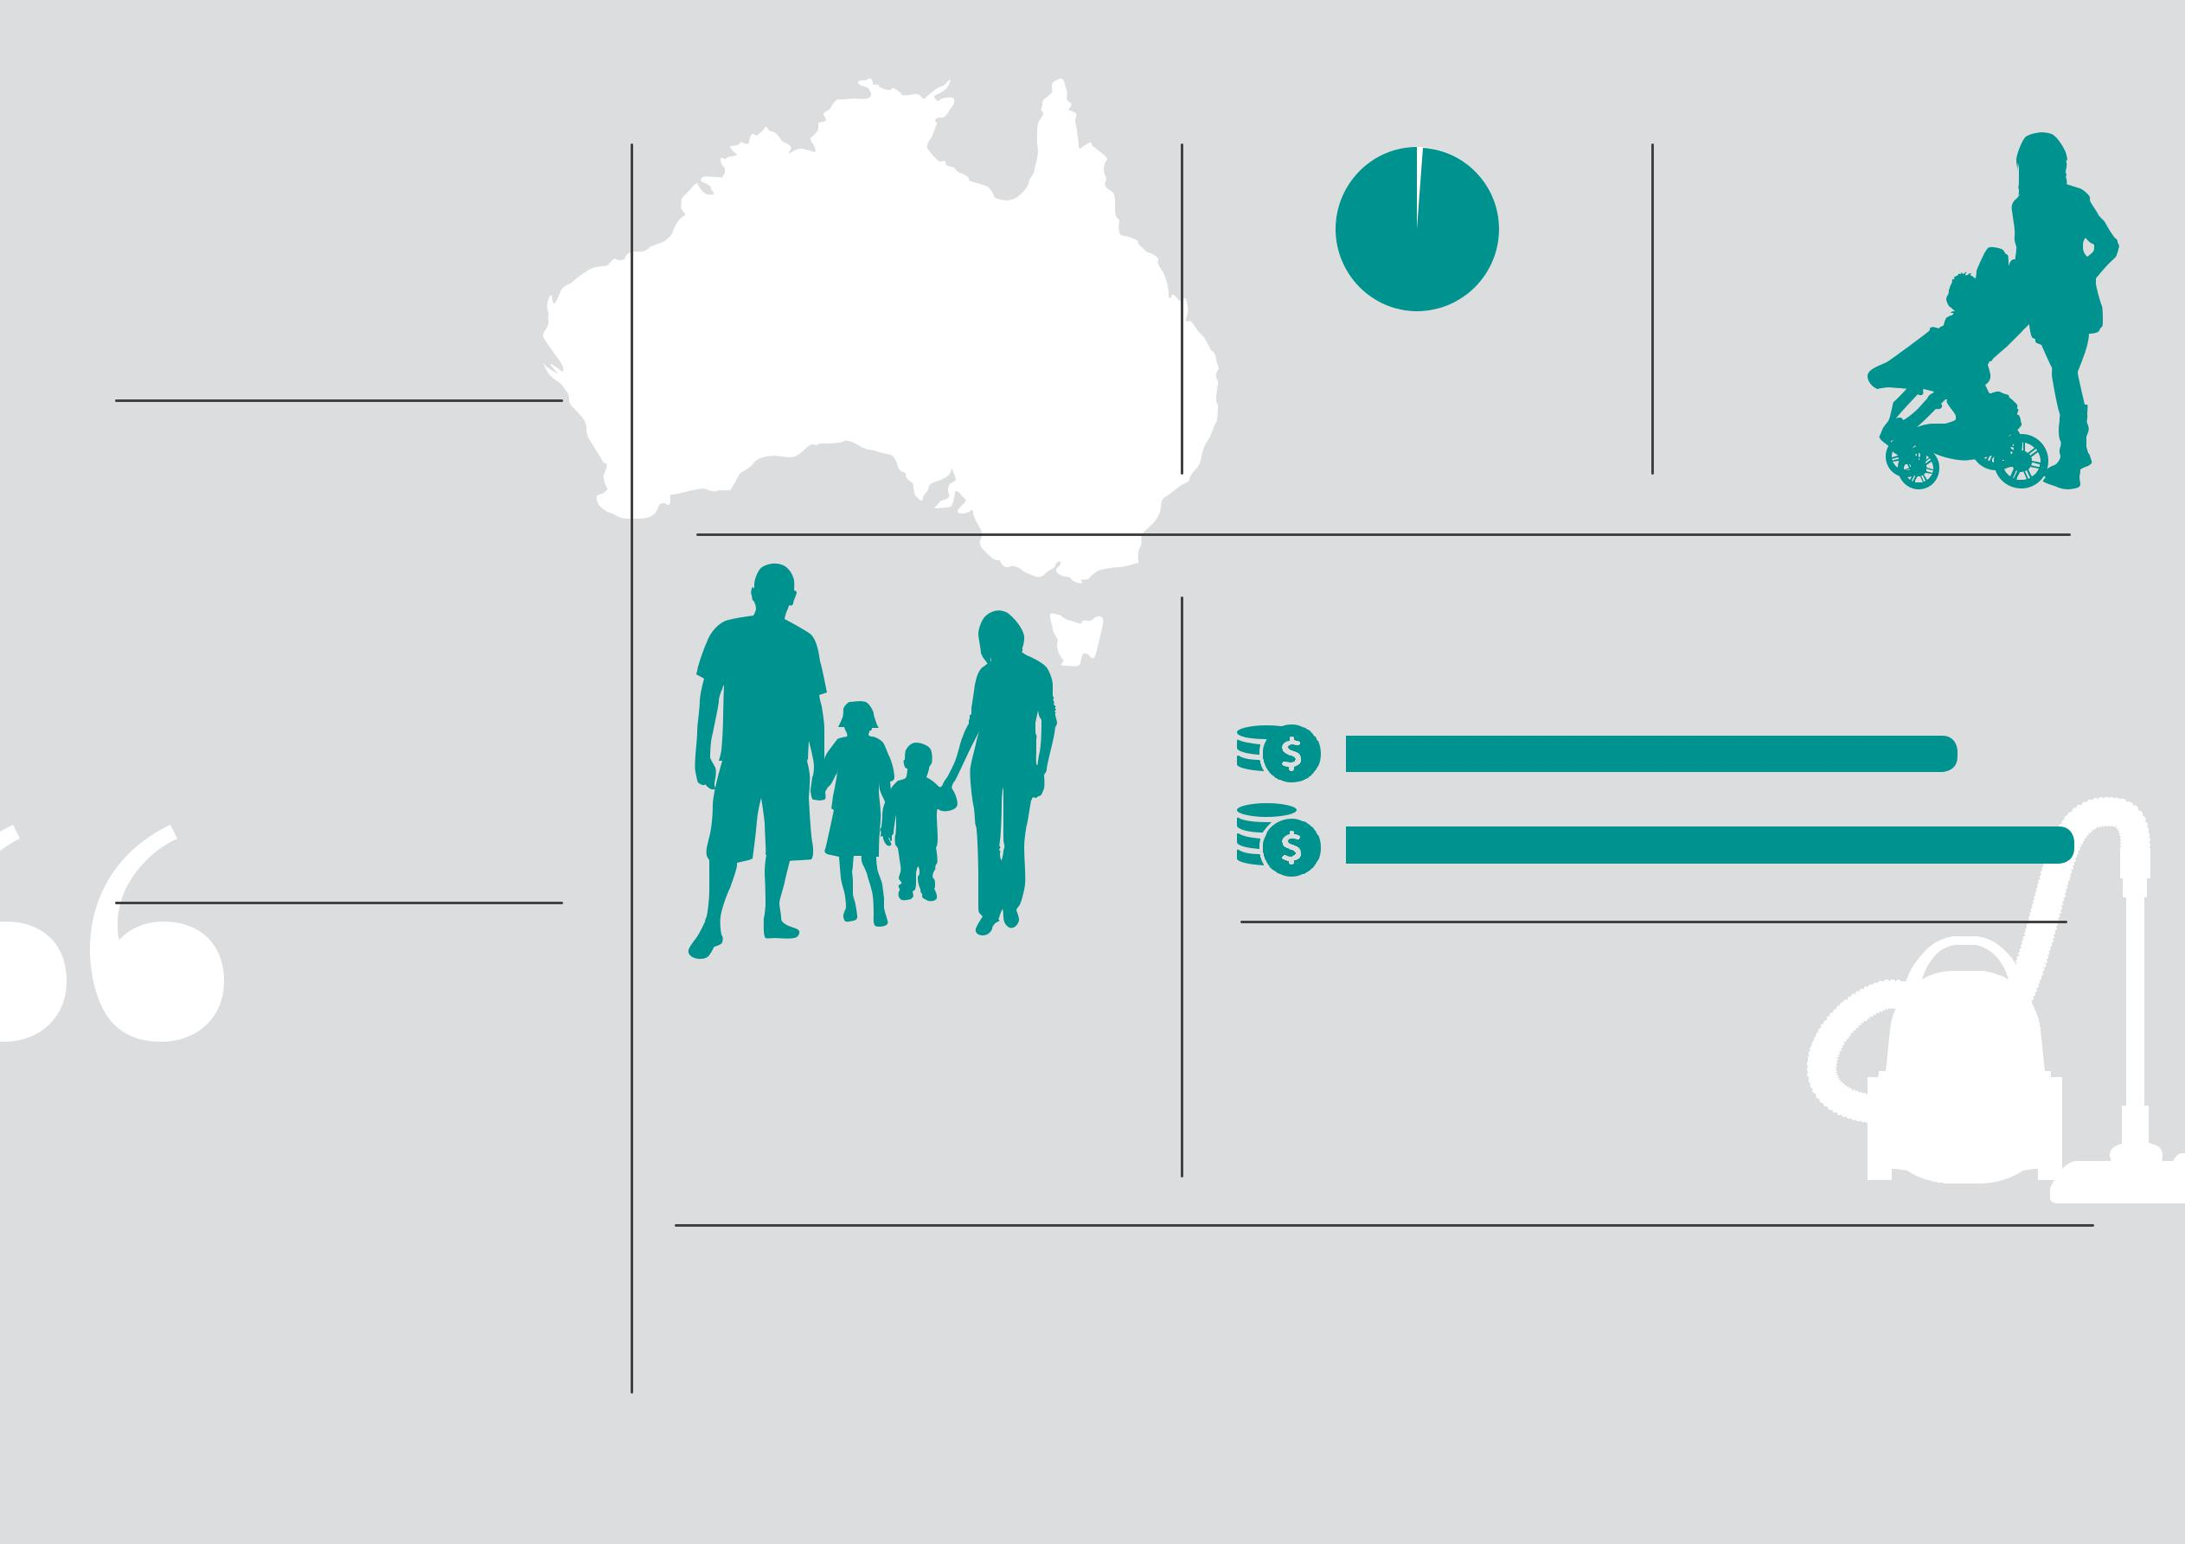

1-2.5% | 1 in every 2
 | mothers experience
 | discrimination
 | during pregnancy,
 | on parental leave
In 2015 2.5% of ASX | or when
In 2015 2.5% of ASX | returning
Directors, and 1 % of ASX | returning
Directors, and 1 % of ASX | to work.
CEOs were culturally | to work.
diverse women

In 2017 women are paid 84% of a man’s pay on average.

“Gender equality –

a perpetual snakes and ladders game. Well, today we begin the end of oscillation between forward progress and

81% do not agree that men should take control in relationships and be the head of the household.

Women spend considerably more time than men undertaking caring responsibilities and unpaid domestic duties. In the EMR in comparison to men, women are almost 5 times more likely to do 30 hours or more of unpaid domestic work each week.

the inevitable backlash. Because we have a plan.”

Hon Fiona Richardson on release of Safe & Strong

Gender equality is a fundamental human right. Advancing gender equality is essential to building a healthier society.

Women’s Health East | Strategic Plan 2017-2021 13

equality
gender advance

Domain |  |  | Outcomes |  | Action Commitments
Women are healthy, equal and well. |  |  | Women experience increased equity |  | Support and add value to the
 |  |  | and decreased discrimination. |  | implementation of Safe and Strong:
 |  |  |  |  | A Victorian Gender Equality Strategy
 |  |  |  |  | across the EMR.
 |  |  |  |  | Advocate to improve the social and
 |  |  |  |  | economic conditions that determine
 |  |  |  |  | women’s health, wellbeing and safety.
 |  |  |  |  | Promote and support a gendered and
 |  |  |  |  | intersectional approach to planning,
 |  |  |  |  | delivery and evaluation of services
 |  |  |  |  | and programs across the EMR.
 |  |  |  |  | Build organisational and workforce
 |  |  |  |  | capacity in gender equity through
 |  |  |  |  | continued support for gender
 |  |  |  |  | equity audits and plans, and the
 |  |  |  |  | provision of high quality training,
 |  |  |  |  | resources and tools.


Women can equitably participate in | Advocate for and support gendered
inclusive and liveable communities. | approaches to build communities
 | in the EMR that are inclusive and
 | liveable, and where women are
 | enabled to participate equitably.

1414 Women’sWomen’s HealthHealth EastEast || StrategicStrategic PlanPlan 20172017--20212021


Prevent violence against women

Violence against women is preventable.

Gender equality is the key to ending violence.

Violence against women is any act of

gender based violence including physical,

sexual and psychological harm and

threats. Violence against women includes

family violence but also includes violence

experienced in other settings such as, but

not exclusive to, workplaces, schools, online

environments, and social situations.

Intimate partner violence is the leading

cause of death, disability and illness in

Australian women aged 18-44 years. This

is more so than any other preventable risk

factor such as smoking or obesity. Violence

against women has profound, wide ranging,

long term impacts on the health and

wellbeing of women and children, families

and communities. Three in ten Australian

women report having experienced physical

violence at least once in their lives, and two

in ten women report having experienced

sexual violence at least once in their lives.

Almost one woman each week is killed by

a current or former partner. In 2015-16

Victoria Police attended almost 24 family

violence incidents each day in the Eastern

Metropolitan Region.

To prevent violence against women we need long term, coordinated action to advance gender equality across all sections of our community, in all of the settings in which people live, work and play: for example

in the home, at schools, in workplaces, in community settings, online, and in the media. Effective primary prevention takes a whole of population approach.

Promoting and normalising gender equality in public and private life is essential to prevent violence from occurring. However, we also know that other intersecting forms of inequality and discrimination, such

as racism, colonialism, ableism, ageism, homophobia and transphobia influence women’s experiences of equality and of violence. To effectively end violence across our whole community we need to develop prevention actions that recognise the full contexts of people’s lives.

Over the next four years Women’s Health East commits to continue its critical leadership and coordination role in building action to prevent violence in our region,

through the Together for Equality & Respect Partnership.

We will work with our partners to strengthen intersectional practice in the primary prevention of violence against women. This means building prevention actions that have reach across the diversity of our region, tailoring efforts to particular groups and contexts. It also means addressing the compounding effects of the various forms of discrimination

in prevention initiatives. We remain committed to ensuring that the voices of women who have experienced violence are central to action to prevent violence against women and are being heard in public policy reform processes.

With government policy and investment and energy from the community for the prevention of violence against women at an all-time high, Women’s Health East is well placed to lead and facilitate this work. We aim to capitalise fully on the prevention opportunities that will flow from the current reforms, and sustain momentum in Melbourne’s East.

Women’s Health East | Strategic Plan 2017-2021 15

To prevent violence against women we need long term, coordinated action across all sections of our community, in all of the settings in which people live, learn, work and play.

“A society where women live free from men’s violence
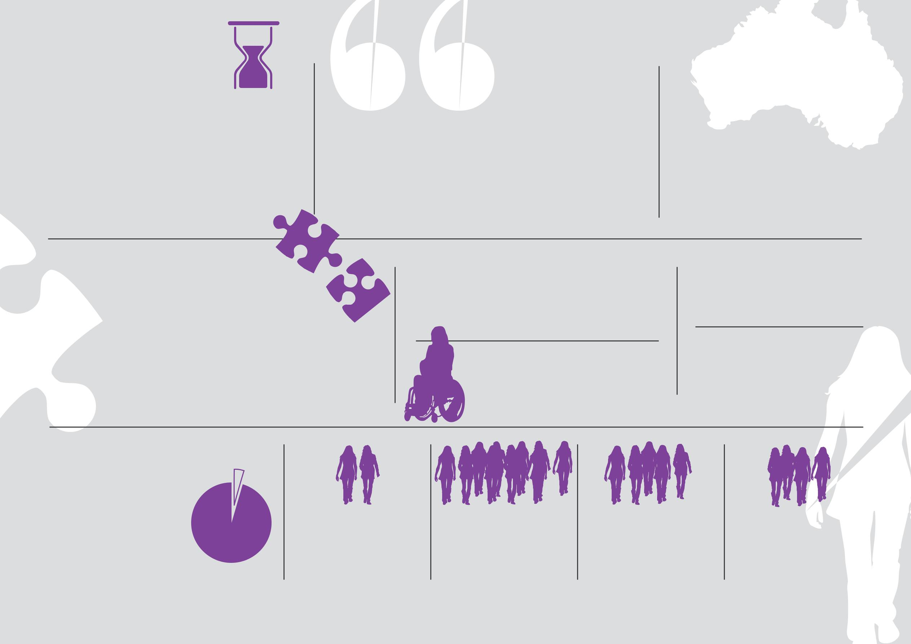
– where every girl and boy grows up to be equally valued, heard and respected, and with equal access to opportunities.”

Together for Equality & Respect vision

Most Australians recognise that violence against women includes a wide range of behaviours designed to intimidate and  control women – not just physical assault.

Action to prevent violence against women should promote and normalise gender equality in public and private life including actions that:

- Challenge condoning of violence against women

- Promote women’s independence and decision-making

- Challenge gender stereotypes and roles

- Strengthen positive, equal and respectful relationships

87% of Australian women have experienced at least one form of verbal or physical street harassment.

Women and girls with disabilities are twice as likely to experience violence as those without.

Family violence against women is the single largest driver of
homelessness for women.

Aboriginal women are 35 times more likely to be hospitalised by family violence than other women.

Only 4% to 6% of | 4-6%
Australians believe
violence against | One in two women | Three in ten women | One in five women
women can be | has experienced | Three in ten women | One in five women
women can be | has experienced | have experienced | have experienced
women can be | sexual harassment | have experienced | have experienced
justified. | sexual harassment | physical violence. | sexual violence.
justified. | during her lifetime. | physical violence. | sexual violence.

One in four women experienced emotional abuse by a current or former partner.

16 Women’s Health East | Strategic Plan 2017-2021

Domain

Women are safe and secure.

Outcomes


Women benefit from coordinated,

evidence informed action to

prevent violence.

Organisations and their

workforces have skills and

knowledge to effectively prevent

violence against women.

Prevention initiatives are informed

by voices of women.

Action Commitments

Lead the Together for Equality and

Respect Partnership across the EMR

and implement action as a part of the

TFER Action Plan.

Contribute to a strengthened

evidence base for the prevention of

violence against women.

Build a stronger intersectional

approach to the prevention of

violence against women in the EMR.

Strengthen organisational

and workforce capacity in the

prevention of violence against

women in the EMR.

Lead the Speaking Out program

to ensure the voices of women

experiencing violence underpin

prevention activities in EMR and

across Victoria.
prevent violence against women

Women’sWomen’s HealthHealth EastEast || StrategicStrategic PlanPlan 20172017--20212021 1717


Improve women’s sexual and reproductive health

Women have a right to optimal

sexual and reproductive health.

Sexual and reproductive health has a

significant impact on women’s physical

and mental health, and emotional and

social wellbeing. Optimal sexual and

reproductive health is about much more

than the absence of disease. It’s about

wellbeing, respect and freedom from

discrimination and violence. It’s about

access to accurate information and

safe, effective and affordable health

services. It’s about women having

autonomy, control and choice over their

sexual and reproductive health.

The Victorian Government identified

‘Improving Sexual and Reproductive

Health’ as one of the six key priorities of

the state’s Public Health and Wellbeing

Plan 2015-2019. Women’s Sexual and

Reproductive Health: Key Priorities 2017-

2020 is the first ever Victorian sexual

and reproductive health strategy and

provides direction for the coordination of

partnership efforts at a statewide, regional

and local level.

The Eastern Metropolitan Region Sexual

- Reproductive Health Needs Analysis launched by Women’s Health East in
2016 identifies six priorities for action in the region, many of which align with the Victorian government strategy. They are:

  - Representation of sexual and reproductive health issues in regional policy and planning

  - Sexually transmitted infections

  - Reproductive empowerment, access and rights

  - Sexualisation and objectification of women

  - Sexual and reproductive health literacy

  - Female genital mutilation /cutting

The needs analysis identified a number of subgroups of women who are likely to experience greater inequities in relation to their sexual and reproductive health and wellbeing. These are young women, newly arrived migrants and women from culturally and linguistically diverse backgrounds (including international students), Aboriginal women, women who experience violence, women with disabilities, and women of diverse sexual and gender identities.

Over the next four years Women’s Health East is committed to improving women’s sexual and reproductive health by supporting the EMR Sexual & Reproductive Health Strategic Reference group and other partners to address these priority action areas. We will work, support and add value to the Victorian government’s Women’s Sexual and Reproductive Health: Key Priorities 2017-2020.

18 Women’s Health East | Strategic Plan 2017-2021

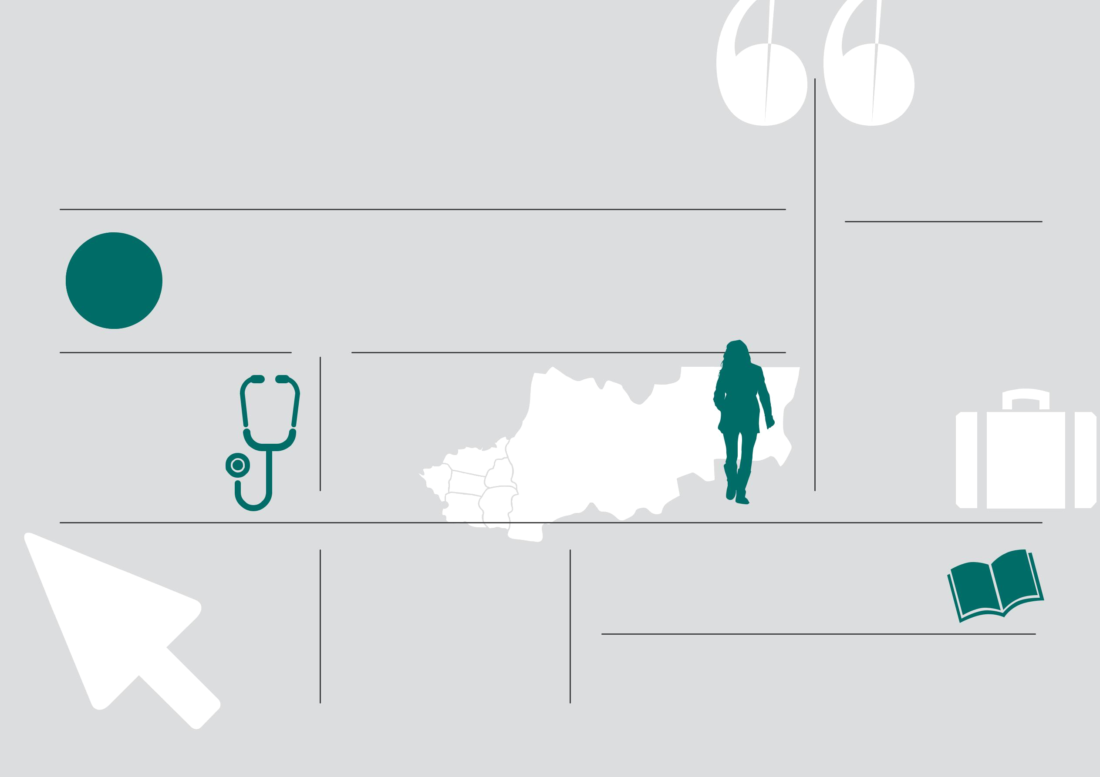
It is a fundamental human right of all people to decide if, when and with whom to have sex, and if and when to have children, free from discrimination, coercion and violence.

25-33% | It is estimated that between one quarter and one third
 | of Australian women will experience an abortion in their
 | lifetime. Surveys have shown that 85% of Victorians support a
 | woman’s right to choose whether or not she has an abortion.
“All the decisions you make about your body should be yours”

Amnesty International

If just 20% of people aged under 30 years received annual chlamydia testing, chlamydia prevalence could be halved in 4 years. Chlamydia is the most commonly reported

Despite being decriminalised in Victoria in 2008; there is very limited access to affordable medical and surgical termination of pregnancy services in the EMR.

The Eastern Metropolitan Region is home to over 4900 people born in countries where female genital cutting is practiced and prevalent. It is also the only metropolitan region in Victoria without a funded response to female genital cutting.

notifiable condition in Australia. The LGA’s of Knox, Yarra Ranges and Boroondara have the highest chlamydia prevalence rates in the EMR.

The sexualisation and objectification of women in the media and pop culture reinforces gender stereotypes and gender inequality.

The EMR has the 7th highest chronic hepatitis B prevalence rate in Australia.

Sexual and reproductive health literacy is influenced by:

- Culture & language, attitudes & beliefs

- General literacy, SRH education

- Attitudes and understanding of health sector

Sexually transmitted infections are a major cause of infertility, particularly in women.

Women’s Health East | Strategic Plan 2017-2021 19

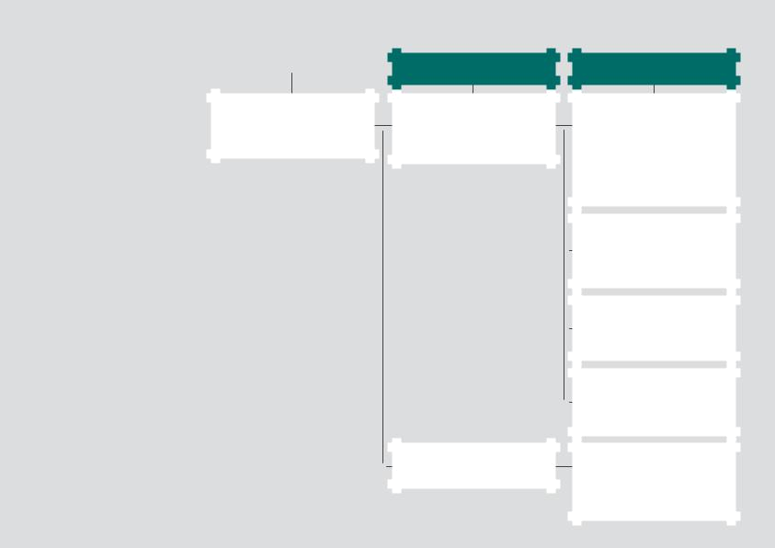  improve women’s sexual |  |  | Domain
 | & reproductive health |  | Women’s right to optimal sexual and
 |  |  | reproductive health and wellbeing is
 |  |  | fully realised.

- Women’s Health East | Strategic Plan 2017-2021

Outcomes

Women in the EMR benefit from coordinated action to address their sexual and reproductive health and rights.

Women in EMR have improved

access to reproductive choices.

Action Commitments

Facilitate a regional focus on addressing women’s sexual and reproductive health aligned to Women’s Sexual and Reproductive Health: Key Priorities 2017-2020 and the Eastern Metropolitan Region Sexual

- Reproductive Health Needs Analysis 2016.

Provide leadership to increase the understanding of women’s sexual and reproductive needs and maximise the delivery of evidence-based health promotion interventions.

Reduce stigma and engage the community to build wide spread awareness and understanding of women’s SRH and rights.

Promote and advocate for realistic, diverse, positive and gender equitable representation of women in the media, online and in popular culture.

Advocate for and facilitate increased access to affordable and inclusive reproductive health information and services, including termination of pregnancy services.

Strengthen our dynamic and sustainable organisation

Women’s Health East prides itself on being an ethical and dynamic organisation and employer, committed to quality and innovation.

As a small organisation with a large

remit, working within an environment of

significant change, Women’s Health East

faces regular new opportunities to expand

our work and to have a significant impact

on the health and wellbeing of women.

As our reputation and reach in relation to

women’s health and wellbeing grows in

our region, we are seeing an increase in

demand for our leadership and expertise.

In response we aim to be dynamic and

nimble. We invest in our staff and maintain

a high level of quality and innovation in our

work. We place significant value on our

partnerships. The external environment

also brings the challenge of how to best

prioritise use of our limited resources.

We therefore also maintain a strong

focus on sustainability, which in line with

our values, includes financial, social and

environmental sustainability.

Over the next four years Women’s Health

East is committed to continuing to build

and strengthen our reputation as thought

leaders in women’s health and wellbeing

in Melbourne’s East. We will seek to be

responsive to the opportunities that arise,

while also continuing the important work

that we have committed to undertake.

Our dedication to evidence informed,

innovative practice will be evident.

We will demonstrate our understanding

of the importance of collaborative

efforts to the achievement of our

strategic directions by nurturing and

supporting our partnerships.

In order to provide greater social impact

through increased financial security, we

will seek to diversify and grow our funding

and pursue opportunities to increase our

capacity and strengthen our sustainability.

Women’s Health East | Strategic Plan 2017-2021 21

Staff training & development
 | Strong, respected
 | partnerships
Leadership & expertise | Quality, innovative work | Our vision:
 | Social impact | Equality, empowerment,
 | Social impact | health & wellbeing
 | Sustainable growth | health & wellbeing
Financial, social & environmental sustainability | Sustainable growth | for all women.
 | Reactive & nimble
 | responses
Ethics & values
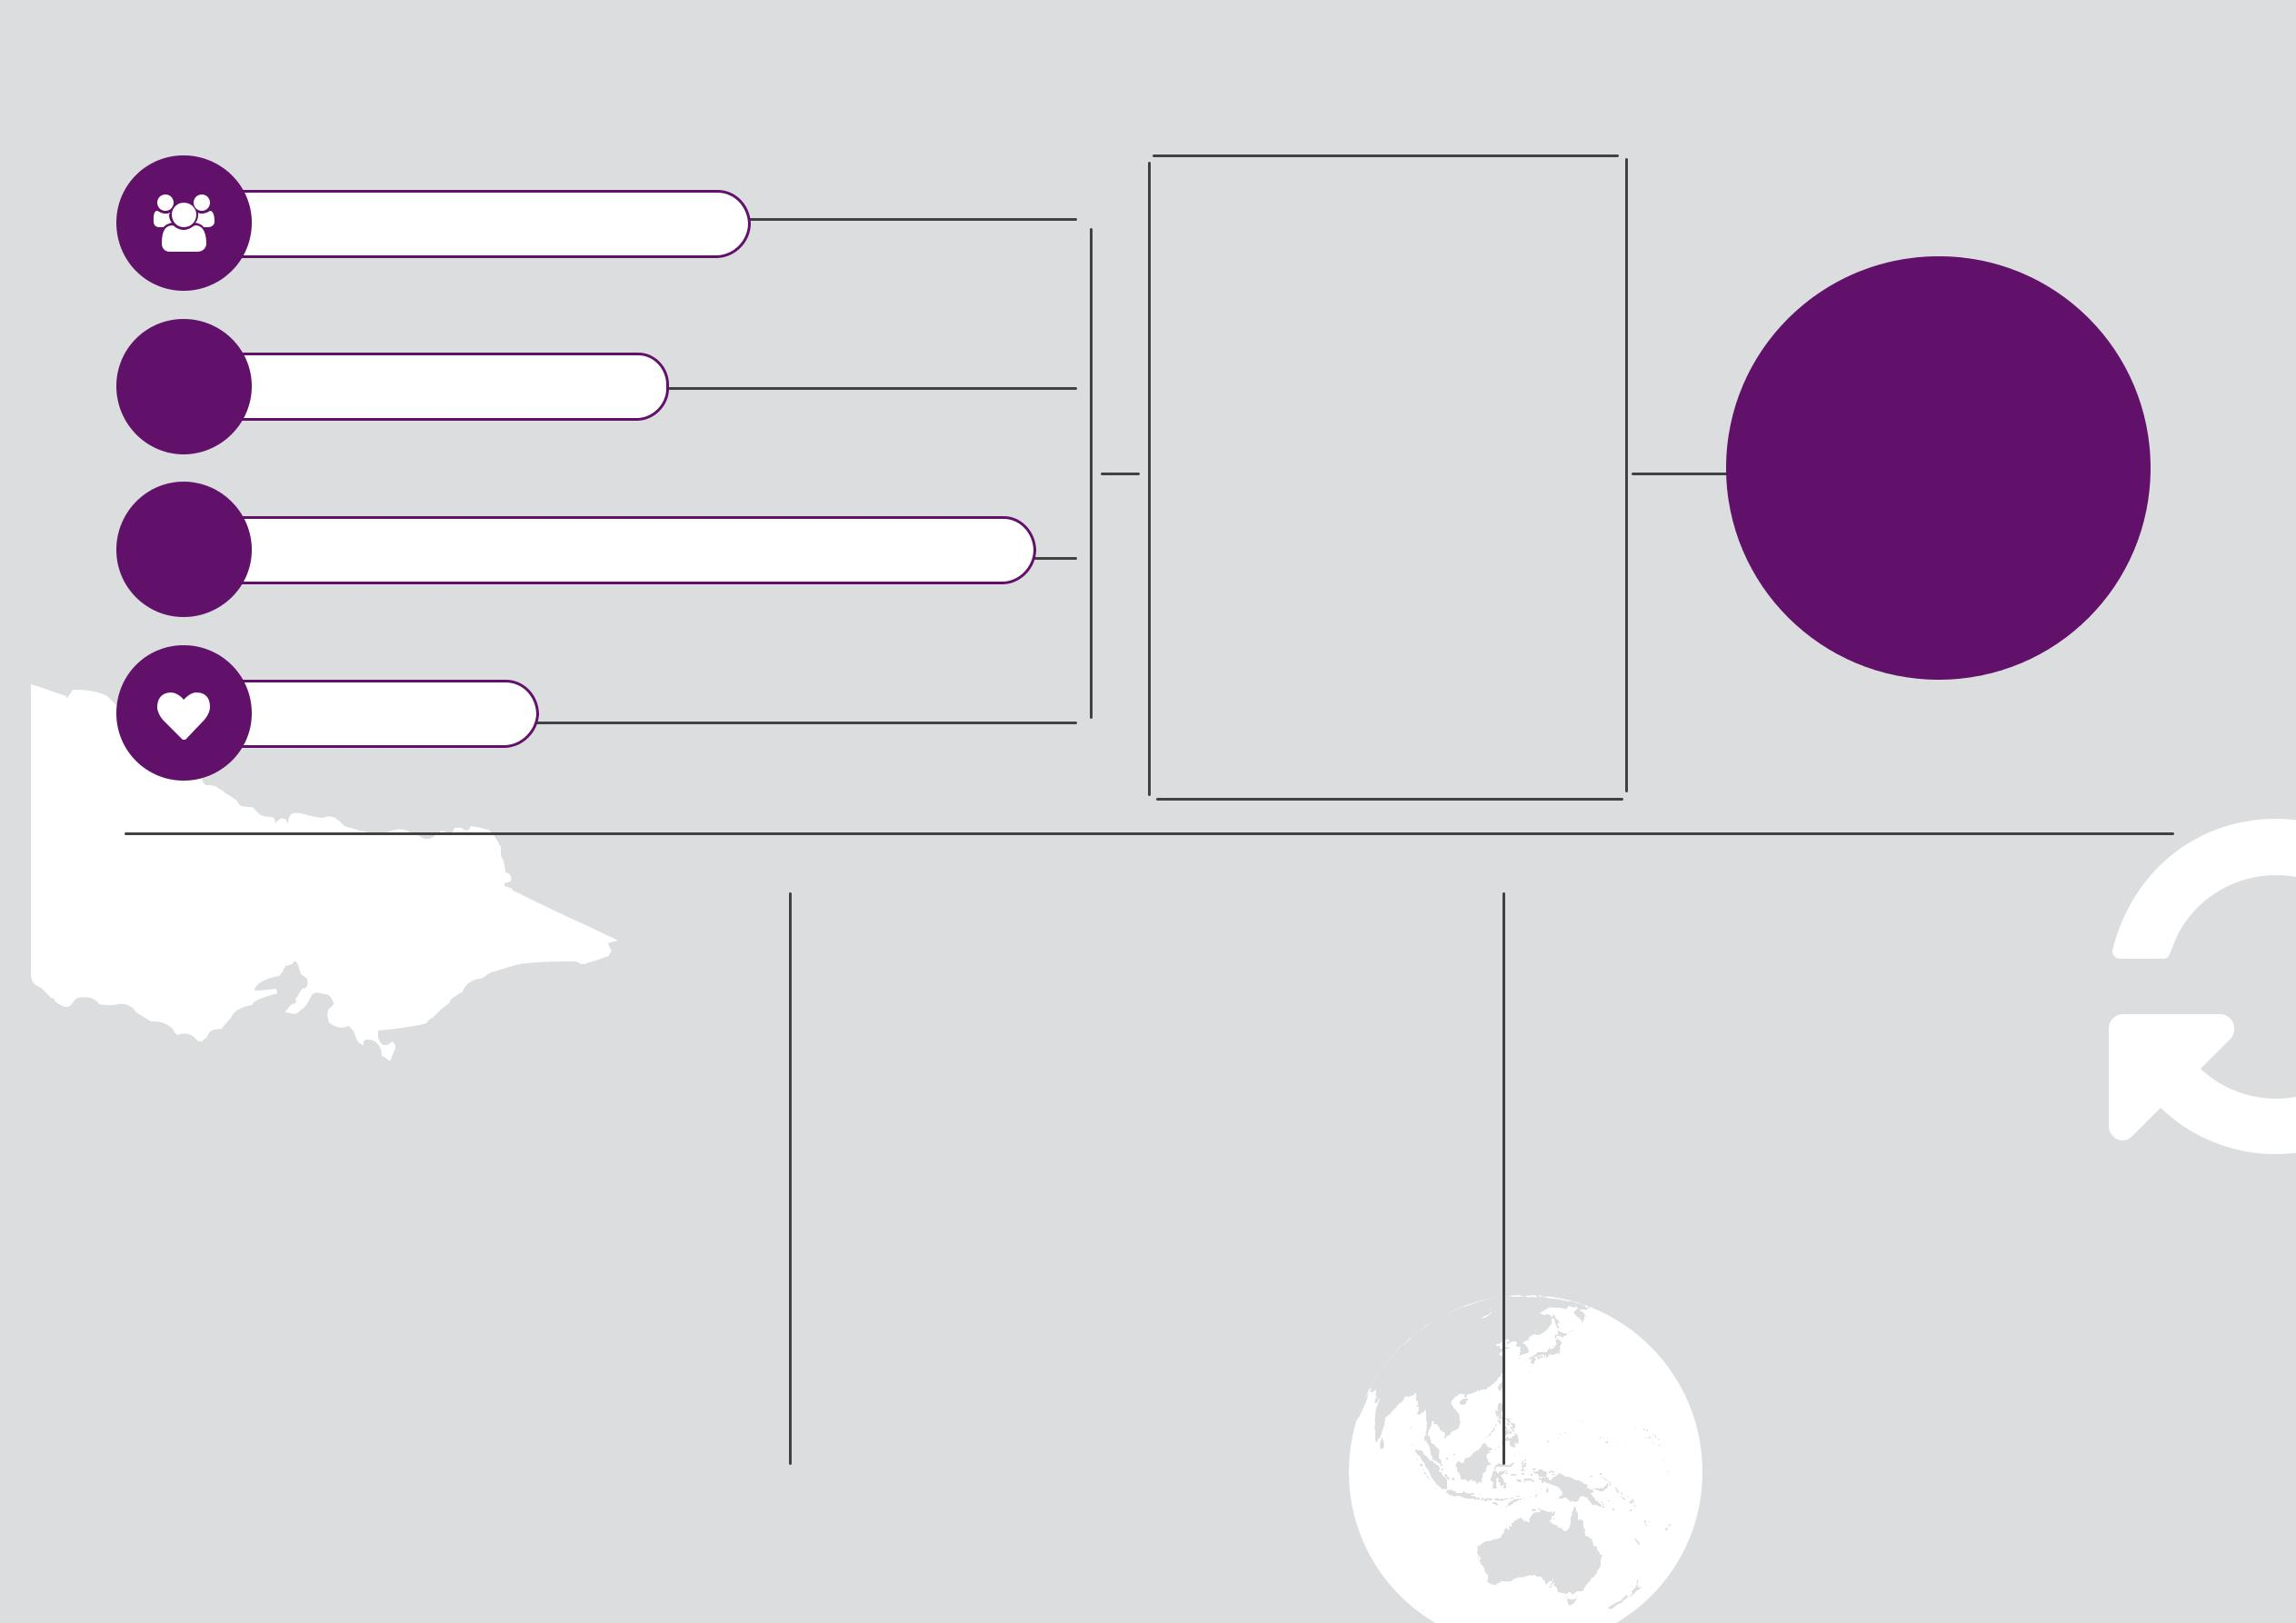

Women’s Health East is a part of the women’s health sector which covers the entire state of Victoria. With shared key priorities, the sector provides an enduring infrastructure for improving women’s health and wellbeing in Victoria.

22 Women’s Health East | Strategic Plan 2017-2021

Women’s Health East acknowledges the importance of a healthy planet to our health and wellbeing. Climate change is an urgent and real threat to our health and one of the greatest economic, social and environmental challenges that exists. Climate change is a gendered issue, with women using energy differently to men, and being potentially more vulnerable to the impacts of climate change. WHE aims to reduce our carbon footprint and advocate for environmental sustainability across the EMR.

Women’s Health East leads the implementation of the Women’s Health Services Quality Framework across the Victorian women’s health sector, including of course in our own organisation! The Framework includes a set of standards covering the key guiding principles and work of the sector.

Domain Outcomes
Action Commitments
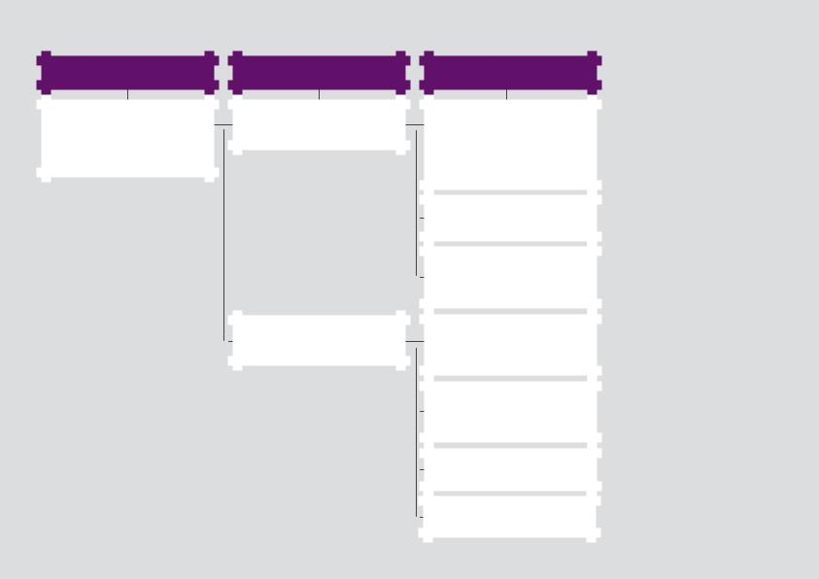

Women’s Health East is an efficient, effective and sustainable

organisation improving outcomes for women’s health and wellbeing.

Women’s Health East is a leader in women’s health.

Women’s Health East is a strong and sustainable organisation.

Maintain a clear and consistent voice | sustainablestrengthen
and advance the reputation of Women’s | sustainablestrengthen
Health East as thought leaders and | sustainablestrengthen
trusted partners in improving women’s | sustainablestrengthen
health and wellbeing. | sustainablestrengthen
Share knowledge and practice- | sustainablestrengthen
evidence. | sustainablestrengthen
Build Women’s Health East’s internal | organisationdynamicour
capability to ensure responsiveness to | organisationdynamicour
existing and emerging issues. | organisationdynamicour
Maintain a strong focus on | organisationdynamicour
continuous quality improvement | organisationdynamicour
systems and practice. | organisationdynamicour
Strengthen and expand partnerships | organisationdynamicour
to increase business efficiency and | organisationdynamicour
deepen our social impact. | organisationdynamicour
Continue to develop, value and | organisationdynamicour
support our staff. | organisationdynamicour
Increase financial sustainability through | &
diversifying our revenue sources.
Women’sWomen’s HealthHealth EastEast || StrategicStrategic PlanPlan 20172017--20212021 2323



Women’s Health East 2017, Strategic Plan 2017 – 2021, WHE, Melbourne

24 Women’s Health East | Strategic Plan 2017-2021

