16 Ways to Call it Out in the 16 Days of Activism Against Gender-Based Violence campaign
5 Grouped Social Media Post toolkit

Women’s Health East in partnership with Together for Equality and Resect partners has developed the following social media campaign to assist organisations and groups across Melbourne’s Eastern Metropolitan Region to participate in the 2020 16 Days of Activism Against Gender-Based Violence Campaign.
The following toolkit provides 16 social media tiles to be posted over 5 posts, using a grouped format, with accompanying text for Facebook, LinkedIn, Instagram, and Twitter, as well as image description text to support accessibility of the campaign.

With the exception of social media tile #1 (1-intro.png), all social media tiles can be posted in any order during the 16 Days of Activism Against Gender-Based Violence campaign, Wednesday 25th November – Thursday 10th December 2020.

Campaign social media tiles have been hyperlinked throughout this document for ease of use. Further campaign materials can be found at www.whe.org.au/16Days.

Please note there is an alternative toolkit for partners who wish to post the 16 social media tiles over 16 days. Check out the 16 social media post toolkit at www.whe.org.au/16Days

Campaign hashtags: #16Days16Ways #16DaysCampaign #RespectIs #CallitOut
Post #1
Image / Description:  1-Intro.png  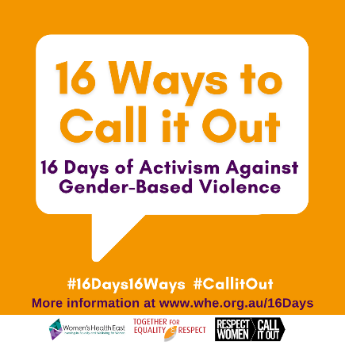 | Image description:  Orange tile featuring a large speech bubble with the text ‘16 ways to call it out, 16 days of activism against gender-based violence’. Below the bubble are two hashtags which read 16 days 16 ways and call it out. Below is text ‘More information at www.whe.org.au/16days’ and the logos of Women’s Health East, Together For Respect At Home and Respect Women: Call It Out
Facebook / LinkedIn / Instagram: | From November 25 until December 10, join us to call out inappropriate behaviour for a world free of sexism, discrimination and inequality.  The #16DaysCampaign is a global movement focused on ending gender-based violence.  Get involved:  - like and share our #16Days16Ways messages on your social media  - be an active bystander - call out inappropriate language or behaviour  - stop the ‘joke’ when people make derogatory comments – they’re NOT okay.  Need more ideas about how to get involved or to learn more about the link between gender inequality and violence against women? Follow our #16Days16Ways campaign over the #16Days of Activism, a global movement bringing attention to ending gender-based violence.  If you or someone you know is experiencing family violence help is available. In an emergency, call 000. For confidential support and information call 1800 RESPECT (1800 737 732)  For further support information or to learn more about the #16Days16Ways campaign visit www.whe.org.au/16Days #RespectIs #CallitOut
Twitter: | #16DaysCampaign is a global movement bringing attention to ending gender-based violence. Get involved by calling out inappropriate behaviour that supports sexism, discrimination and inequality. Follow and share our #16Days16Ways campaign Nov 25-Dec 10 www.whe.org.au/16Days

Post #2
Images:  Group 1 Images | 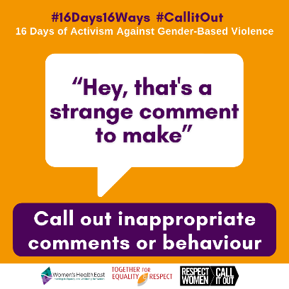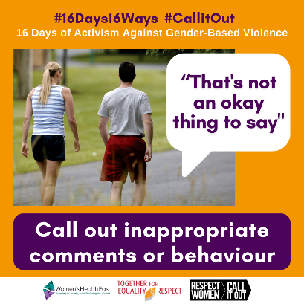  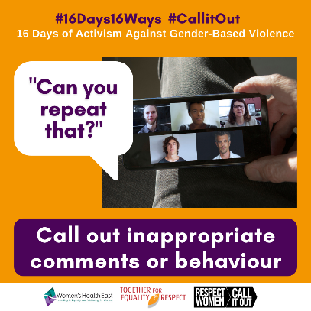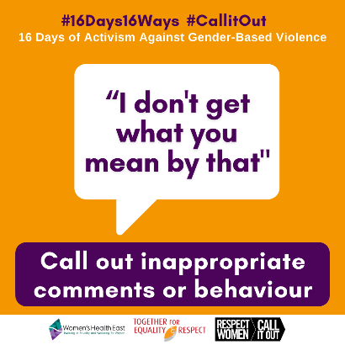
Image descriptions: | Image 2- A large speech bubble of text ‘Hey, that’s a strange comment to make’. Above the bubble are two hashtags and a tagline which read # 16 days 16 ways, # call it out, 16 days of activism against gender-based violence. Below the speech bubble is a text box which reads ‘call out inappropriate comments and behaviour’ and the logos of Women’s Health East, Together For Respect At Home and Respect Women: call it out.  Image 3- # 16 days 16 ways, # call it out, 16 days of activism against gender-based violence. Image of two people walking for exercise outside while talking. Paired text which reads “that’s not an okay thing to say” ‘call out inappropriate comments and behaviour’ and the logos of Women’s Health East, Together For Respect At Home and Respect Women: call it out.  Image 4- # 16 days 16 ways, # call it out, 16 days of activism against gender-based violence. Image a phone with a video call of five diverse people on the screen. Paired text which reads “Can you repeat that?” ‘Call out inappropriate comments and behaviour’ and the logos of Women’s Health East, Together For Respect At Home and Respect Women: call it out.  Image 5- A large speech bubble of text “I don’t get what you mean by that”. Above the bubble are two hashtags and a tagline which read # 16 days 16 ways, # call it out, 16 days of activism against gender-based violence. Below the speech bubble is a text box which reads ‘call out inappropriate comments and behaviour’ and the logos of Women’s Health East, Together For Respect At Home and Respect Women: call it out.
Facebook / LinkedIn / Instagram: | Pulling someone up for sexist or discriminatory behaviour is the first step to creating lasting change towards a society that respects and values women.  Sometimes sexist comments are made by people who don’t understand that their attitudes and behaviours are harmful.  That’s why it’s important to call it out.  When we stay silent, we are reinforcing that the behaviour is acceptable. When we call it out, we’re sending a really clear message that it’s not okay.  Spark conversations, encourage change, and work towards a future where women, men and gender diverse people are safe, equal and respected.  #16Days16Ways #16DaysCampaign #RespectIs #CallitOut
Twitter: | Pulling someone up for using sexism or discriminatory behaviour is the first step to creating lasting change regarding the way we talk about, respect and value women.  #16Days16Ways #16DaysCampaign #RespectIs #CallitOut  www.whe.org.au/16Days  OR  Changing harmful attitudes might not happen overnight, but the more valuable conversations we have that challenge these kinds of behaviours, the closer we can get to achieving a gender equal society for all. www.whe.org.au/16Days  #16Days16Ways #16DaysCampaign #CallitOut

Post #3
Images:  Group 2 Images | 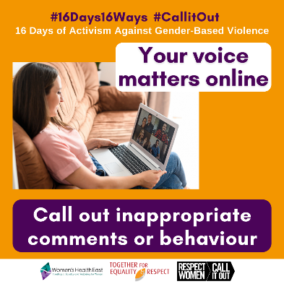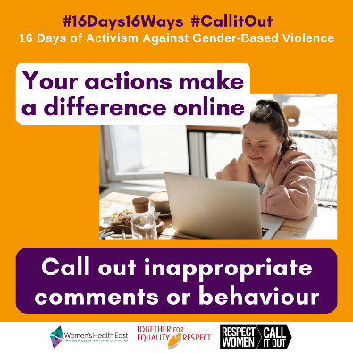
Image descriptions: | Image 6- # 16 days 16 ways, # call it out, 16 days of activism against gender-based violence. Image a female sitting on a couch using a laptop to video chat with five other people. Paired text which reads ‘your voice matters online’ ‘call out inappropriate comments and behaviour’ and the logos of Women’s Health East, Together For Respect At Home and Respect Women: call it out.  Image 7- # 16 days 16 ways, # call it out, 16 days of activism against gender-based violence. Image a young female working on a laptop. Paired text which reads ‘your actions make a difference online’ ‘call out inappropriate comments and behaviour’ and the logos of Women’s Health East, Together For Respect At Home and Respect Women: call it out.
Facebook / LinkedIn / Instagram: | Call out disrespect online when you see it. Take action to speak up, or comment against disrespect. Show your support and create safe online spaces for others.  More and more we spend time online interacting and socialising with others. Using social media to connect online has been central to our daily lives in 2020.  Sometimes we witness disrespect online, whether these are posts made by other people, or comments on your own posts.  It is important to know that your voice matters online.  Check out this online video to learn more - www.youtube.com/watch?v=IWB-8FrTNQE  For online safety information and support visit www.whe.org.ay/16Days  #16Days16Ways #16DaysCampaign #RespectIs #CallitOut
Twitter: | #CallitOut when you see disrespect online. Take action to show your support online by unfollowing individuals, posting a comment or liking comments that show respect or call out disrespect. Know that your voice matters online. #16Days16Ways #16DaysCampaign

Post #4
Images:  Group 3 Images | 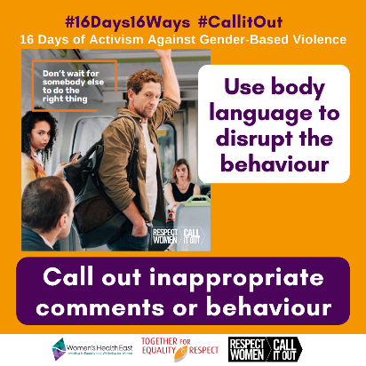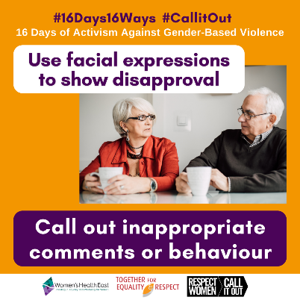  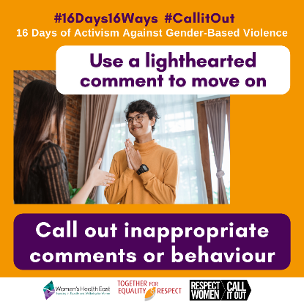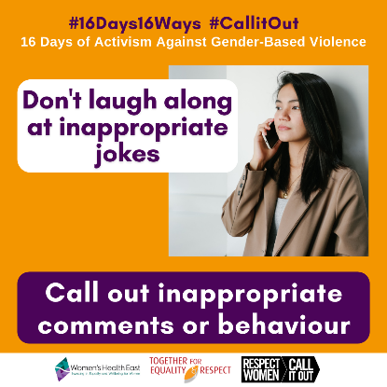
Image descriptions: | Image 8- # 16 days 16 ways, # call it out, 16 days of activism against gender-based violence. Image of a male standing between a male and female passenger on a train. Standing male giving the male a disapproving look. Paired text which reads ‘use body language to disrupt the behaviour’ ‘call out inappropriate comments and behaviour’. Logos of Women’s Health East, Together For Respect At Home and Respect Women: call it out.  Image 9- # 16 days 16 ways, # call it out, 16 days of activism against gender-based violence. Image of an older couple having a cup of tea at the table. Women is giving the man a disapproving look. Paired text which reads ‘use facial expressions to show disapproval’ ‘call out inappropriate comments and behaviour’ and the logos of Women’s Health East, Together For Respect At Home and Respect Women: call it out.  Image 10- # 16 days 16 ways, # call it out, 16 days of activism against gender-based violence. Image young man and woman in conversation. Paired text which reads ‘use a light hearted comment to move on’ ‘call out inappropriate comments and behaviour’ and the logos of Women’s Health East, Together For Respect At Home and Respect Women: call it out.  Image 11- # 16 days 16 ways, # call it out, 16 days of activism against gender-based violence. Image of a young female looking serious with her mobile phone to her ear. Paired text which reads ‘don’t laugh along at inappropriate jokes’ ‘call out inappropriate comments and behaviour’ and the logos of Women’s Health East, Together For Respect At Home and Respect Women: call it out.
Facebook / LinkedIn / Instagram: | By not giving airtime to inappropriate behaviour in social settings, we are committing to creating a safe and respectful community for everyone.  Remember that any action is better than no action. It’s up to all of us to change the culture of letting an inappropriate sexist and discriminatory behaviour unchallenged by calling it out when we can.  This can be something as simple as a facial expression to communicate your disapproval, a lighthearted comment, using body language to disrupt the behaviour, or not laughing along at sexist ‘jokes’.  To see how a situation like this might play out, check out this video by @OurWatchAus - www.youtube.com/watch?v=6Hwj38L9bxY  #16Days16Ways #16DaysCampaign #RespectIs #CallitOut
Twitter: | Small and seemingly insignificant acts can be powerful in disrupting inappropriate behaviour. This can include using your body language whether that be standing in front or between the situation. Know your actions can make a difference. #16Days16Ways #16DaysCampaign #CallitOut

Post #5
Images:  Group 4 Images | 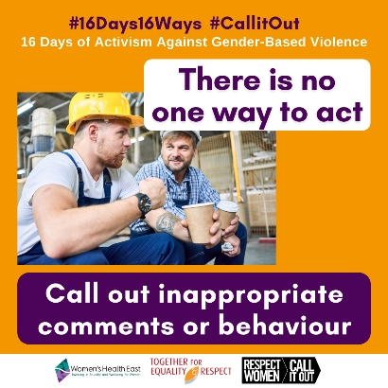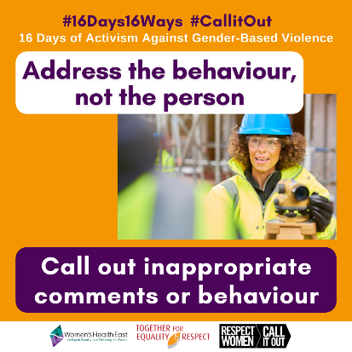  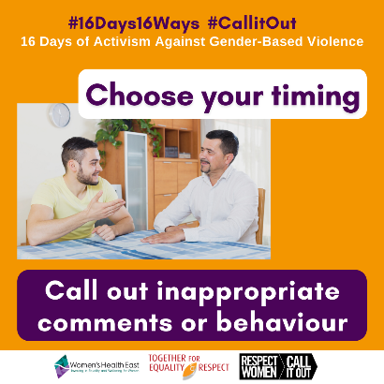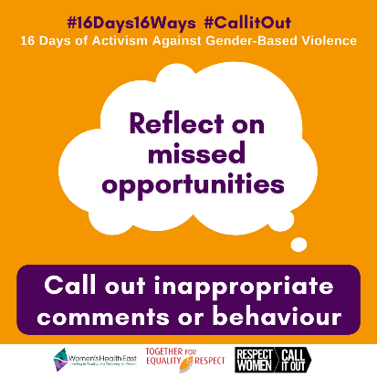
Image descriptions: | Image 12- # 16 days 16 ways, # call it out, 16 days of activism against gender-based violence. Image of a two male construction worker eating lunch and talking with paired text which reads ‘address the behaviour, not the person’ ‘call out inappropriate comments and behaviour’ and the logos of Women’s Health East, Together For Respect At Home and Respect Women: call it out.  Image 13- # 16 days 16 ways, # call it out, 16 days of activism against gender-based violence. Image of a female construction worker speaking with paired text which reads ‘address the behaviour, not the person’ ‘call out inappropriate comments and behaviour’ and the logos of Women’s Health East, Together For Respect At Home and Respect Women: call it out.  Image 14- # 16 days 16 ways, # call it out, 16 days of activism against gender-based violence. Image of two males having a conversation at the dining table with paired text which reads ‘choose your timing’ ‘call out inappropriate comments and behaviour’ and the logos of Women’s Health East, Together For Respect At Home and Respect Women: call it out.  Image 15- A large speech bubble of text ‘reflect on missed opportunities. Above the bubble are two hashtags and a tagline which read # 16 days 16 ways, # call it out, 16 days of activism against gender-based violence. Below the speech bubble is a text box which reads ‘call out inappropriate comments and behaviour’ and the logos of Women’s Health East, Together For Respect At Home and Respect Women: call it out.
Facebook / LinkedIn / Instagram: | Every situation is different. There is no one way to respond to situations or comments that disrespect women. Showing your support and speaking up are great options.  You can choose how to call out inappropriate behaviour depending on the setting. It might be a simple roll of the eye, a shake of the head, making a comment to pull up the behaviour or supporting the target by acknowledging what happened and asking if they’re ok.  It’s important to know that there’s always an opportunity to call out inappropriate behaviour after the event, too.  The important thing is to do something, because doing nothing does harm.  Learn more about how to show it’s not okay here- www.doingnothingdoesharm.org.au/DoingNothingDoesHarm/Home#show  #16Days16Ways #16DaysCampaign #RespectIs #CallitOut
Twitter: | Every situation is different. There's no one way to respond to disrespect towards women. Showing support and speaking up are great options. It might be a simple roll of the eye, a shake of the head, or asking the target if they’re okay. #16Days16Ways #16DaysCampaign #CallitOut

