16 Ways to Call it Out in the 16 Days of Activism Against Gender-Based Violence campaign
16 Social Media Post toolkit

Women’s Health East in partnership with Together for Equality and Resect partners has developed the following social media campaign to assist organisations and groups across Melbourne’s Eastern Metropolitan Region to participate in the 2020 16 Days of Activism Against Gender-Based Violence Campaign.
The following toolkit provides 16 social media tiles to be posted over 16 days with accompanying text for Facebook, LinkedIn, Instagram, and Twitter, as well as image description text to support accessibility of the campaign.

With the exception of social media tile #1 (1-intro.png), all social media tiles can be posted in any order during the 16 Days of Activism Against Gender-Based Violence campaign, Wednesday 25th November – Thursday 10th December 2020.

Campaign social media tiles have been hyperlinked throughout this document for ease of use. Further campaign materials can be found at www.whe.org.au/16Days.

Please note there is an alternative toolkit for partners who wish to post the 16 social media tiles over fewer days, in a grouped format. Check out the 5 grouped social media posts toolkit at www.whe.org.au/16Days

Campaign hashtags: #16Days16Ways #16DaysCampaign #RespectIs #CallitOut

Image / Description:  1-Intro.png  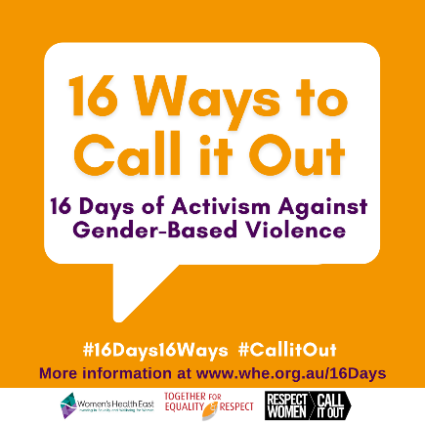 | Image description:  Orange tile featuring a large speech bubble with the text ‘16 ways to call it out, 16 days of activism against gender-based violence’. Below the bubble are two hashtags which read 16 days 16 ways and call it out. Below is text ‘More information at www.whe.org.au/16days’ and the logos of Women’s Health East, Together For Respect At Home and Respect Women: call it out.
Facebook / LinkedIn / Instagram: | From November 25 until December 10, join us to call out inappropriate behaviour for a world free of sexism, discrimination and inequality.  The #16DaysCampaign is a global movement focused on ending gender-based violence.  Get involved:  - like and share our #16Days16Ways messages on your social media  - be an active bystander - call out inappropriate language or behaviour  - stop the ‘joke’ when people make derogatory comments – they’re NOT okay.  Need more ideas about how to get involved or to learn more about the link between gender inequality and violence against women? Follow our #16Days16Ways campaign over the #16Days of Activism, a global movement bringing attention to ending gender-based violence.  If you or someone you know is experiencing family violence help is available. In an emergency, call 000. For confidential support and information call 1800 RESPECT (1800 737 732)  For further support information or to learn more about the #16Days16Ways campaign visit www.whe.org.au/16Days #RespectIs #CallitOut
Twitter: | #16DaysCampaign is a global movement bringing attention to ending gender-based violence. Get involved by calling out inappropriate behaviour that supports sexism, discrimination and inequality. Follow and share our #16Days16Ways campaign Nov 25-Dec 10 www.whe.org.au/16Days

Image / Description:  2-That’s a strange comment.png  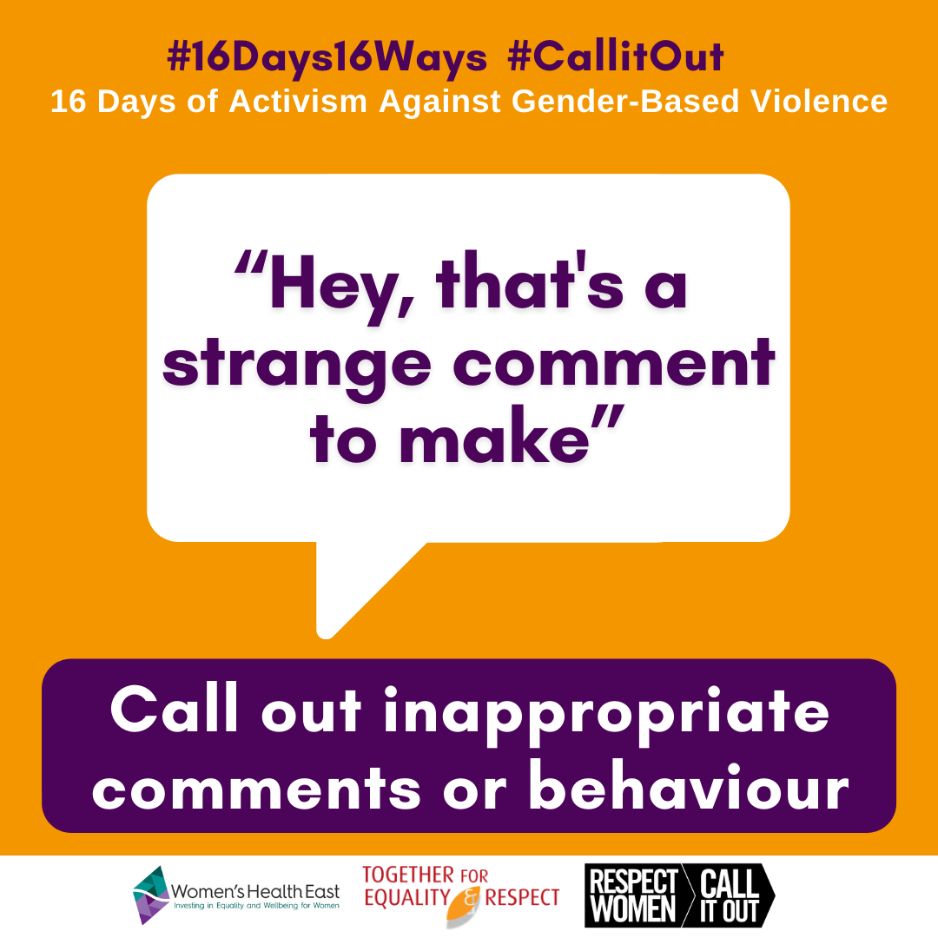 | Image description:  A large speech bubble of text ‘Hey, that’s a strange comment to make’. Above the bubble are two hashtags and a tagline which read # 16 days 16 ways, # call it out, 16 days of activism against gender-based violence. Below the speech bubble is a text box which reads ‘call out inappropriate comments and behaviour’ and the logos of Women’s Health East, Together For Respect At Home and Respect Women: call it out.
Facebook / LinkedIn / Instagram: | Pulling someone up for sexist or discriminatory behaviour is the first step to creating lasting change towards a society that respects and values women.  If somebody you know makes a derogatory comment, disrupt the behaviour to show your disapproval. Try using a statement like - “Hey, that’s a strange comment to make.”  By making a statement you send a message that this behaviour is not okay or acceptable. As more people start calling out these behaviours, everyone will learn that it’s not ok.  Spark conversations, encourage change, and work towards a future where women, men and gender diverse people are safe, equal and respected.  #16Days16Ways #16DaysCampaign #RespectIs #CallitOut
Twitter: | Pulling someone up for using sexist or discriminatory behaviour is the first step to creating lasting change regarding the way we talk about, respect and value women.  #16Days16Ways #16DaysCampaign #RespectIs #CallitOut  www.whe.org.au/16Days

Image / Description:  3-Not an Ok thing to say.png  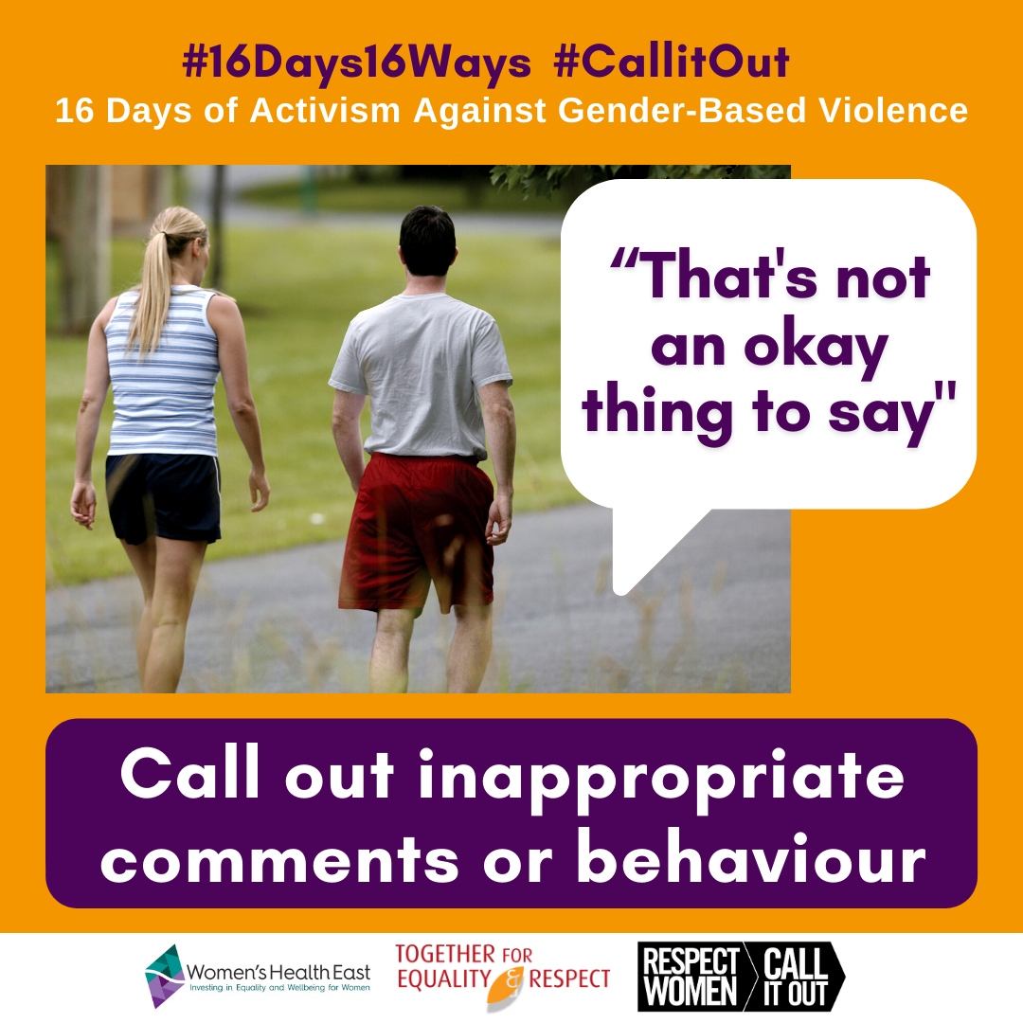 | Image description:  # 16 days 16 ways, # call it out, 16 days of activism against gender-based violence. Image of two people walking for exercise outside while talking. Paired text which reads “that’s not an okay thing to say” ‘call out inappropriate comments and behaviour’ and the logos of Women’s Health East, Together For Respect At Home and Respect Women: call it out.
Facebook / LinkedIn / Instagram: | Sometimes sexist comments are made by people who don’t understand that their attitudes and behaviours are harmful.  That’s why it’s important to call it out.  What’s obvious for you may not be for them. Respectfully informing them could help them to understand and support them to change their behaviour.  Changing harmful attitudes might not happen overnight. The more valuable conversations we have that challenge these kinds of behaviours, the closer we will get to achieving a gender equal society for all.  #16Days16Ways #16DaysCampaign #RespectIs #CallitOut
Twitter: | Changing harmful attitudes might not happen overnight, but the more valuable conversations we have that challenge these kinds of behaviours, the closer we get to achieving a gender equal society for all www.whe.org.au/16Days  #16Days16Ways #16DaysCampaign #RespectIs #CallitOut

Image / Description:  4-Can you repeat that.png  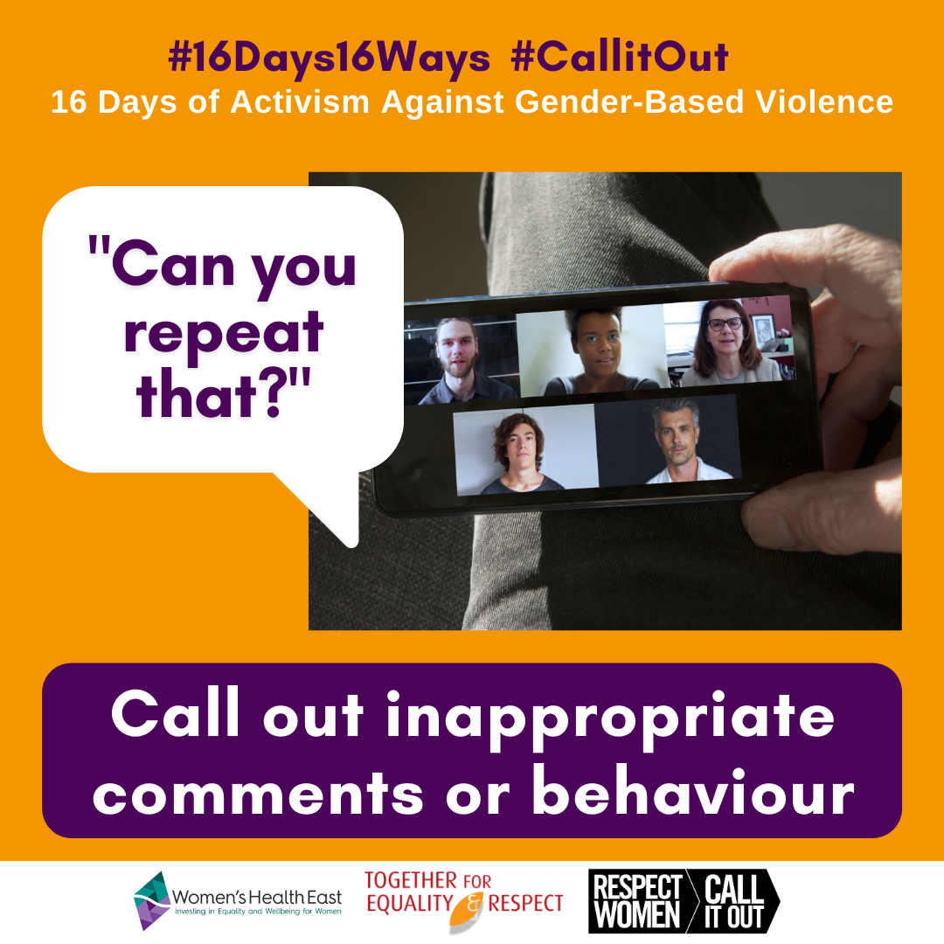 | Image description:  # 16 days 16 ways, # call it out, 16 days of activism against gender-based violence. Image a phone with a video call of five diverse people on the screen. Paired text which reads “Can you repeat that?” ‘Call out inappropriate comments and behaviour’ and the logos of Women’s Health East, Together For Respect At Home and Respect Women: call it out.
Facebook / LinkedIn / Instagram: | “Can you repeat that?”  It’s a simple question that you can ask somebody if they’ve made an inappropriate sexist or discriminatory comment.  By asking the person to repeat the statement, it gives them an opportunity to think about what they have said. It can also give them the opportunity to rethink their statement and correct themselves.  When we stay silent, we are reinforcing that the behaviour is acceptable. When we call it out, we’re sending a really clear message that it’s not okay.  #16Days16Ways #16DaysCampaign #RespectIs #CallitOut
Twitter: | By asking the person to repeat the statement, it gives them an opportunity to think about what they have said. It can also give them the opportunity to rethink their statement and correct themselves.  #16Days16Ways #16DaysCampaign #RespectIs #CallitOut  www.whe.org.au/16Days

Image / Description:  5-I don't get what you mean.png  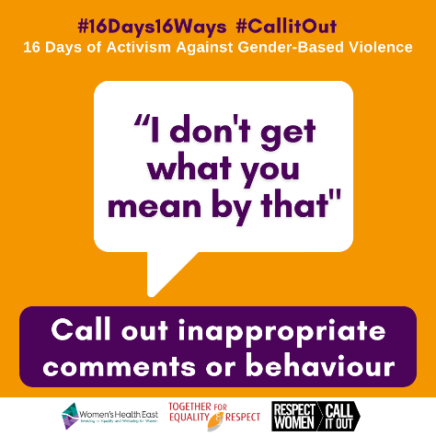 | Image description:  A large speech bubble of text “I don’t get what you mean by that”. Above the bubble are two hashtags and a tagline which read # 16 days 16 ways, # call it out, 16 days of activism against gender-based violence. Below the speech bubble is a text box which reads ‘call out inappropriate comments and behaviour’ and the logos of Women’s Health East, Together For Respect At Home and Respect Women: call it out.
Facebook / LinkedIn / Instagram: | People often use sexist comments as a ’joke’. These may seem innocent and harmless, but they contribute to a society which promotes disrespect and discrimination.  A person using the sexist ‘joke’ may not intend harm, but the bottom line is they’re being offensive, not funny.  It can be complicated and uncomfortable to explain this to someone, especially in a group setting.  One way to challenge these ‘jokes’ is to ask the person to explain what they meant by it. If you remain poised and serious, they may be forced to confront the plain truth that their comment was offensive, not humorous. This can also deter them from using these behaviours in the future.  #16Days16Ways #16DaysCampaign #RespectIs #CallitOut
Twitter: | Often sexist comments are labelled as a harmless ‘joke’, but they contribute to a society that promotes disrespect. Challenge these ‘jokes’ by asking the person to explain what they meant by it. It can deter this behaviour in the future.  #16Days16Ways #16DaysCampaign #CallitOut

Image / Description:  6-Your voice matters online.png  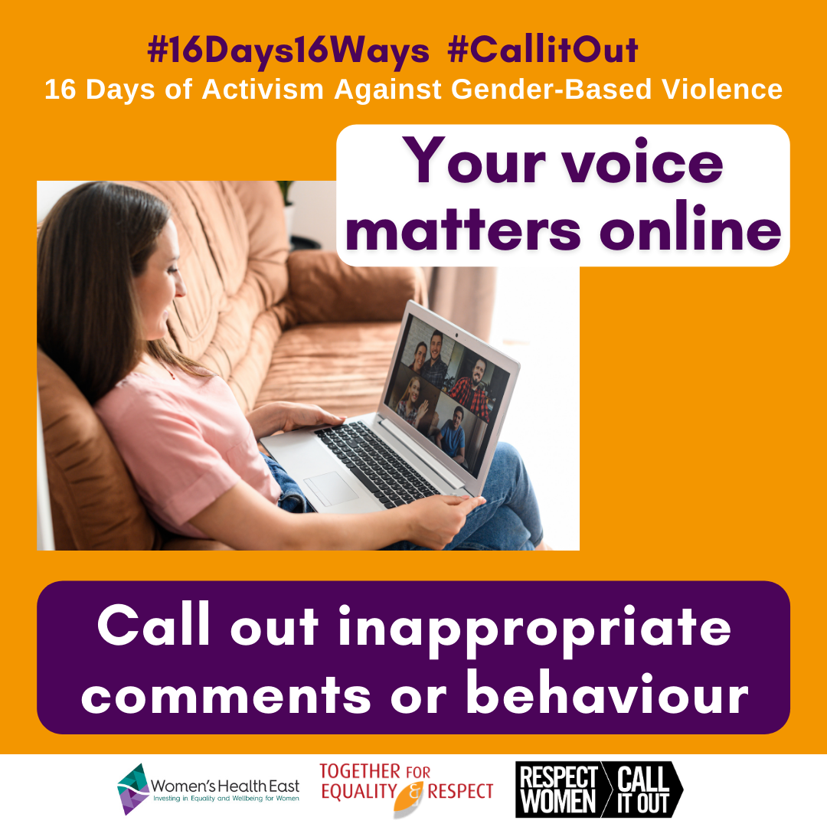 | Image description:  # 16 days 16 ways, # call it out, 16 days of activism against gender-based violence. Image a female sitting on a couch using a laptop to video chat with five other people. Paired text which reads ‘your voice matters online’ ‘call out inappropriate comments and behaviour’ and the logos of Women’s Health East, Together For Respect At Home and Respect Women: call it out.
Facebook / LinkedIn / Instagram: | Call Out disrespect online when you see it. Take action to speak up, or comment against disrespect. Show your support and create safe online spaces for others.  More and more we spend time online interacting and socialising with others. Using social media to connect online has been central to our daily lives in 2020.  Sometimes we witness disrespect online, whether these are posts made by other people, or comments on your own posts.  It is important to know that your voice matters online.  Check out this online video to learn more - www.youtube.com/watch?v=IWB-8FrTNQE  For online safety information and support visit www.whe.org.ay/16Days  #16Days16Ways #16DaysCampaign #RespectIs #CallitOut
Twitter: | #CallitOut when you see disrespect online. Speak up and show your support to create a safe online space. Using social media to connect has been central to our daily lives in 2020, so when we witness disrespect online, know that your voice matters #16Days16Ways #16DaysCampaign

Image / Description:  7-Your actions make a difference online.png  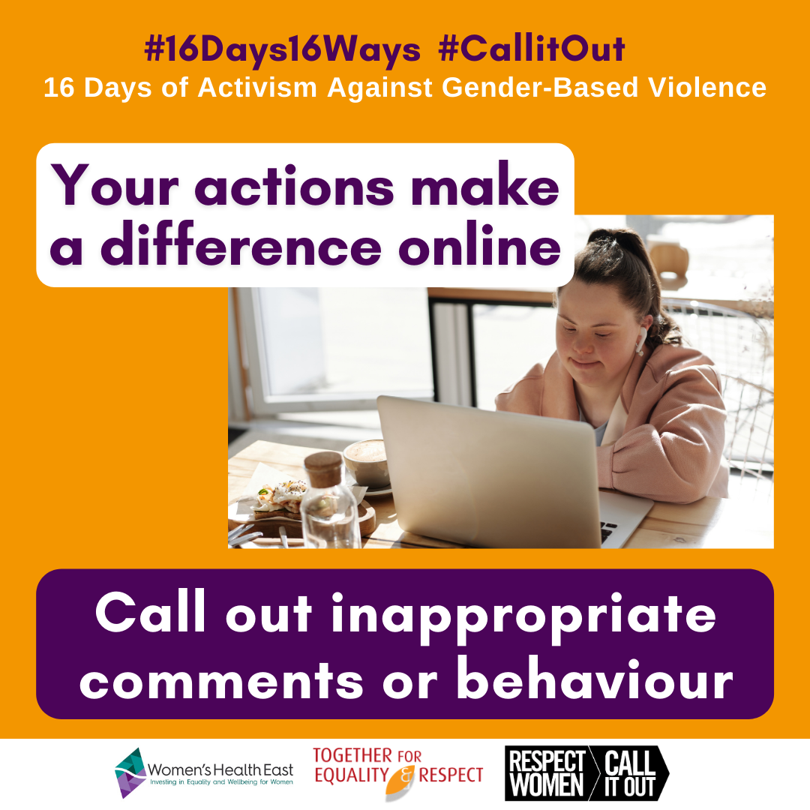 | Image description:  # 16 days 16 ways, # call it out, 16 days of activism against gender-based violence. Image a young female working on a laptop. Paired text which reads ‘your actions make a difference online’ ‘call out inappropriate comments and behaviour’ and the logos of Women’s Health East, Together For Respect At Home and Respect Women: call it out.
Facebook / LinkedIn / Instagram: | Have you seen a post or a comment on social media and thought “that’s just not right”, but haven’t been sure what to say?  You can show your support and call out disrespect, sexism or other forms of discrimination online by:  - Unfollowing the person making the inappropriate comments  - Consider posting a comment or calling out the behaviour like “Am I the only one who feels uncomfortable about this?”  - Show your support by sharing or liking comments that show respect or call out disrespect.  Your actions do make a difference online and could really make a difference to the person being targeted.  Together we’re stronger online. Check out this online video to learn more -https://youtu.be/xMTxeQV3YvI  For online safety information and support visit www.whe.org.ay/16Days  #16Days16Ways #16DaysCampaign #RespectIs #CallitOut
Twitter: | Have you seen a post or comment on social media and thought “that’s just not right”? You can show your support and #CallitOut online by: unfollowing individuals, posting a comment or liking comments that show respect or call out disrespect.  #16Days16Ways #16DaysCampaign

Image / Description:  8-Use body language.png  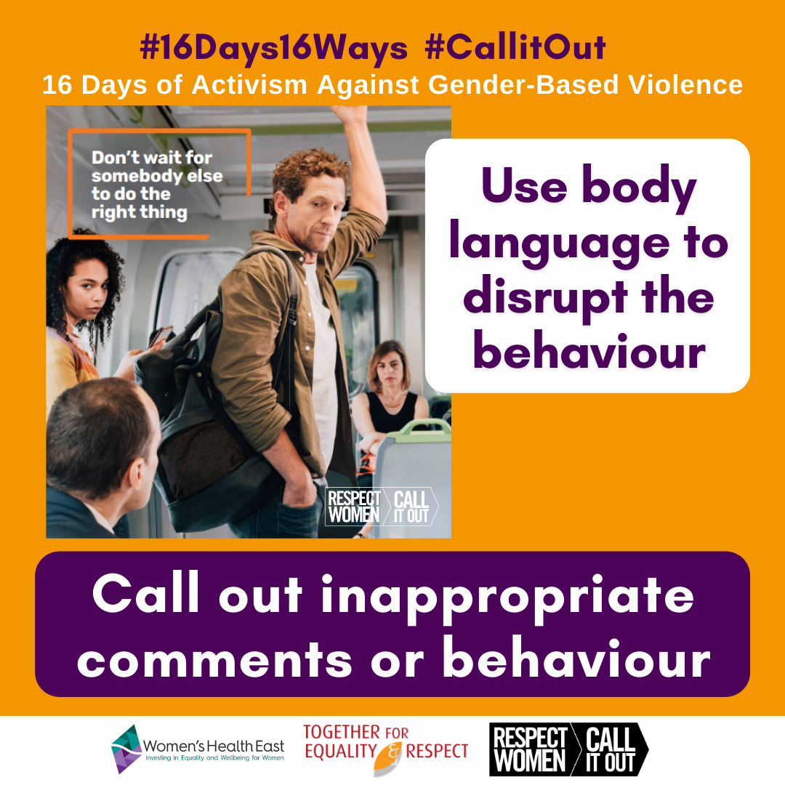 | Image description:  # 16 days 16 ways, # call it out, 16 days of activism against gender-based violence. Image of a male standing between a male and female passenger on a train. Standing male giving the male a disapproving look. Paired text which reads ‘use body language to disrupt the behaviour’ ‘call out inappropriate comments and behaviour’. Logos of Women’s Health East, Together For Respect At Home and Respect Women: call it out.
Facebook / LinkedIn / Instagram: | Have you seen the @RespectVictoria #CallitOut public transport advertisement?  Check it out here: www.youtu.be/UHxAxRYIlfE  Small and seemingly insignificant acts can be powerful in disrupting inappropriate behaviour. This can include using your body language whether that be standing in front or between the situation.  We all have a role to play to create a safe and respectful community for all. And by not giving inappropriate behaviour airtime, we show that it is not okay and not acceptable.  Know your actions can make a difference.  Learn more about how to not give inappropriate behaviour airtime and how to disrupt in public settings here: www.respectvictoria.vic.gov.au/campaigns/respect-women-call-it-out-public-transport  #16Days16Ways #16DaysCampaign #RespectIs #CallitOut
Twitter: | Small and seemingly insignificant acts can be powerful in disrupting inappropriate behaviour. This can include using your body language whether that be standing in front or between the situation. Know your actions can make a difference. #16Days16Ways #16DaysCampaign #CallitOut

Image / Description:  9-Use facial expressions.png  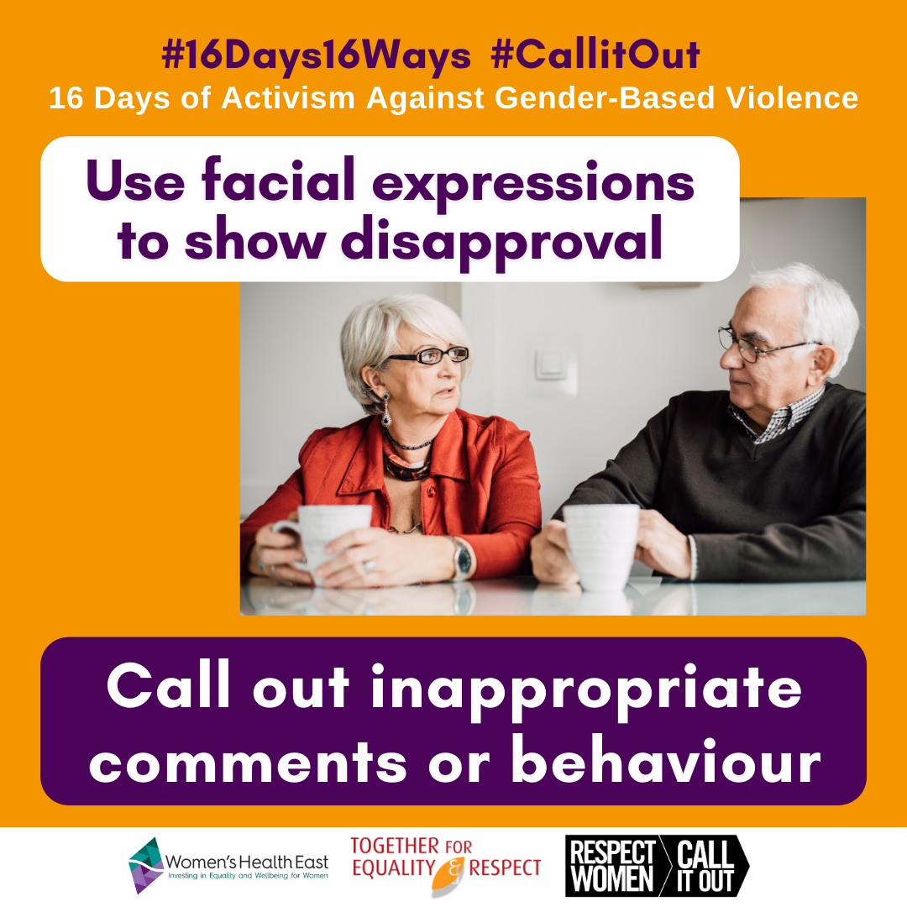 | Image description:  # 16 days 16 ways, # call it out, 16 days of activism against gender-based violence. Image of an older couple having a cup of tea at the table. Women is giving the man a disapproving look. Paired text which reads ‘use facial expressions to show disapproval’ ‘call out inappropriate comments and behaviour’ and the logos of Women’s Health East, Together For Respect At Home and Respect Women: call it out.
Facebook / LinkedIn / Instagram: | Although it might not feel like much, a roll of the eyes or arch of a brow, a pointed glare or a disapproving look are all simple but effective ways we can send a powerful message to a person that their comments are not okay.  By not giving airtime to inappropriate behaviour in social settings, we are committing to creating a safe and respectful community for everyone.  Remember that any action is better than no action. It’s up to all of us to change the culture of letting an inappropriate sexist and discriminatory behaviour unchallenged by calling it out when we can.  This can be something as simple as a facial expression to communicate your disapproval.  To see how a situation like this might play out, check out this video by @OurWatchAus - www.youtube.com/watch?v=6Hwj38L9bxY  #16Days16Ways #16DaysCampaign #RespectIs #CallitOut
Twitter: | It may not feel like much but a roll of the eyes, arch of a brow or a disapproving look are simple, effective ways we can send a powerful message to a person that their comments aren’t OK. Remember that any action is better than no action #16Days16Ways #16DaysCampaign #CallitOut

Image / Description:  10-Use a lighthearted comment.png  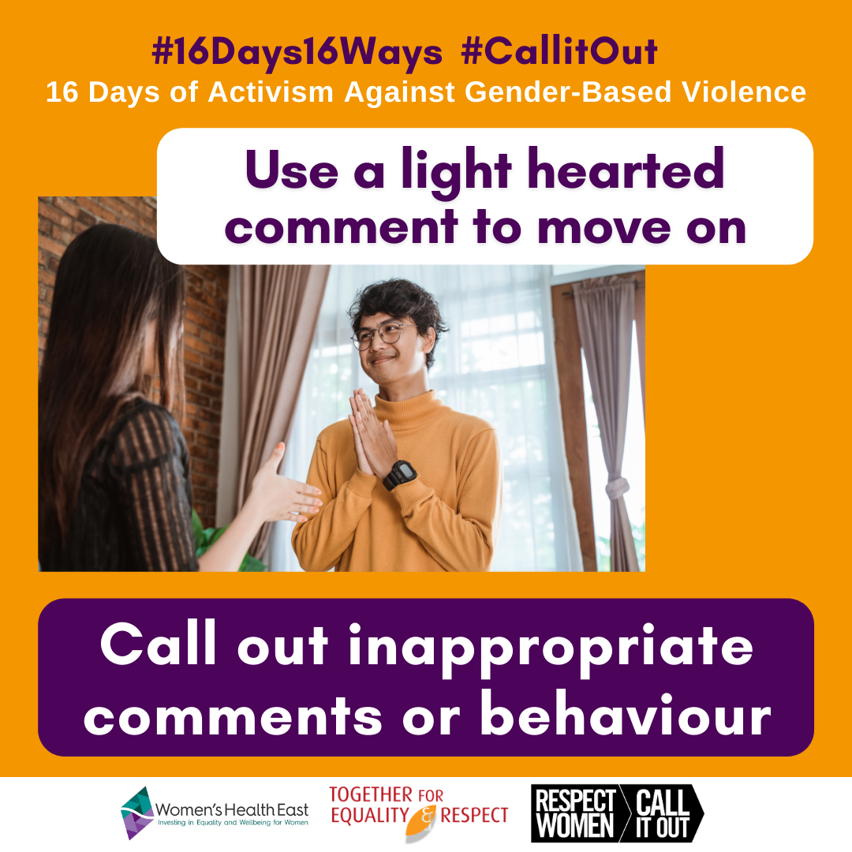 | Image description:  # 16 days 16 ways, # call it out, 16 days of activism against gender-based violence. Image young man and woman in conversation. Paired text which reads ‘use a light hearted comment to move on’ ‘call out inappropriate comments and behaviour’ and the logos of Women’s Health East, Together For Respect At Home and Respect Women: call it out.
Facebook / LinkedIn / Instagram: | Occasionally you might witness a situation where a person makes an inappropriate comment about someone else. Or maybe a person is retelling an event where they did or said something that’s not okay.  You have an opportunity to #CallitOut if you feel safe to do so. An easy way to do this could be to respond with a light-hearted comment and then move on. This rejects these harmful attitudes and sends a message that it is not acceptable.  Some examples of phrases you could use:  “What decade are you living in?”  “Yeah, that’s not a ‘thing’ anymore...”  “Hmmm and you thought that was okay?!”  By saying something, you are supporting the person who is the target of the behaviour. You are also challenging the comments directly.  To see how a situation like this might play out, check out this video by @OurWatchAus - www.youtube.com/watch?v=pYRaVcG3tS8  #16Days16Ways #16DaysCampaign #RespectIs #CallitOut
Twitter: | Occasionally you might witness a situation where a person makes an inappropriate comment about someone else. Using a light-hearted comment is an easy way to #CallitOut if you feel safe to do so. #16Days16Ways #16DaysCampaign #RespectIs

Image / Description:  11-Don't laugh along.png  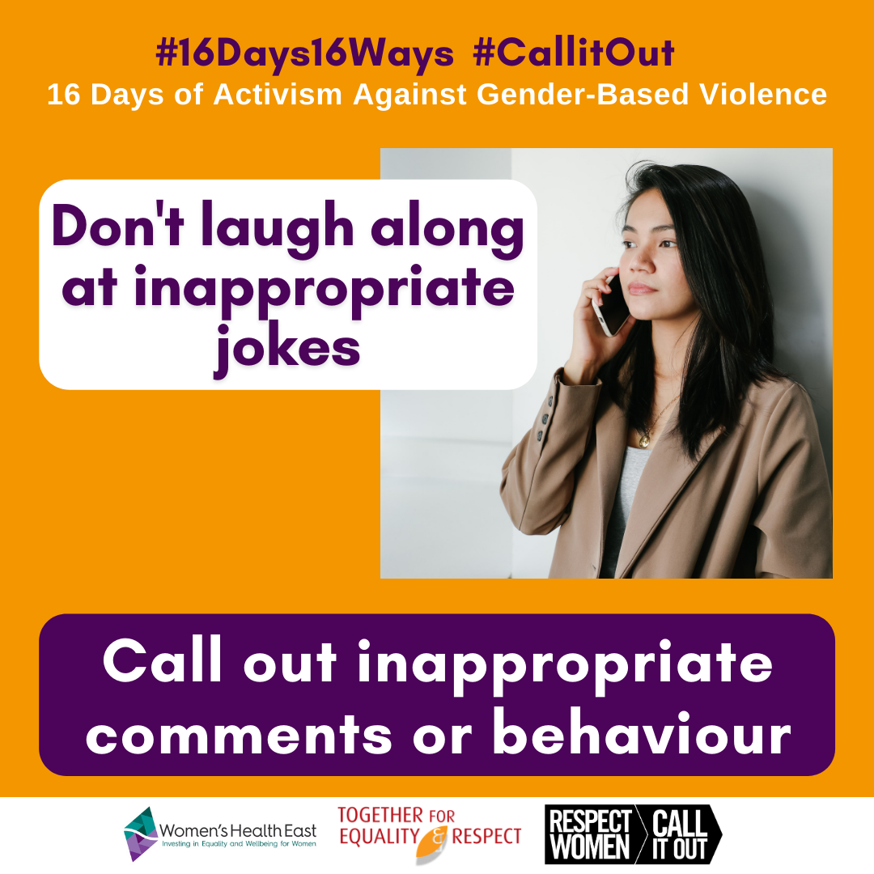 | Image description:  # 16 days 16 ways, # call it out, 16 days of activism against gender-based violence. Image of a young female looking serious with her mobile phone to her ear. Paired text which reads ‘don’t laugh along at inappropriate jokes’ ‘call out inappropriate comments and behaviour’ and the logos of Women’s Health East, Together For Respect At Home and Respect Women: call it out.
Facebook / LinkedIn / Instagram: | Have you heard of the saying ‘the standard you walk past is the standard you accept’?  This is true when we laugh along at sexist and discriminatory comments or jokes. We send the message that we think that is okay and acceptable.  It’s important to not give the airtime to these behaviours and show that they are not acceptable.  Calling out inappropriate behaviour can be as simple and effective as not laughing along. Or if you feel comfortable and safe you may also choose to explain why you’re not laughing.  We all have a role to play in creating a society based on respect and equality for all.  Learn more about how to show it’s not okay here- www.doingnothingdoesharm.org.au/DoingNothingDoesHarm/Home#show  #16Days16Ways #16DaysCampaign #RespectIs #CallitOut
Twitter: | When we support sexist jokes we send the message that it's acceptable. It’s important to not give the airtime to these behaviours & show that they're not OK. Calling it out can be as simple and effective as not laughing along. #16Days16Ways #16DaysCampaign #RespectIs #CallitOut

Image / Description:  12-There is no one way to act.png  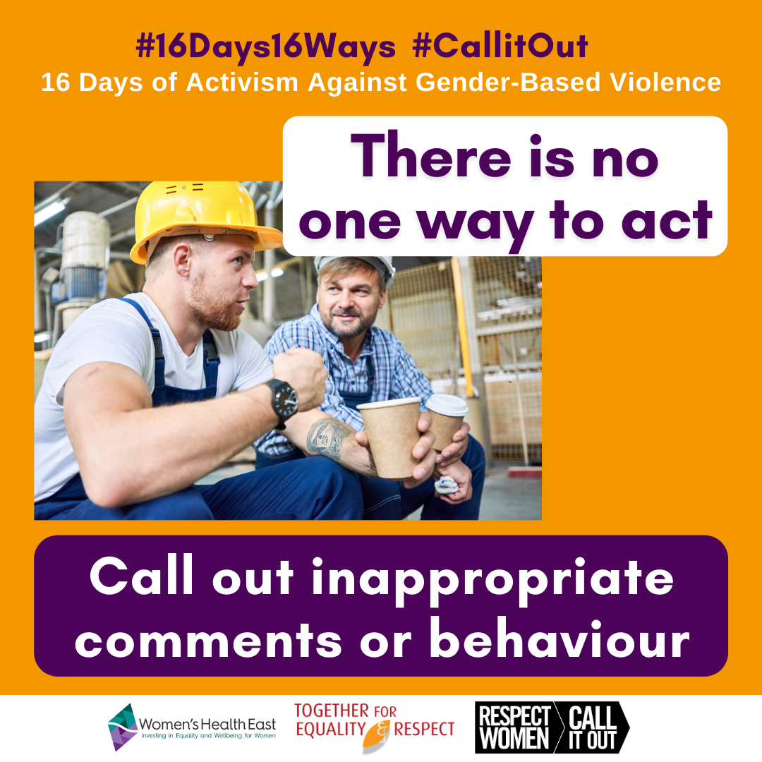 | Image description:  # 16 days 16 ways, # call it out, 16 days of activism against gender-based violence. Image of a two male construction worker eating lunch and talking with paired text which reads ‘address the behaviour, not the person’ ‘call out inappropriate comments and behaviour’ and the logos of Women’s Health East, Together For Respect At Home and Respect Women: call it out.
Facebook / LinkedIn / Instagram: | Every situation is different. There is no one way to respond to situations or comments that disrespect women. Showing your support and speaking up are great options.  You can choose how to call out inappropriate behaviour depending on the setting. It might be a simple roll of the eye, a shake of the head, making a comment to pull up the behaviour or supporting the target by acknowledging what happened and asking if they’re ok.  The important thing is to do something, because doing nothing does harm.  Learn more about how to show it’s not okay here- www.doingnothingdoesharm.org.au/DoingNothingDoesHarm/Home#show  #16Days16Ways #16DaysCampaign #RespectIs #CallitOut
Twitter: | Every situation is different. There's no one way to respond to disrespect towards women. Showing support and speaking up are great options. It might be a simple roll of the eye, a shake of the head, or asking the target if they’re okay. #16Days16Ways #16DaysCampaign #CallitOut

Image / Description:  13-Address the behaviour.png  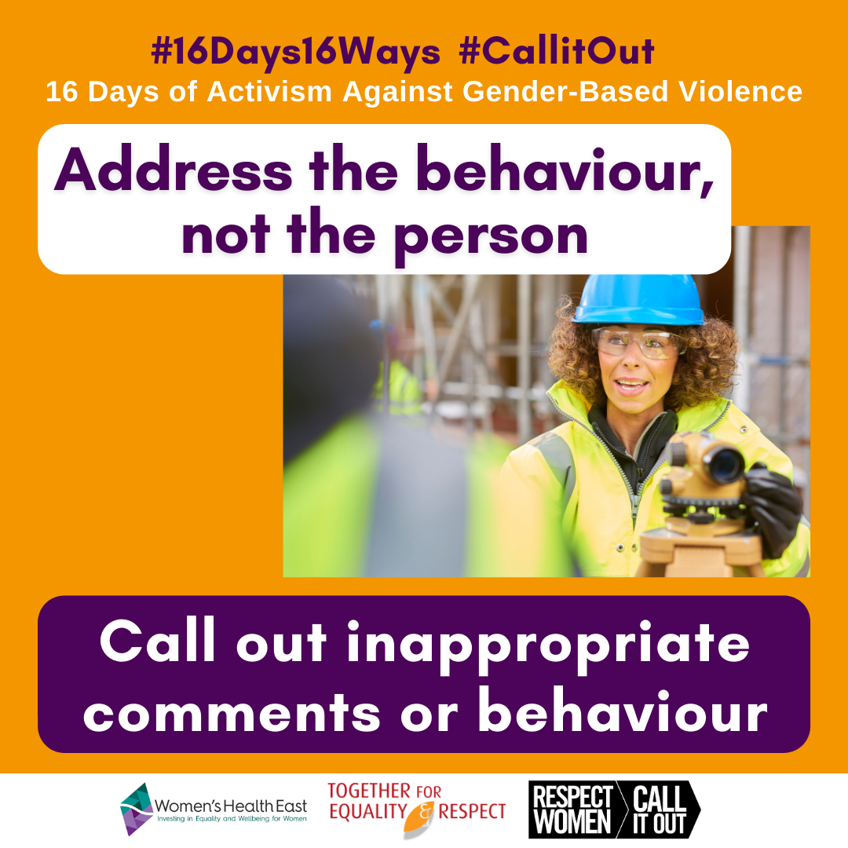 | Image description:  # 16 days 16 ways, # call it out, 16 days of activism against gender-based violence. Image of a female construction worker speaking with paired text which reads ‘address the behaviour, not the person’ ‘call out inappropriate comments and behaviour’ and the logos of Women’s Health East, Together For Respect At Home and Respect Women: call it out.
Facebook / LinkedIn / Instagram: | Address the behaviour, not the person.  By calling out disrespectful or inappropriate behaviour, we’re showing that we don’t tolerate harmful attitudes towards women.  Speaking up doesn’t have to be confrontational. Calling out sexist behaviours in an amicable/easy going way can ensure the person understands why the behaviour or comment is not okay.  Focusing on calling out the behaviour rather than the individual can make your point without it being a personal attack.  Try saying “those ideas aren't cool” or “I don’t agree with that” instead of using language like “you’re wrong”.  #16Days16Ways #16DaysCampaign #RespectIs #CallitOut
Twitter: | Speaking up doesn’t have to be confrontational. #CallitOut in an amicable way to ensure the person understands why it's not OK. Focusing on calling out the behaviour rather than the individual can make your point without it being a personal attack. #16Days16Ways #16DaysCampaign

Image / Description:  14-Choose your timing.png  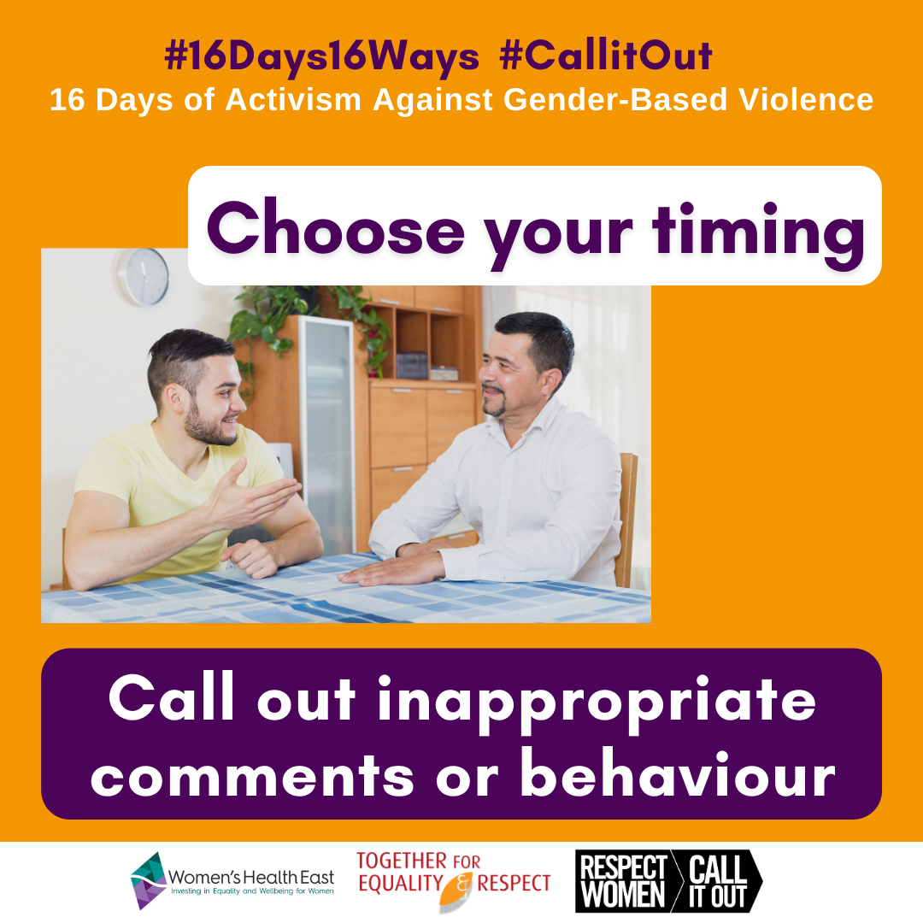 | Image description:  # 16 days 16 ways, # call it out, 16 days of activism against gender-based violence. Image of two males having a conversation at the dining table with paired text which reads ‘choose your timing’ ‘call out inappropriate comments and behaviour’ and the logos of Women’s Health East, Together For Respect At Home and Respect Women: call it out.
Facebook / LinkedIn / Instagram: | Do you ever reflect on past events and think ‘I could have said something!’ or ‘why didn’t I speak up?!’  It’s important to know that there’s always an opportunity to call out inappropriate behaviour after the event.  Maybe you didn’t get up the courage at the time and you’ve since acknowledged that it should have been called out. Or maybe it wasn’t a suitable setting to pull someone aside to have that chat.  Either way, you know the importance of calling out inappropriate behaviour, so follow it up and talk to the person at another time.  This can be as simple as; “Hey, I just wanted to talk about that comment you made the other night…” or “As my friend, I wanted to let you know I wasn’t comfortable when...”  By letting comments slide, we unknowingly send the message that sexist or discriminatory behaviours or comments are okay and acceptable.  Remember: Doing nothing does harm.  #16Days16Ways #16DaysCampaign #RespectIs #CallitOut
Twitter: | Did you know there’s opportunity to #CallitOut after the event? This can be as simple as; “Hey, I just wanted to talk about that comment you made the other night...” By letting comments slide, we send the message that the behaviour is acceptable. #16Days16Ways #16DaysCampaign

Image / Description:  15-Reflect on missed opportunities.png  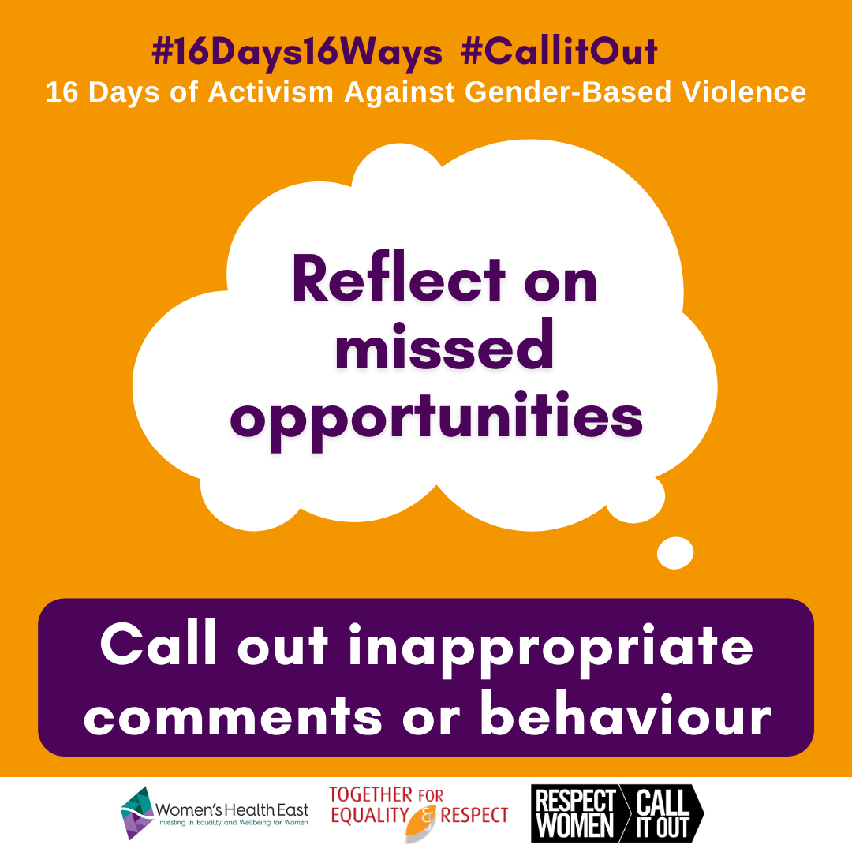 | Image description:  A large speech bubble of text ‘reflect on missed opportunities. Above the bubble are two hashtags and a tagline which read # 16 days 16 ways, # call it out, 16 days of activism against gender-based violence. Below the speech bubble is a text box which reads ‘call out inappropriate comments and behaviour’ and the logos of Women’s Health East, Together For Respect At Home and Respect Women: call it out.
Facebook / LinkedIn / Instagram: | Do you ever reflect on missed opportunities and think ‘I could have said something’ or ‘I wish I said it a different way’?  It’s important to reflect on missed opportunities and think about what you will do next time in a similar situation. Practicing and improving the ways we call people out when they use disrespectful comments or behaviour is important.  Some further tips include writing down what you want to say, or talking it through with a friend. That way if another situation arises you will be more practiced at managing it.  In the moment, ask the person who is being disrespectful to repeat themselves to give yourself some time to hold your ground in a calm and respectful manner.  If you try one thing and it doesn’t feel right, practice a different approach.  #16Days16Ways #16DaysCampaign #RespectIs #CallitOut
Twitter: | It’s important to reflect on missed opportunities and think about what you'll do next time in a similar situation. Practicing and improving ways we #CallitOut is key. If you try one thing and it doesn’t feel right, practice a different approach #16Days16Ways #16DaysCampaign

Image / Description:  16-We all have a role to play.png  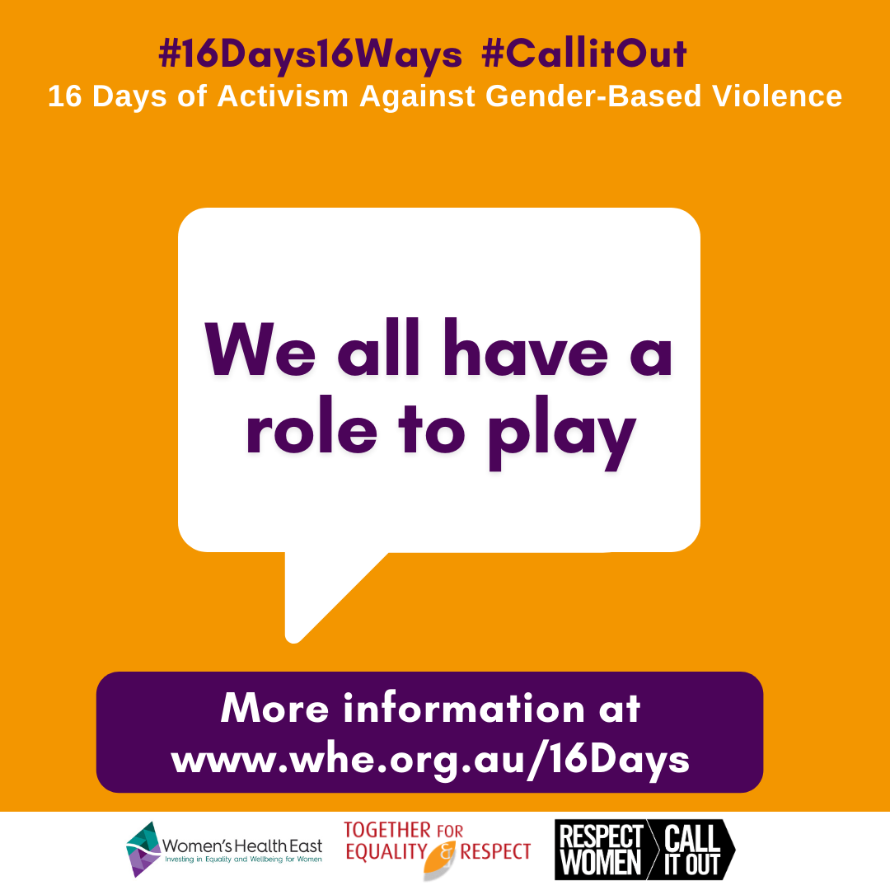 | Image description:  A large speech bubble of text ‘we all have a role to play’. Above the bubble are two hashtags and a tagline which read # 16 days 16 ways, # call it out, 16 days of activism against gender-based violence. Below the speech bubble is a text box which reads ‘more information at www.whe.org.au/16days’ and the logos of Women’s Health East, Together For Respect At Home and Respect Women: call it out.
Facebook / LinkedIn / Instagram: | Today, December 10 is #HumanRightsDay.  The day calls on us all to stand up for human rights for everyone rights regardless of race, colour, religion, gender identity, sex, language, political or other opinion, national or social origin, property, birth or other status. Disrespect for basic human rights continues to be widespread in all parts of the globe. Violence against women is one of the most prevalent violations of human rights in Australia and around the world.  It is important we all play a role in calling out behaviour that supports sexism, discrimination, and inequality. This action promotes equality and respect across the whole community.  For more information about the #16Days16Ways campaign, support services or to learn more about the link between gender inequality and violence against women visit www.whe.org.au/16Days  #16Days16Ways #16DaysCampaign #RespectIs #CallitOut
Twitter: | Today is #HumanRightsDay. Violence against women is one of the most prevalent violations of human rights in Australia and around the world. We all play a role in calling out sexist and discriminatory behaviour.  #16Days16Ways #16DaysCampaign #CallitOut

December 3  International Day of People with Disabilities | International Day of People with Disabilities (3 December) occurs during the 16 Days. We strongly encourage partners to acknowledge this day and the rights and contributions of people with disabilities. Please see below for suggested text, which can be added your social media posts scheduled for this day:  Today, December 3 is the United Nations internationally recognised Day of People with Disabilities: a day to promote respect for the rights and dignity, capabilities and contributions of people with disabilities. We acknowledge the seriousness of violence against women with disabilities, the importance of calling out ableism, sexism and other forms of discrimination experienced by women with disabilities, and centring the expertise of women with lived experience of disability in creating a society based on respect and equality for all people with disabilities.

